SPECIAL NOTES ON LCD MONITORS … | 1
INFORMATION FOR YOUR SAFETY AND COMFORT … | 2
UNPACKING … | 5
ATTACHING / REMOVING THE BASE … | 6
SCREEN POSITION ADJUSTMENT … | 6
WALL MOUNTING (OPTINAL). | 7
CONNECTING THE POWER CORD … | 8
SAFETY PRECAUTION … | 8
CLEANING YOUR MONITOR … | 8
POWER SAVING …8 | 9
DDC …8 | 9
CONNECTOR PIN ASSIGNMENT … | 10
STANDARD TIMING TABLE ... | 11
INSTALLATION ... | 12
USER CONTROLS ………. | 13
HOW TO ADJUST A SETTING ….. | 14
TROUBLESHOOTING | 18

SPECIAL NOTES ON LCD MONITORS
The following symptoms are normal with LCD monitor and do not indicate a problem.

NOTES
- Due to the nature of the fluorescent light, the screen may flicker during initial use. Turn off the Power Switch and then turn it on again to make sure the flicker disappears.
- You may find slightly uneven brightness on the screen depending on the desktop pattern you use.
- The LCD screen has effective pixels of 99.99% or more. It may include blemishes of 0.01% or less such as a missing pixel or a pixel lit all of the time.
- Due to the nature of the LCD screen, an afterimage of the previous screen may remain after switching the image, when the same image is displayed for hours. In this case, the screen is recovered slowly by changing the image or turning off the Power Switch for hours.

INFORMATION FOR YOUR SAFETY AND COMFORT

Safety instructions
Read these instructions carefully. Keep this document for future reference. Follow all warnings and instructions marked on the product.

CAUTION for plug as disconnecting device
Observe the following guidelines when connecting and disconnecting power to the power supply unit:
Install the power supply unit before connecting the power cord to the AC power outlet.
Unplug the power cord before removing the power supply unit from the product.
If the system has multiple sources of power, disconnect power from the system by unplugging all power cords from the power supplies.

CAUTION for accessibility
Be sure that the power outlet you plug the power cord into is easily accessible and located as close to the equipment operator as possible. When you need to disconnect power to the equipment, be sure to unplug the power cord from the electrical outlet.

Warnings
- Do not use this product near water.
- Do not place this product on an unstable cart, stand or table. If the product falls, it could be seriously damaged.
- Slots and openings are provided for ventilation to ensure reliable operation of the product and to protect it from overheating. These openings must not be blocked or covered. The openings should never be blocked by placing the product on a bed, sofa, rug or other similar surface. This product should never be placed near or over a radiator or heat register, or in a built-in installation unless proper ventilation is provided.
- Never push objects of any kind into this product through cabinet slots as they may touch dangerous voltage points or short-out parts that could result in a fire or electric shock. Never spill liquid of any kind onto or into the product.
- To avoid damage of internal components and to prevent battery leakage, do not place the product on a vibrating surface.
- Never use it under sporting, exercising, or any vibrating environment which will probably cause unexpected short current or damage rotor devices, HDD, Optical drive, and even exposure risk from lithium battery pack.

Safe listening
Follow these instructions, suggested by hearing experts, to protect your hearing.
- Gradually increase the volume until you can hear it clearly and comfortably and without distortion.
- After setting the volume level, do not increase it after your ears adjust.
- Limit the amount of time listening to music at high volume.
- Avoid turning up the volume to block out noisy surroundings.
- Turn the volume down if you can’t hear people speaking near you.

Product servicing
Do not attempt to service this product yourself, as opening or removing covers may expose you to dangerous voltage points or other risks. Refer all servicing to qualified service personnel.
Unplug this product from the wall outlet and refer servicing to qualified service personnel when:
- the power cord or plug is damaged, cut or frayed liquid was spilled into the product
- the product was exposed to rain or water
- the product has been dropped or the case has been damaged
- the product exhibits a distinct change in performance, indicating a need for service
- the product does not operate normally after following the operating instructions

 | Note: Adjust only those controls that are covered by the operating instructions, since improper adjustment of other controls may result in damage and will often require extensive work by a qualified technician to restore the product to normal condition.

LCD Pixel Statement
The LCD unit is produced with high-precision manufacturing techniques. Nevertheless, some pixels may occasionally misfire or appear as black or red dots. This has no effect on the recorded image and does not constitute a malfunction.

Tips and information for comfortable use
Computer users may complain of eyestrain and headaches after prolonged use. Users are also at risk of physical injury after long hours of working in front of a computer. Long work periods, bad posture, poor work habits, stress, inadequate working conditions, personal health and other factors greatly increase the risk of physical injury.
Incorrect computer usage may lead to carpal tunnel syndrome, tendonitis, tenosynovitis or other musculoskeletal disorders. The following symptoms may appear in the hands, wrists, arms, shoulders, neck or back:
- numbness, or a burning or tingling sensation
- aching, soreness or tenderness
- pain, swelling or throbbing
- stiffness or tightness
- coldness or weakness
If you have these symptoms, or any other recurring or persistent discomfort and/or pain related to computer use, consult a physician immediately and inform your company’s health and safety department.
The following section provides tips for more comfortable computer use.

Finding your comfort zone
Find your comfort zone by adjusting the viewing angle of the monitor, using a footrest, or raising your sitting height to achieve maximum comfort. Observe the following tips:
- refrain from staying too long in one fixed posture
- avoid slouching forward and/or leaning backward
- stand up and walk around regularly to remove the strain on your leg muscles
- take short rests to relax your neck and shoulders
- avoid tensing your muscles or shrugging your shoulders
- install the external display, keyboard and mouse properly and within comfort able reach
- if you view your monitor more than your documents, place the display at the center of your desk to minimize neck strain

Taking care of your vision
Long viewing hours, wearing incorrect glasses or contact lenses, glare, excessive room lighting, poorly focused screens, very small typefaces and low-contrast displays could stress your eyes. The following sections provide suggestions on how to reduce eyestrain.

Eyes
- Rest your eyes frequently.
- Give your eyes regular breaks by looking away from the monitor and focusing on a distant point.
- Blink frequently to keep your eyes from drying out.

Display
- Keep your display clean.
- Keep your head at a higher level than the top edge of the display so your eyes point downward when looking at the middle of the display.
- Adjust the display brightness and/or contrast to a comfortable level for enhanced text readability and graphics clarity.
- Eliminate glare and reflections by:
- placing your display in such a way that the side faces the window or any light source
- minimizing room light by using drapes, shades or blinds
- using a task light
- changing the display’s viewing angle
- using a glare-reduction filter
- using a display visor, such as a piece of cardboard extended from the display’s top front edge
- Avoid adjusting your display to an awkward viewing angle.
- Avoid looking at bright light sources, such as open windows, for extended periods of time.

Developing good work habits
Develop the following work habits to make your computer use more relaxing and productive:
- Take short breaks regularly and often.
- Perform some stretching exercises.
- Breathe fresh air as often as possible.
- Exercise regularly and maintain a healthy body.

 | Warning! We do not recommend using the product on a couch or bed. If this is unavoidable, work for only short periods, take breaks regularly, and do some stretching exercises.
 | For more information and help in recycling, please visit the following websites: Worldwide: http://global.acer.com/about/sustainability.htm

UNPACKING
Please check the following items are present when you unpack the box, and save the packing materials in case you will need to ship or transport the monitor in future.

LCD Monitor

15-pin D-Sub Cable | DVI Cable  (Only Dual-Input Model) | AC Power Cord
User Manual | Quick Start Guide
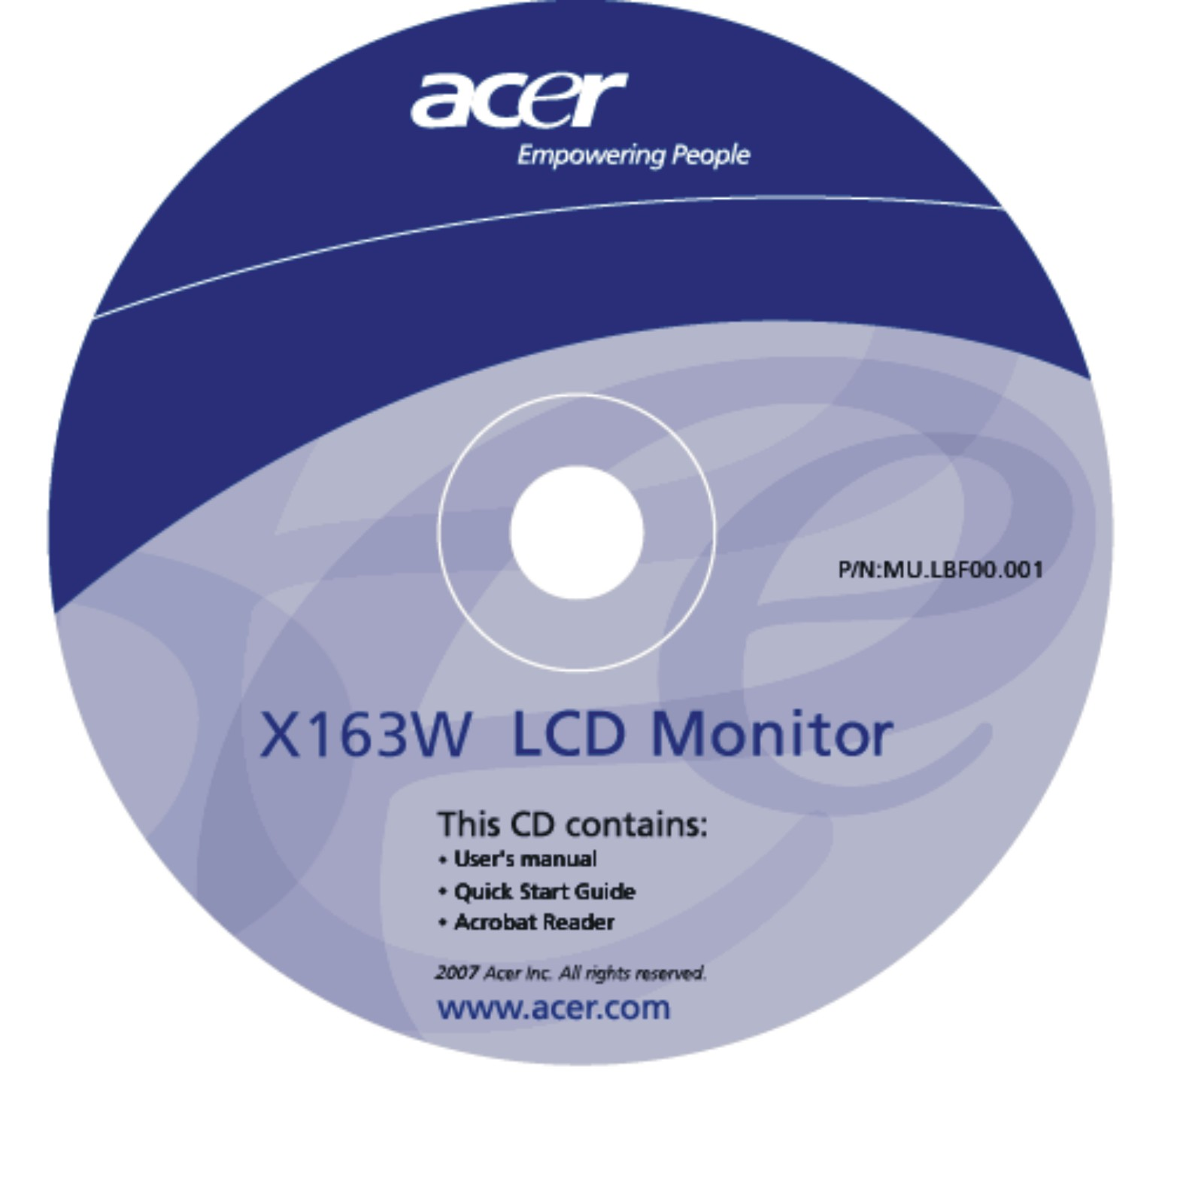 | 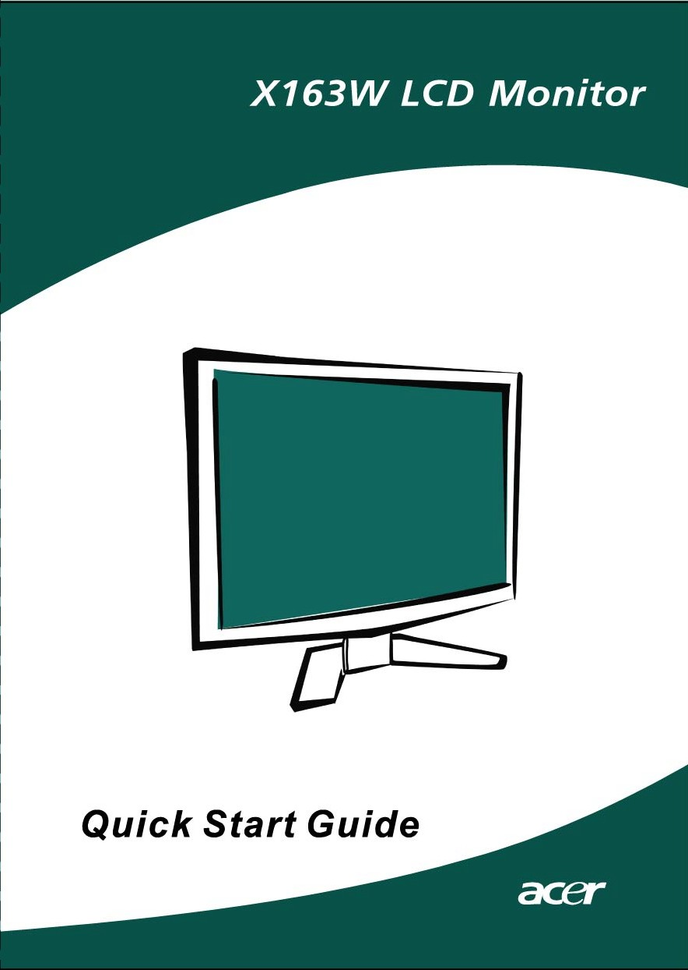

ATTACHING / REMOVING THE BASE
Install:  Align the release button on the bottom of the monitor with the corresponding slots on the bottom of the base. | Remove:  Depress the release button as indicated first before removing the base and follow the arrow direction to remove it.

SCREEN POSITION ADJUSTMENT
In order to optimize the best viewing position, you can adjust the tilt of the monitor by using both of your hands to hold the edges of the monitor as shown in the figure below.
The monitor can be adjusted to 15 degrees up or 5 degrees down as indicated by arrow below.

WALL MOUNTING (OPTIONAL)
To obtain a wall-mounting kit, contact your local dealer, Refer to the instructions that come with the base mounting kit.

Screw holes (100 mm X 100 mm)
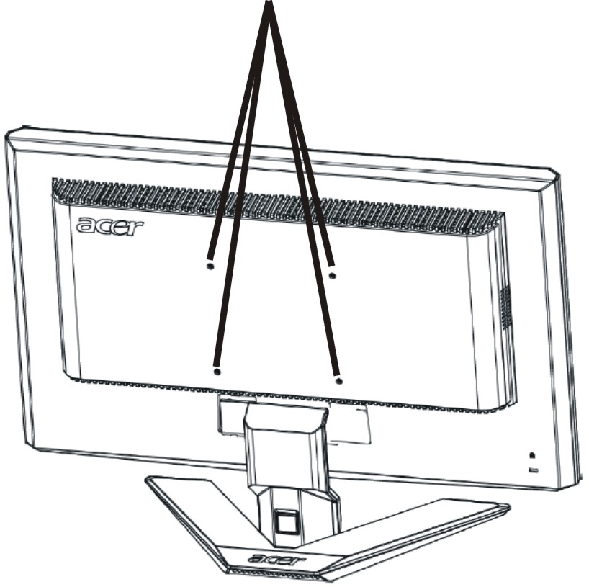

* Note: Please use UL Listed wall mount bracket with M4 mm x 10 mm (L) screw for application.

CONNECTING THE POWER CORD
- Check first to make sure that the power cord you use is the correct type required for your area.
- This monitor has a universal power supply that allows operation in either 100/120V AC or 220/240 V AC voltage areas. No user-adjustment is required.
- Plug one end of the power cord to the AC Inlet, plug another end to a proper AC outlet.
- For unit using at 120 V AC:
- Use a UL Listed Cord Set, Type SVT wire and plug rated 10 A/125 V.
- For unit using at 220/240 V AC (outside of U.S.):
- Use a Cord Set consisting of H05VV-F cord and plug rated 10 A, 250 V. The cord set should have the appropriate safety approvals for the country in which the equipment will be installed.

SAFETY PRECAUTION
- Avoid placing the monitor, or any other heavy object, on the power cord to avoid damage to the cable.
- Do not expose the monitor to rain, excessive moisture, or dust.
- Do not cover the ventilation slots or openings of the monitor. Always put the monitor in a place where there is adequate ventilation.
- Avoid placing the monitor against a bright background or where sunlight or other light sources may reflect on the face of the monitor. Place the monitor just below eye level.
- Handle with care when transporting the monitor.
- Refrain from giving shock or scratch to the screen, as screen is fragile.

CLEANING YOUR MONITOR
Please carefully follow the below guidelines when cleaning the monitor.
- Always unplug the monitor before cleaning.
- Use a soft cloth to wipe the screen and cabinet front and sides.

POWER SAVING
The monitor will be driven into Power Saving” mode by the control signal from the display controller, as indicated by the amber-color power LED.

State | LED Light
ON | Blue
Power Saving Mode | Amber

The power saving states will be kept until a control signal has been detected or the keyboard or mouse is activated. The recovery time from Active OFF state back to ON state is around 5 seconds.

DDC
To make your installation easier, the monitor is able to Plug and Play with your system if your system also supports DDC protocol. The DDC (Display Data Channel) is a communication protocol through which the monitor automatically informs the host system about its capabilities, for example, supported resolutions and corresponding timing. The monitor supports DDC2B standard.

CONNECTOR PIN ASSIGNMENT

15-Pin Color Display Signal Cable

PIN NO. | DESCRIPTION | PIN NO. | DESCRIPTION
1. | Red | 9. | +5V
2. | Green | 10. | Logic Ground
3. | Blue | 11. | Monitor Ground
4. | Monitor Ground | 12. | DDC-Serial Data
5. | DDC-return | 13. | H-Sync
6. | R-Ground | 14. | V-Sync
7. | G-Ground | 15. | DDC-Serial Clock
8. | B-Ground

STANDARD TIMING TABLE
To reduce the need for adjustment for different modes, the monitor has default setting modes that are most commonly used as given in the table below. For optimum adjustment, the user is suggested to perform the Auto Setup under Windows “Full Screen” pattern or using the pattern in the floppy disk provided. The only condition to store as a user mode is the new display information must have 1 KHz difference for horizontal frequency or 1 Hz for vertical frequency or the sync signal polarities are different from the default modes.

Display Mode |  | Hor. Frequency (kHz) | Vert. Frequency  (Hz) | Pixel Frequency (MHz) | SYNC Polarity (H/V)
VESA | VGA 640x480 | 31.469 | 59.940 | 25.175 | -/-
VESA | VGA 640x480 | 37.861 | 72.809 | 31.500 | -/-
VESA | VGA 640x480 | 37.500 | 75.000 | 31.500 | -/-
VESA | SVGA 800x600 | 35.156 | 56.250 | 36.000 | +/+
VESA | SVGA 800x600 | 37.879 | 60.317 | 40.000 | +/+
VESA | SVGA 800x600 | 48.077 | 72.188 | 50.000 | +/+
VESA | SVGA 800x600 | 46.875 | 75.000 | 49.500 | +/+
VESA | XGA 1024x768 | 48.363 | 60.004 | 65.000 | -/-
VESA | XGA 1024x768 | 56.476 | 70.069 | 75.000 | -/-
VESA | XGA 1024x768 | 60.023 | 75.029 | 78.750 | +/+
VESA | SXGA 1152x864 | 67.500 | 75.000 | 108.000 | +/+
VESA | SXGA 1280x1024 | 63.981 | 60.020 | 108.000 | +/+
VESA | SXGA 1280x1024 | 79.976 | 75.025 | 135.000 | +/+
VESA | WXGA 1366x768 | 47.765 | 59.856 | 85.500 | -/+
VESA | 1280x960 | 60.000 | 60.000 | 108.000 | +/+
VESA | 1360x768 | 47.712 | 60.015 | 85.500 | +/+
VESA | 1280x720 | 44.772 | 59.855 | 74.500 | -/+
VGA TEXT | 720 x 400 | 31.469 | 70.087 | 28.322 | -/+
Macintosh | 640x480 | 35.000 | 66.667 | 30.240 | -/-
Macintosh | 832 x 624 | 49.725 | 74.500 | 57.283 | -/-
Macintosh | 1024 x 768 | 60.150 | 74.720 | 80.000 | -/-

INSTALLATION
To install the monitor to your host system, please follow the steps as given
below:
Steps
1. | 1-1 | Connect Video Cable
 | a. | Make sure both the monitor and computer are powered-OFF.
 | b. | Connect the VGA video cable to the computer.
 | 1-2 | Digital Cable (Only Dual-Input Model)
 | a. | Make sure both the monitor and computer are powered-OFF.
 | b. | Connect one end of the 24-pin DVI cable to the back of the monitor and connect the other end to the computer's port.
2. | Connect power cord  Connect the power cord to the monitor, then to a properly grounded AC outlet.
3. | Power-ON Monitor and Computer  Power-ON the monitor first, then power-ON the computer.  This sequence is very important.
4. | If the monitor still does not function properly, please refer to the troubleshooting section to diagnose the problem.

USER CONTROLS

Front Panel Controls
1.Power Switch:
To turn ON or OFF the power.

2.Power LED:
Lights up to indicate the power is turned ON.

3.Empowering / Exit:
1) When OSD menu is in active status, this button will act as EXIT-KEY(EXIT OSD menu).
2) When OSD menu is in off status, press this button to select scenario
mode.

4.Auto Adjust button / Exit:
1)When OSD menu is in active status, this button will act as EXIT-KEY (EXIT OSD menu).
2)When OSD menu is in off status, press this button for 2 seconds to activate the Auto Adjustment function. The Auto Adjustment function is used to set the HPos, VPos, Clock and Focus.

5.< / >
Press < or > to select the desired function. Press < or > to change the settings of the current function.

6.MENU / ENTER:
Activate OSD menu when OSD is OFF or activate/de-activate adjustment function when OSD is ON.

HOW TO ADJUST A SETTING
- Press the MENU-button to activate the OSD window.
- Press < or > to select the desired function.
- Press the MENU-button to select the function that you want to adjust.
- Press < or > to change the settings of the current function.
- To exit and save, select the exit function. If you want to adjust any other function, repeat steps 2-4.

  - P/X Series OSD behave
When user press “MENU” button on front bezel

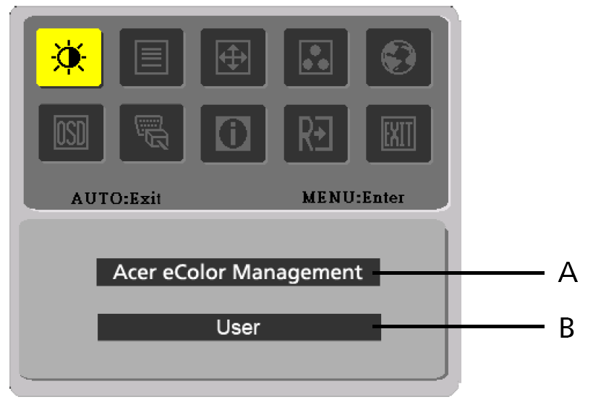

A. Acer eColor Management
If selected to “Acer eColor Management” item, will appear the Acer eColor” OSD
B. USER
If selected to “USER” item, will appear the Standard OSD

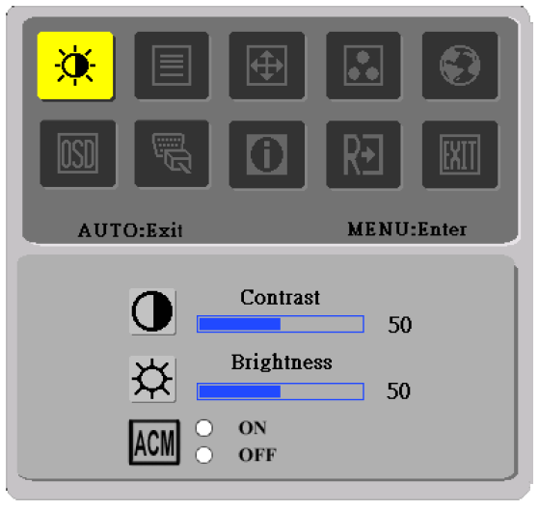 | 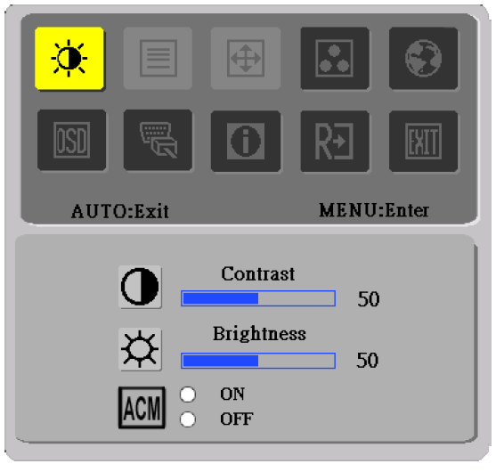
I. Only Analog Input Model | II. Only Dual Input ModeI
ADJUSTING THE PICTURE
The descriptions for function control LEDS

A. Acer eColor Management
Main Menu icon | Sub Menu icon | Sub Menu item | Description
 | N/A | User mode | User defined. Settings can be fine-tuned to suit any situation
 | N/A | Text mode | Optimal balance of brightness and contrast prevent eyestrain. The most comfortable way to read onscreen text
 | N/A | Standard mode | Default Setting. Reflects native display capability
 | N/A | Graphic mode | Enhances colors and emphasize fine detail
 | N/A | Movie mode | Displays scenes in clearest detail. Pictures and photographs appear in vibrant colors with sharp detail

B. USER.
Main Menu icon | Sub Menu icon | Sub Menu item | Description
 |  | Contrast | Adjust the contrast between the foreground and background of the screen image
 |  | Brightness | Adjust the background brightness of the screen image
 |  | ACM | ACM (Adaptive Contrast Management)A CM ON/OFF Switch, default "OFF"
 |  | Focus | Adjust picture Focus  (available in analog mode only)
 |  | Clock | Adjust picture Clock  (available in analog mode only)

Main Menu icon | Sub Menu icon | Sub Menu item | Description
 |  | H. Position | Adjust the horizontal position.  (available in Analog mode only)
 |  | V. Position | Adjust the vertical position.  (available in Analog mode only)
 | N/A | Warm | Set the color temperature to warm white.
 | N/A | Cool | Set the color temperature to cool white.
 |  | User /Red | Adjusts Red/Green/Blue intensity
 |  | User /Green | Adjusts Red/Green/Blue intensity
 |  | User /Blue | Adjusts Red/Green/Blue intensity
 | N/A | English | Multi-language selection.
 | N/A | 繁體中文 | Multi-language selection.
 | N/A | Deutsch | Multi-language selection.
 | N/A | Français | Multi-language selection.
 | N/A | Español | Multi-language selection.
 | N/A | Italiano | Multi-language selection.
 | N/A | 简体中文 | Multi-language selection.
 | N/A | 日本語 | Multi-language selection.
 | N/A | Suomi | EMEA version OSD only
 | N/A | Nederlands | EMEA version OSD only
 | N/A | Русский | EMEA version OSD only
 |  | H. Position | Adjust the horizontal position of the OSD.
 |  | V. Position | Adjust the vertical position of the OSD.
 |  | OSD Timeout | Adjust the OSD timeout.
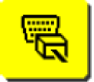 | N/A | Analog | Select input signal from analog (D-Sub)
 | N/A | Digital (only Dual Input Model) | Select input signal from digital(DVI)  (only Dual-Input Model)
 | N/A | DDC/CI | Turn ON/OFF DDC/CI support
 | N/A | Information | Show the resolution, H/V frequency and input port of current input timing.
 | N/A | Reset | Clear each old status of Auto-  configuration and set the color temperature to Cool.
 | N/A | Exit | Save user adjustment and OSD disappear.
Acer eColor Management OSD

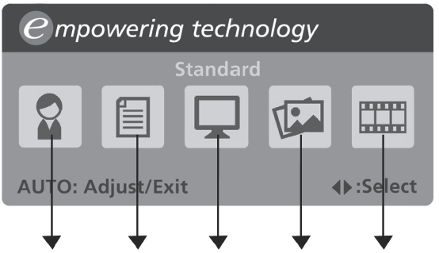
User mode
Text mode
Standard mode
Graphic mode
Movie mode

Operation instructions

Acer eColor Management
Step 1: | Press “ Key” to open the Acer eColor Management OSD and access the scenario modes
Step 2: | Press “<” or “>” to select the mode
Step 3: | Press “Auto Key” to confirm the mode and run Auto Adjust

Features and Benefits

Mode | Features | Benefits
Standard | Default settings | Reflects native display capability
Text | Optimal balance of brightness and contrast prevents eyestrain | The most comfortable way to read onscreen text
Graphics | Enhances colors and emphasizes fine detail | Pictures and photographs appear in vibrant colors with sharp detail
Movie | Displays scenes in clearest detail | Presents great visuals, even in unsuitably-lit environments
User | User defined | Settings can be fine-tuned to suit any situation

TROUBLESHOOTING
Before sending your LCD monitor for servicing, please check the troubleshooting list below to see if you can self-diagnose the problem.

(VGA Mode)
Problems | Current Status | Remedy
No Picture | LED ON | - Using OSD, adjust brightness and contrast to maximum or reset to their default settings.
No Picture | LED OFF | - Check the power switch.
No Picture | LED OFF | - Check if AC power cord is properly connected to the monitor.
No Picture | LED displays amber color | - Check if video signal cable is properly connected at the back of monitor.
No Picture | LED displays amber color | - Check if the power of computer system is ON.
Abnormal Picture | Unstable Picture | - Check if the specification of graphics adapter and monitor is in compliance which may be causing the input signal frequency mismatch.
Abnormal Picture | Display is missing, center shift, or too small or too large in display size | - Using OSD, adjust RESOLUTION, CLOCK, CLOCK-PHASE, H-POSITION and VPOSITION with non-standard signals.
Abnormal Picture |  | - Using OSD, in case of missing full-screen image, please select other resolution or other vertical refresh timing.
Abnormal Picture |  | - Wait for a few seconds after adjusting the size of the image before changing or disconnecting the signal cable or powering OFF the monitor.

(DVI Mode)
Problems | Current Status | Remedy
No Picture | LED ON | - Using OSD, adjust brightness and contrast to maximum or reset to their default settings.
No Picture | LED OFF | - Check the power switch.
No Picture | LED OFF | - Check if AC power cord is properly connected to the monitor.
No Picture | LED displays amber color | - Check if video signal cable is properly connected at the back of monitor.
No Picture | LED displays amber color | - Check if the power of computer system is ON.


ENERGY STAR is a government program (public/private partnership) that gives people the power to protect the environment in a cost effective way and without sacrificing quality or product features. Products that earn the ENERGY STAR prevent greenhouse gas emissions by meeting strict energy efficiency guidelines set by the US Environmental Protection Agency (EPA) and the US Department of Energy (DOE). In the average home, 75% of all electricity used to power home electronics is consumed while the products are turned off. ENERGY STAR qualified home electronic products in the off position use up to 50% less energy than conventional equipment. More information refers to http://www.energystar.gov and http://www.energystar.gov/powermangement.
As an ENERGY STAR partner, Acer Inc. has determined that this product meets the ENERGY STAR guidelines for energy efficiency.

Note: The statement above is applicable only to Acer LCD Monitor with an ENERGY STAR logo.

This product has been shipped enabled for power management:
- Activate display’ Sleep mode within 15 minutes of user inactivity.
- Activate computer’s Sleep mode within 30 minutes of user inactivity.
- Wake the computer from Sleep mode by pushing power button.


Declaration of Conformity
We,
Acer Computer (Shanghai) Limited
3F, No. 168 Xizang medium road, Huangpu District,
Shanghai, China

Contact Person: Mr. Easy Lai
Tel: 886-2-8691-3089 Fax: 886-2-8691-3000
E-mail: easy_lai@acer.com.tw

Hereby declare that:
Product: 15.6”W LCD Monitor
Trade Name: Acer
Model Number: X163W
SKU Number: X163Wxxx (“x” = 0~9, a ~ z, A ~ Z or Blank)

Is compliant with the essential requirements and other relevant provisions of the following EC directives, and that all the necessary steps have been taken and are in force to assure that production units of the same product will continue comply with the requirements.

EMC Directive 89/336/EEC, amended by 92/31/EEC and 93/68/EEC as attested by conformity with the following harmonized standards:
-. EN55022:1998 + A1:2000 + A2:2003, AS/NZS CISPR22:2002, Class B
-. EN55024:1998 + A1:2001 + A2:2003
-. EN61000-3-2:2000, Class D
-. EN61000-3-3:1995 + A1:2001

Low Voltage Directive 2006/95/EC as attested by conformity with the following harmonized standard:
-. EN60950-1:2001

RoHS Directive 2002/95/EC on the Restriction of the Use of certain Hazardous Substances in Electrical and Electronic Equipment

_______________________________ Jul. 30, 2026
Easy Lai / Director Date
Acer Computer (Shanghai) Limited



Federal Communications Commission
Declaration of Conformity

This device complies with Part 15 of the FCC Rules. Operation is subject to the following two conditions: (1) this device may not cause harmful interference, and (2) this device must accept any interference received, including interference that may cause undesired operation.

The following local Manufacturer /Importer is responsible for this declaration:

Product: | 15.6”W LCD Monitor
Model Number: | X163W
SKU Number:  (“x” = 0~9, a ~ z, or A ~ Z) | X163Wxxx
Name of Responsible Party: | Acer America Corporation
Address of Responsible Party: | 333 West San Carlos St.  San Jose, CA 95110  U. S. A.
Contact Person: | Acer Representative
Phone No.: | 254-298-4000
Fax No.: | 254-298-4147

