CE MARK TECHNICAL FILE

AUSTRALIA EMC CONSTRUCTION FILE

of

Notebook Personal Computer

Model

1904

Contains:

1. Declaration of Conformity
2. EN55022/CISPR 22, AS/NZS 3548 Class B EMI test report
3. Test report of EN50082-1, AS/NZS 4252.1, EN60555-2, and EN60555-3
4. Certificate of EN60950
5. Block Diagram and Schematics
6. User`s manual



Date: Mar. 9, 2000

ISL-00A039E
Acer Incorporated
7 Hsin Ann Road
Science-Based Industrial Park
Hsinchu 300, Taiwan
R.O.C.
Telephone: (035) 770-707
Facsimile: (035) 778-500
Declaration of Conformity

Name of Manufacturer: Acer Inc
Address of Manufacturer: 7 Hsin Ann Rd., Science-Based Industrial Park
Hsinchu 30077
Taiwan, R. O. C.

Declares that product: Notebook Personal Computer
Product Model Number: 1904

Assembled by: Same as above

Address: Same as above

Conforms to the EMC Directive 89/336/EEC as attested by conformity with the following harmonized standards:

EN55022 Class B: 1994/A1:1995/A2:1997: Limits and Methods of Measurement of Radio Interference characteristics of Information Technology Equipment,

EN50082-1: 1992: Generic Immunity Standard -Part 1: Domestic Commercial and Light Industry,

EN60555-2: 1987: Disturbances in supply systems caused by household appliances and similar electrical equipment- Part 2: Harmonics,

EN60555-3: 1987: Disturbances in supply systems caused by household appliances and similar electrical equipment- Part 3: Voltage Fluctuations.

Conforms to the Low Voltage Directive 73/23/EEC as attested by conformity with the following harmonized standard:

EN60950:1992 /A1:1993, A2:1993 /A3:1995 /A4:1997 /A11:1997: Safety of Information Technology Equipment Including electrical business equipment.

Conforms to the C-Tick Mark requirement as attested by conformity with the following standards:

AS/NZS 3548: 1995 /A1:1997 /A2:1997: Information technology equipment
AS/NZS 4252.1:1994: Generic Immunity.

Apr. 12, 2000
--------------------------- ------------------
Angus Hsieh / Director Date
Acer Inc ISL-00A039E

EN50082-1 / AS/NZS 4252.1 / IMMUNITY
EN60555-2 / HARMONICS
EN60555-3 / VOLTAGE FLUCTUATIONS

TEST REPORT

of

Notebook Personal Computer

Model

1904

Applied by:

Acer Inc
7 Hsin Ann Rd., Science-Based Industrial Park
Hsinchu 30077
Taiwan, R. O. C.

Test Performed by:
(NVLAP Lab. Code: 200234-0)
International Standards Laboratory
No. 21, Alley 37, Lane 122, Sec. 2
Hsiwan Rd. Hsichih Chen
Taipei Hsien 22117
Taiwan, R.O.C.

Tel:(02)2646-2550
Fax:(02)2646-4641

Contents of Report

1. General 1
1.1 Certification of Accuracy of Test Data 1
2. Summary 2
2.1.1 Aplicant Information 2
2.1.2 Operation Environment 2
2.2 Description of Equipment Under Test 2
2.2.1 Software for Controlling Support Unit 5
2.2.2 I/O Cable Condition of EUT and Support Units 6
2.3 Description of Equipment Under Test 7
3. Electrostatic discharge (ESD) immunity 9
3.1 Electrostatic discharge (ESD) immunity test 9
4. Radiated electromagnetic field immunity 10
4.1 Radiated electromagnetic field immunity test 10
5. Electrical Fast transients/burst immunity 11
5.1 Fast transients/burst immunity test 11
5.2 Fast transients/burst immunity test for I/O cable 12
6. Harmonics 13
6.1 Harmonics test 13
7. Voltage Fluctuations 15
7.1 Voltage Fluctuations test 15
8. Photographs 16
8.1 Photos of ESD measurement 16
8.2 Photos of RF Field Strength Susceptibility Measurement 16
8.3 Photos of Electrical Fast Transient/Burst measurement 17
8.4 Photos of Harmonics and Voltage Fluctuations 17
8.5 Appendix: Photographs of EUT 18

General

Certification of Accuracy of Test Data

The immunity tests which this report describes were conducted by an independent electromagnetic compatibility consultant, International Standards Laboratory in accordance with the Generic Immunity Standards EN50082-1:1992 / AS/NZS 4252.1:1994 which include IEC 801 series regulations, Harmonic Current Emissions EN60555-2: 1987, and Voltage Fluctuations EN60555-3: 1987.

Equipment Tested: Notebook Personal Computer
Model: 1904
Applied by Acer Inc
Date of test: Mar. 9, 2000
Test Engineer: David Y.Y. Wu

Standard | Comment | Test Results
IEC 801-2, 1984 | ElectroStatic Discharge | Complies
IEC 801-3, 1984 | Radiated Electromagnetic Field | Complies
IEC 801-4, 1988 | Fast Transient/Burst | Complies
EN60555-2, 1987 | Harmonic Current Emissions | Complies
EN60555-3, 1987 | Voltage Fluctuations | Complies

Approve & Signature



-------------------------------------------------
Jammy Chen/Manager

This test report accurately contains the test results of Electrostatic discharge, Radiation Electromagnetic Field, Fast Transient/Burst Test, Harmonic current Emissions of the sample equipment tested, and Voltage Fluctuations at the time of the test.

The results in this report apply only to the sample(s) tested.

This test report shall not be reproduced except in full, without the written approval of International Standards Laboratory.

Summary

Aplicant Information

Applicant: Acer Inc
7 Hsin Ann Rd., Science-Based Industrial Park
Hsinchu 30077
Taiwan, R. O. C.

Operation Environment

Power supply : 230 Vac / 50 Hz

Description of Equipment Under Test

- Description: Sony Video Monitor
Model Number: PVM-14M2U
Serial Number: RK08570317
Power Supply Type: N/A
Power Cord: N/A
FCC ID: N/A
- Description: Acer Digital Camera
Model: DVC-VII
Serial Number: N/A
Power Supply Type: From PC USB Port
Power Cord: N/A
FCC ID: (Comply with FCC DOC)
- Description: Acer USB Mouse
Model Number: MUSXT
Serial Number: 81130159
Power Supply Type: N/A
Power Cord: N/A
FCC ID: (comply with FCC DOC)
- Description: KOKA Microphone
Model Number: DM-510
Serial Number: N/A
Power Supply Type: N/A
Power Cord: N/A
FCC ID: N/A
- Description: SONY radio cassette player
Model Number: WM-FX50
Serial Number: N/A
Power Supply Type: N/A
Power Cord: N/A
- Description: Acer Speaker
Model Number: PS033761
Serial Number: 970700460
Power Supply Type: N/A
Power Cord: N/A
FCC ID: N/A
- Description: Logitech Mouse
Model Number: M-SAH
Serial Number: LZB81251703
Power Supply Type: N/A
Power Cord: N/A
FCC ID: DZL211029
- Description: HP Printer (for parallel interface port)
Model Number: C2642E
Serial Number: N/A
Power Supply Type: AC Adaptor (HP,Model: C2175A )
Power Cord: Nonshielded, Detachable
Data Cable: Shielded, Detachable, With Metal Hood
FCC ID: (Comply with FCC DOC)
- Description: Aceex Modem
(for serial interface port)
Model Number: DM1414
Serial Number: 960063771
Power Supply Type: Linear, Power Adapter
( AC to AC Xfmr, Wall Mounted Type )
Power Cord: Nonshielded, Without Grounding Pin
FCC ID: IFAXDM1414
- Description: IBM Monitor
Model: 2237-00N
Serial Number: 23-KV210
Power Supply Type: Switching
Power Cord: Nonshielded, Detachable
FCC ID : A3KM071
- Description: Acer Keyboard
Model Number: 6511-TW4C
Serial Number: 916600704C83D11076S00000
Power Supply Type: N/A
Power Cord: N/A
FCC ID: JVPKBS-WIN

Software for Controlling Support Unit
A test program which generates a complete line of continuously repeating "H" pattern is used as the software test program. The program was executed as follows:

- Read and write to the disk drives.
- Send H pattern to the video port device (Monitor).
- Capture Video image from digital camera than playback to display.
- Receive audio signal from the microphone.
- Receive audio signal from walkman.
- Send audio signal to the speaker.
- Send H pattern to the parallel port device (Printer).
- Send H pattern to the serial port device (Modem).
- Send H pattern to the video port device (Monitor).
- Repeat the above steps.

 | Filename | Issued Date
Monitor | Htest3.exe | 8/20/1991
Modem 1 | Modem1.exe | 8/20/1991
Printer1 | wordpad.exe | 11/11/1999
TV | Htest3.exe | 8/20/1991

I/O Cable Condition of EUT and Support Units
Description | Path | Cable Length | Cable Type | Connector Type
AC Power Cord | 110V (~240V) to AC Power Cord Inlet (3-pin) | 1.8M | Nonshielded, Detachable | Plastic Head  Plastic Hood
Telephone Line | RJ 11 Connector to 600Ω Load | 1.2M | Nonshielded, Detachable to PC | Plastic Head  Plastic Hood
Keyboard Data Cable | Keyboard to PC Keyboard port | 1.8M | Shielded, Undetachable | Metal Head  Plastic Hood
Monitor Data Cable | Monitor to PC VGA port | 1.6M | Shielded, Detachable | Metal Head  Plastic Hood
Modem Data Cable | Modem to PC COM 1 port | 1.5M | Shielded, Detachable | Metal Head  Metal Hood
Printer Data Cable | Printer to PC Parallel port | 1.5M | Shielded, Detachable | Metal Head  Plastic Hood
Mouse Data Cable | Mouse to PC Mouse port | 1.8M | Shielded, Undetachable | Metal Head  without Hood
Speaker Data Cable | Speaker to PC Line out port | 1.5M | Nonshielded, Detachable | Metal Head  without Hood
Audio-in Data Cable | Walkman to PC Audio-In Port | 1.5M | Nonshielded, Detachable to PC | Metal Head  Plastic Hood
Microphone Data Cable | Microphone to Mic Jack of PC | 1.5M | Nonshielded, Undetachable | Metal Head  without Hood
USB Mouse Data Cable | Mouse to PC USB port | 1.8M | Shielded, Undetachable | Metal Head  without Hood
USB CCD Data Cable | Digital camera to PC USB port | 1.6M | Shielded, Detachable | Metal Head  Plastic Hood
TV Data Cable | TV to PC S Terminal | 1.6M | Shielded, Detachable | Metal Head  Plastic Hood

Description of Equipment Under Test

EUT

Description: Notebook Personal Computer
Condition: Pre-Production
Model: 1904
Serial Number: N/A
AC Adapter Type: Delta (Model:ADP-60XB ) or
Lite-on (Model:PA-1600-01)
Hard Disk Driver: IBM (Model: DARA-206000) 6.0GB or
Hitachi (Model: DK23AA-60) 6.0GB or
IBM (Model: DARA-212000) 12GB or
Hitachi (Model: DK23AA-12) 12GB
Floppy Driver: Mitsumi (Model: D353G) or
Panasonic (Model: JU-226A252FC)
CD-ROM Driver: TEAC (Model: CD-224E-B26 )
DVD-ROM Driver: MKE (Model: SR-8174)
Modem Card: Ambit (Model:U98M005.01)
FDD/HDD Controller and
Parallel/Serial ports: Built on Motherboard
Parallel Port: one 25-pin
Serial Port: one 9-pin
Keyboard Connector: 6-pin
Mouse Connector: 6-pin
USB Connector: two 4-pin
LAN Connector: 4-pin
Speaker Port: one
Microphone Port: one
Line In Port: one
Easy Port: Acer (Model: ADSC)
Battery Sanyo (Model:BTP-34A1
SDRAM (optional) NEC (Model:W17064IHNC86220) 64 MB or
Mitsubishi (Model:MH4S64BJ-8TA) 64 MB or
Siemens (Model:HYS64V8220GDL-8) 64 MB or
Winbond (Model:W9864CASA-75) 64 MB or
NEC (Model:W17128I8NC8622A) 128 MB or
Mitsubishi (Model:MH16S64VS-8TA) 128 MB or
Winbond (Model:W9812CASA-75) 128 MB
Power Cord: Nonshielded, Detachable
LCD Hitachi (Model: TX31D35VC1CAA )12.1 Inch or
IBM (Model: ITXG76C )14.1 Inch or
ADT (Model: L141X1 )14.1 Inch or
UNIPAC (Model: UB141X01 )14.1 Inch
Display: LCD & CRT & TV
Maximum Resolution : 1024X768 Noninterlaced

Speed & CPU
Speed CPU LCD HDD CDROM/DVD AC Adapter:
100MHz PIII 500MHz Unipac 14.1inch Hitachi 6GB CDROM Lite-on
100MHz PIII 600MHz ADT 14.1inch IBM 12GB DVD Lite-on
100MHz PIII 650MHz Hitachi 12.1inch IBM 6GB CDROM Delta
100MHz PIII 700MHz IBM 14.1inch Hitachi 12GB DVD Delta

All types of CPU, LCD & Adapters have been tested, only shown the worst data using CPU: Pentium III-700MHz, LCD:IBM 14.1” TFT XGA, Adapter: Delta 3-pin, with easy port, LCD & CRT resolution at 1024x768 Noninterlaced, HDD: IBM 12GB, DVD ROM: MKE, SDRAM: Mitsubish 128MB x 2 in this test report.

EMI Noise Source:
Crystal: 24.576MHz (X1), 32.768KHz (X2), 14.318MHz (X3), 29.498MHz (X4), 8MHz (X5), 32.768KHz (X6), 32.768KHz (X7)
Clock Buffer: One Clock Buffer U65 (Model: ICS9112-17)
Clock Generator: One Clock Generator U60 (Model:ICS924861)

EMI Solution:
1. Added a gasket between fan and lower case, show as figure eut-8-1.
2. Added a gasket on Lan/Modem Port to contact I/O backet and added three gaskets on upper case to contact I/O ports which including CRT, Lan/Modem and USB ports, show as figure eut8-2.
3. Added three gaskets on I/O bracket to contact upper case, show as figure eut-9.
4. The enclosure of the upper case was plated inside, show as figure eut13-1.
5. Added a gasket on upper case to contact lower case, show as figure eut13-2.
6. On PCB of touch pad and plated area of upper case paste one shielding tape to contact well.
7. On lower case added a gasket to contact HDD, show as figure eut-14.
8. Added a gasket on bottom-side of Lcd panel to contact LCD cable, shows as figure eut-18.

Electrostatic discharge (ESD) immunity

Electrostatic discharge (ESD) immunity test

Port: Enclosure
Basic Standard: IEC 801-2
Requirements: 8 kV (level 3)
Criteria: B
Temperature: 27 degree C
Humidity: 55%

Test Procedure

The electronic discharges were applied as follows:
The EUT was set up on a nonconductive table, 1mm above a reference ground plane.
±8kV to all accessible parts of cabinet from outside.

Performance

No fatal operation errors were detected during or after the discharges.

Test equipment used

EMC-Partner Transient 1000-216.

Result

Performance of EUT complies with the given specification.

Radiated electromagnetic field immunity

Radiated electromagnetic field immunity test

Port: Enclosure
Basic Standard: IEC 801-3
Requirements: 3 V/m
Criteria: A

Test Procedure

EUT was exposed to specified field:

Field: 3 V/m ~ 3.3 V/m (modulated)
Frequency range: 26 MHz - 1 GHz
Step: 1% of last Frequency
Step time: 800 msec

The field sensor is placed on the position of EUT to calibrate the filled strength as required before EUT was setup on the table. The EUT was setup on a nonconductive table 0.8m above at a full-anechoic chamber.

The EUT is 3 m away from the transmitting antenna mounted on the antenna tower and turns 90 centigrade each time to have each sides of EUT face the antenna during each circle of test. The antenna is fixed 1.1 m above ground. Both vertical and horizontal polarization of antenna are set during the measurement . A CCD camera is used to monitor the condition of EUT for the performance judgement.

Performance

No fatal operation errors were detected during or after the exposure.

Test equipment used

Signal Generator: HP 8656B
Field Strength Meter Amplifier Research FM2000
Field Strength Sensor Amplifier Research FP2000
Power Amplifier Amplifier Research 100W1000M1
Power Antenna EMCO 3143

Result

Performance of EUT complies with the given specification at 3 V/m.

Electrical Fast transients/burst immunity

Fast transients/burst immunity test

Port: AC mains
Basic Standard: IEC 801-4
Requirements: 1 kV
Criteria: B

Test Procedure

The EUT was setup on a nonconductive table 0.8 m above a reference ground plane.

Test Point: Power Line
AC Power Source: 230VAC, 50Hz
 | Voltage | 1 KV
Test Points | Polarity | Result | Comment
Line | + | N | 90 sec
 | - | N | 90 sec.
Neutral | + | N | 90 sec
 | - | N | 90 sec.
Ground | + | N | 90 sec
 | - | N | 90 sec.
Note: ’N’ means normal, the EUT function is correct during the test.
Performance

No fatal errors were detected after the transient/burst firing.

Test equipment used

EMC-Partner Transient 1000-216.

Result

Performance of EUT complies with the given specification.

Fast transients/burst immunity test for I/O cable

Port: phone, USB port
Basic Standard: IEC 801-4
Requirements: 0.5 kV
Criteria: B

Test Procedure

The EUT was setup on a nonconductive table 0.8 m above a reference ground plane.

Performance

No fatal errors were detected after the transient/burst firing.

Test equipment used

EMC-Partner Transient 1000-216.

Result

Performance of EUT complies with the given specification.

Harmonics

Harmonics test

Port: AC mains
Basic Standard: EN60555-2

Test Procedure

The EUT is supplied in series with shunts or current transformers from a source having the same nominal voltage and frequency as the rated supply voltage and frequency of the EUT.

If the current harmonics vary more than proportionately with the supply voltage, tests at supply voltages of 0.94 times and 1.06 times the rated voltage shall be performed.

Equipment having more than one rated voltage shall be tested at the rated voltage producing the highest harmonics as compared with the limits. For equipment marked with a rated voltage range, the measurements shall be made at the extremes of that supply range.

Test equipment used

Standard Impedance Xitron Technologies 2520
3-Channel Power Analysis System Xitron Technologies 2503AH
Frequency Converter Extech Electronics CFC-110

Result

Performance of EUT complies with the given specification.
Test Data

 | Class A | PASS
Power (W) | Power Factor | Power Voltage | Power Current
48.975 | 0.529 | 230.101 | 0.217

Voltage Fluctuations

Voltage Fluctuations test

Port: AC mains
Basic Standard: EN60555-3

Test Procedure

The EUT is supplied in series with reference impedance from a power source with the voltage and frequency as the nominal supply voltage and frequency of the EUT.

The EUT was tested for 10 minutes under the condition producing the highest voltage fluctuation.

Test equipment used

Standard Impedance Xitron Technologies 2520
3-Channel Power Analysis System Xitron Technologies 2503AH
Frequency Converter Extech Electronics CFC-110

Result

Performance of EUT complies with the given specification.

Photographs

Photos of ESD measurement

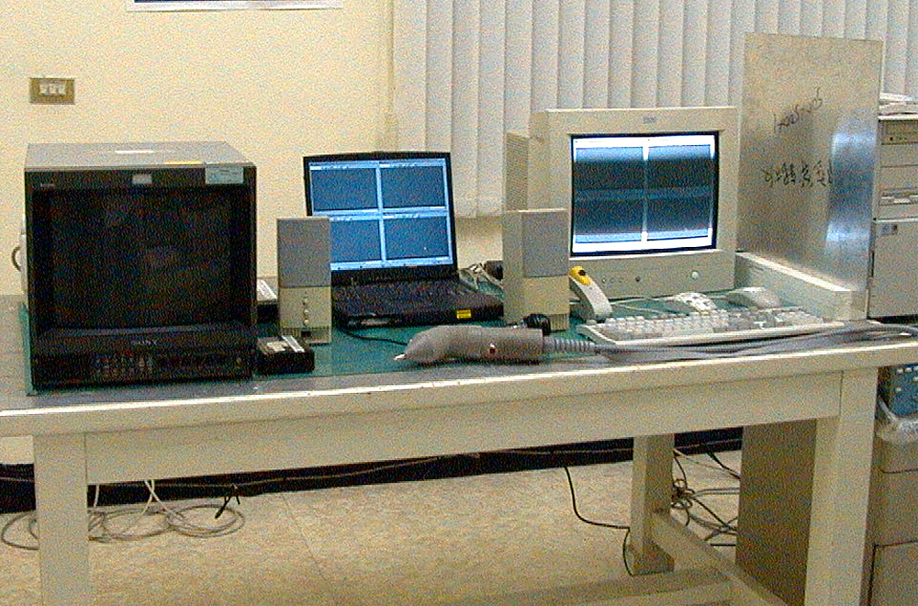

Photos of RF Field Strength Susceptibility Measurement
.

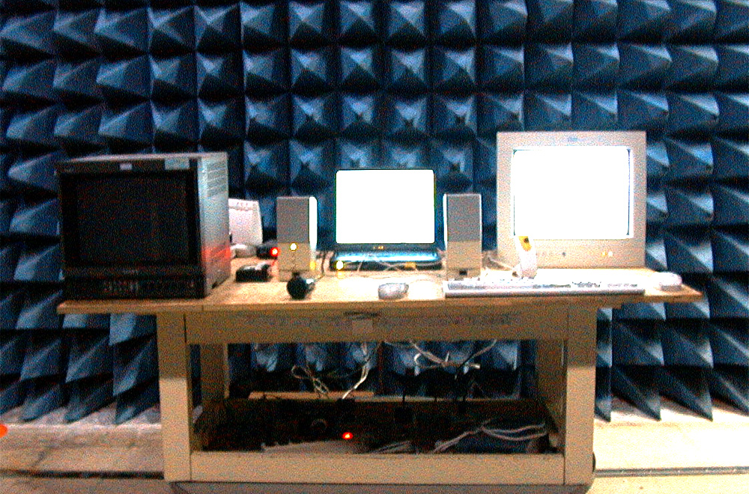Photos of Electrical Fast Transient/Burst measurement

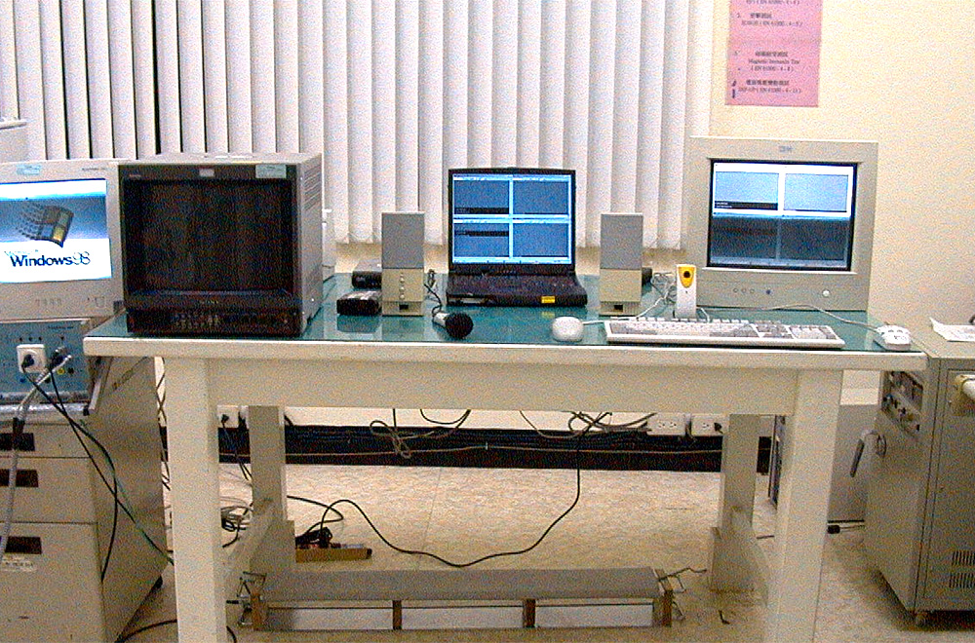

Photos of Harmonics and Voltage Fluctuations

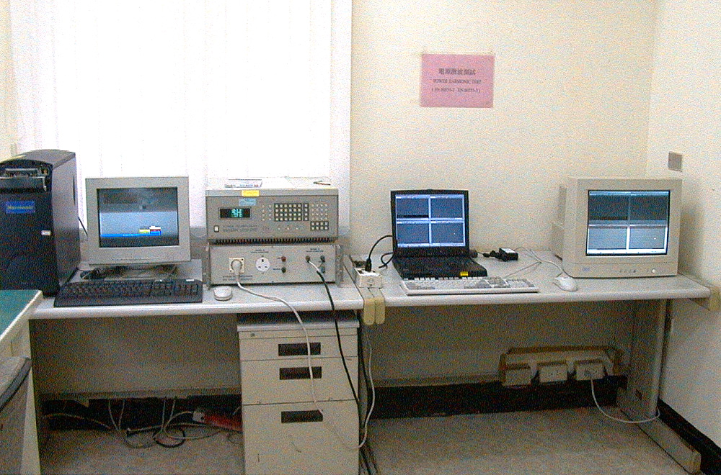

Appendix: Photographs of EUT

Please find this appendix in the File of ISL-00A039P

❑ Product System( PS )  Other( X )
Subject: |  | Notebook Personal Computer 1904 |  |  |  | Part No.: |  |  |  |  |  | Rev:
 |  | CE Mark Technical File Release |  |  |  | Doc. No.:
Project Code: |  | 91.4101.001 |  |  |  | Release Date: |  |  |  |  |  | Page of
Model No.: |  | 1904 |  |  |  |  |  |  |  |  |  | Revision status
Description: |  |  |  | Release 1904 CE Mark Technical File |  |  |  |  |  |  |  | Page | Rev.
 |  |  |  | It has passed the CE Mark Limits
Reason For Released: |  |  |  | First Release
Item | Contents |  |  |  |  |  |  |  | Q`ty | Unit
1 | CE Mark Technical File Cover Page |  |  |  |  |  |  |  | 1 | Page
2 | CE Mark Declaration of Conformity Letter |  |  |  |  |  |  |  | 1
3 | CISPR Class B Test Report |  |  |  |  |  |  |  | 22
4 | EMS Test Report |  |  |  |  |  |  |  | 18
5 | Appendix: Photos of EUT (refer to BSMI Report) |  |  |  |  |  |  |  | 40
Copy To (All Contents): |  |  |  | M0H0>M2MQ00
Copy (Cover Sheet): |  |  |  | MNP900
Approved By/ |  |  | Reviewed By/ |  |  |  |  | QA |  |  | Prepared By/
___________________ |  |  |  |  |  |  |  |  |  |  | __________________

