Auto Provision Manual

Contents

Auto Provision Manual 1

1.1 Summary 2

2.1 Obtain the server address 2

2.1.1 Pushed by Zero-Sp-Touch 2

2.1.2 Pushed by PnP servers 3

2.1.3 Detect DHCP custom option. 3

2.1.4 Detect DHCP Option 66. 4

2.1.5 Detect DHCP Option 43. 4

2.1.6 Detect the phone flash. 4

2.2 Download configuration files 6

2.3 Resolve and apply the configurations 6

2.4 Do other updates 9

2.4.1 Upload ringtone 9

2.4.2 Update LCD language 9

2.4.3 Upload local contacts 9

2.4.4 Update firmware 10

2.4.5 Upload LCD logo 10

2.4.6 Upload and delete Trusted Certificates 11

2.4.7 Upload and delete Server Certificates 12

2.5 Description of configuration parameters in CFG file 13

# 1.1 Summary

The presented document will show you how auto provision works and how to make auto provision work. The process of a successful auto provision is:

1. Obtain a server address in which store the configuration files.
2. Download the configuration files from the configured server.
3. Resolve and apply the configurations written in the configuration file.
4. Do other updates, for example the firmware updating.

# 2.1 Obtain the server address

When the phone boots up, it will go by the following process to try to obtain the server address:

Zero-Sp-Touch🡺PnP server 🡺 DHCP custom option 🡺 DHCP option 66 🡺 DHCP option 43 🡺 Phone Flash

The following are the details of each process:

## 2.1.1 Pushed by Zero-Sp-Touch

Zero-Sp-Touch is a function can help users to configure Auto Provision and network parameters quickly.

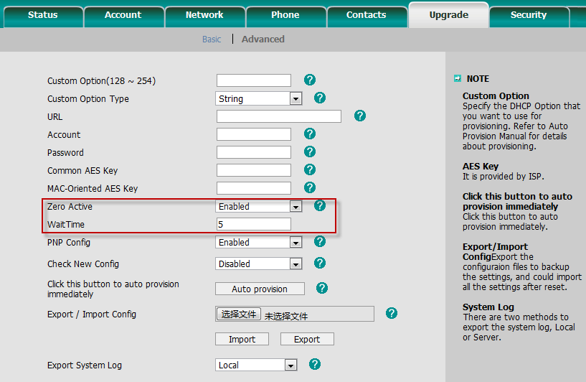

After this function is enabled, there will be a Config Guide on LCD during the booting up process. User can make the Auto Provision configuration within the Wait Time.

## 2.1.2 Pushed by PnP servers

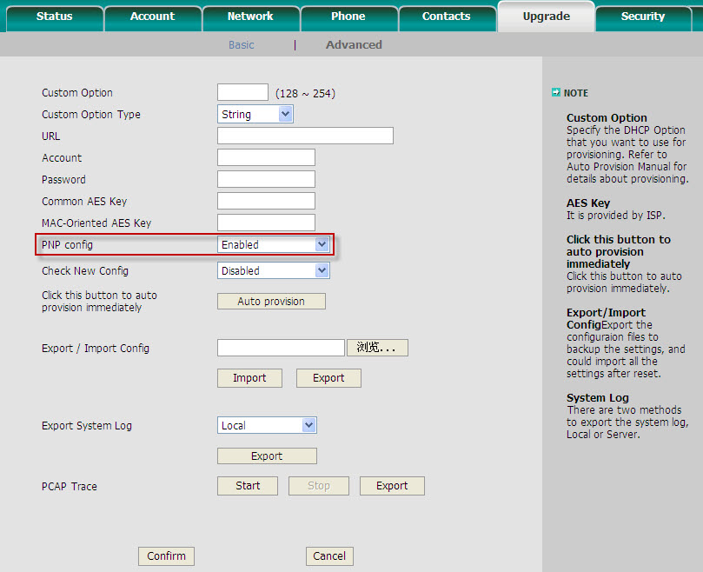

Note： Plug ‘n Play (PnP) provides a proprietary method to enable "Auto Provisioning". If **PnP config** is Enabled, the phone will send SIP SUBSCRIBE messages to a multicast address when it boots up. Any SIP server understanding that message will reply with a SIP NOTIFY message containing the Auto Provisioning Server URL where the phones can request their configuration. Modern SIP PBXs/Proxies can provide the PnP configuration data. Please refer to the manual of your PBX/Proxy. This kind of auto provision is mainly used under some possible circumstance like your phones have no default provisioning server set and are not able to detect DHCP options (when the they use static IP address). Pay attention to the point that **PnP config** has the highest priority in obtaining the provisioning server address and if it fails to get any information from PnP servers, it won’t go to other processes. **In V50 firmware or higher, it will go to the other processes.**

## 2.1.3 Detect DHCP custom option.

It must be configured on the phone by web management:

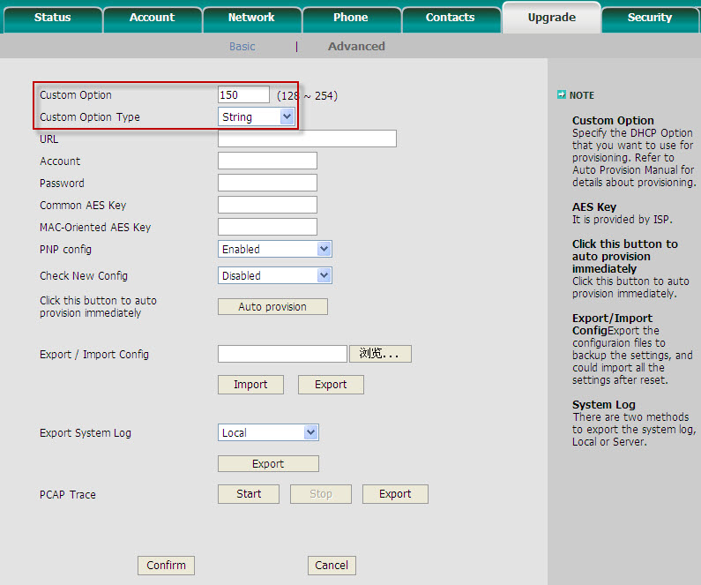

Note: A valid **Custom Option** is from 128 to 254. The **Custom Option Type** must be in accordance with the one defined in the DHCP server.

## 2.1.4 Detect DHCP Option 66.

Yealink phones will check this option by default. If the phone fails to get any information from DHCP Option 66, it will go to detect DHCP Option 43.

## 2.1.5 Detect DHCP Option 43.

Yealink phones will check this option by default. If the phone fails to get any information from DHCP Option 43 and **Check New Config** is not Disabled, it will go to detect the phone flash.

## 2.1.6 Detect the phone flash.

The value is what you can read from the web management of the phone:

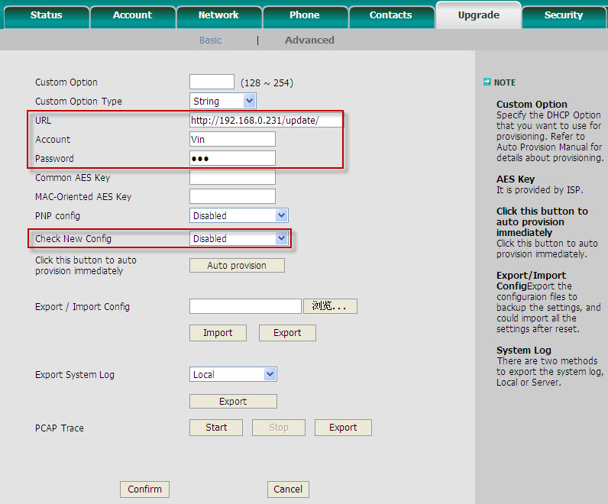

Note: This process depends on the setting of **Check New Config** and if it is set to be **Disabled**, the phone won’t detect the FLASH. The supported protocols of a **URL** are: HTTP/HTTPS/FTP/TFTP. **Account** and **Password** will be used to access to the URL if required. FTP server always has this requirement. For example, the following settings will make the phone access to FTP server 192.168.0.231, using account Vin and Passwords 123 (on the web it is hid by 3 points), when the phone powers on. If the phone fails to get any information from phone flash, the current round of obtaining server address will stop here.

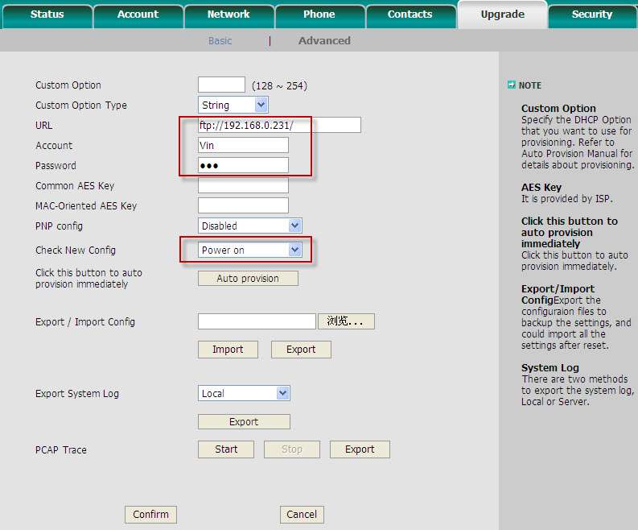

# 2.2 Download configuration files

There are 2 configuration files both of which are CFG formatted that the phone will try to download from the server during provisioning. We call them Common CFG file and MAC-Oriented CFG file. The Common CFG file will be effectual for all the phones of the right model. However, a MAC-Oriented CFG file will only be effectual for the specific phone which can be told by its MAC address. A common CFG file has a fixed name for each model while a MAC-Oriented CFG file is named after a MAC address of the specific phone. The names of the Common CFG file for each model are:

T28: y000000000000.cfg

T26: y000000000004.cfg

T22: y000000000005.cfg

T20: y000000000007.cfg

T12: y000000000008.cfg

T18: y000000000009.cfg

There are 11 zeros between the letter y and the last number. Except 0 for T28 which is special, the last number for other models is decided by the hardware version of the relevant model, for it is the first number of the hardware version of the model. For instance, for a T22 whose MAC address is 001565113af8, the 2 configuration files for it will be: y000000000005.cfg and 001565113af8.cfg.

To have this name division on configuration files will help when doing same auto provision to mass phones. For example, assumed that you have 1000 pieces of T28 and you want to update firmware for all phones, you just need to prepare only one y000000000000.cfg which defines the firmware update request, then put it onto the provisioning server.

Note: In case that the phone is on a live call, it will keep on asking for the CFG files with an interval of 30 seconds for up to 2 hours.

# 2.3 Resolve and apply the configurations

If the downloaded configuration files have been AES encrypted, the AES Keys will be needed. The **Common AES Key** is for decrypting the Common CFG file. The **MAC-Oriented AES Key** is for decrypting the MAC-Oriented CFG file. The keys must be 16 bytes and the supported characters are: 0 ~ 9, A ~ Z, a ~ z and the following special characters: # $ % * + , - . : = ? @ [ ] ^ _ { } ~

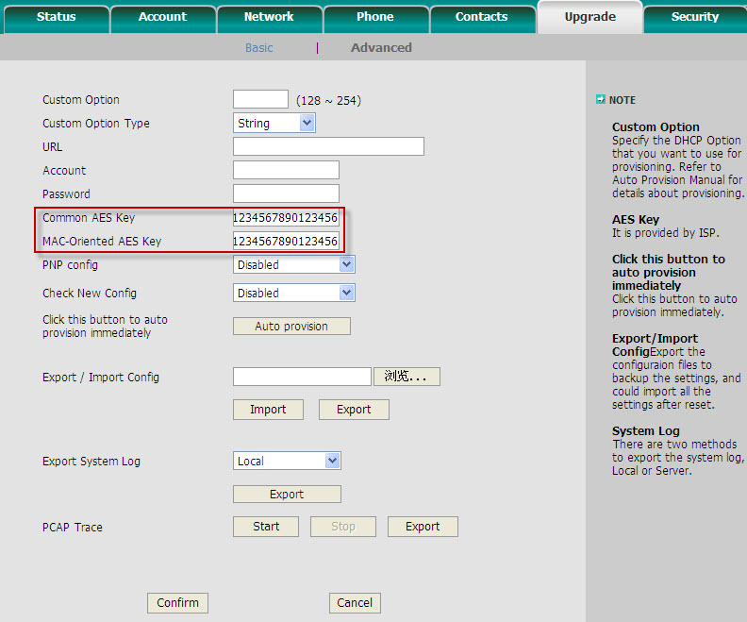

In a CFG file, there are texts defining configurations. Here’s a brief description to the texts. Take the AES_KEY section in the following picture for example.

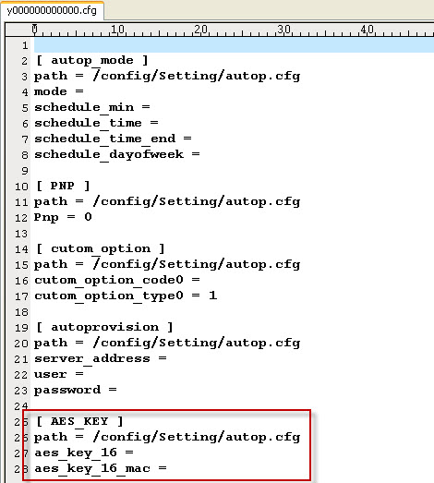

The following texts are system-defined that cannot be changed manually; otherwise it will cause a failure to auto provision:

1. The section header [AES_KEY]

2. The directory of the section path = /config/Setting/autop.cfg

3. The parameters aes_key_16 and aes_key_16_mac

You can only specify a valid value after the equal sign “=”. This is a section for specifying the AES keys. So you can make it like follow to specify 1234567890123456 for both **Common AES Key** and **MAC-Oriented AES Key**:

[ AES_KEY ]

path = /config/Setting/autop.cfg

aes_key_16 = 1234567890123456

aes_key_16_mac =1234567890123456

The lines start with # are instructions, they don’t make any sense to the configuration, just for easy understanding when read by certain person. For the detailed instruction of the parameters written in the CFG files, please refer to the **Appendix A**.

Note: If the phone finds that the downloaded CFG files are completely the same as it is applied the very last time, the auto provision will stop here. The phone knows it by comparing the MD5 value of the downloaded CFG files and the latest applied CFG files.

# 2.4 Do other updates

It depends on the texts written in the CFG files to decide whether to make other updates. There are mainly the following other updates:

## 2.4.1 Upload ringtone

The section defining request for ringtone upload in the CFG files:

#######################################################################################

[ ringtone ]

path = /tmp/download.cfg

server_address =

#######################################################################################

The server_address must link to a .wav file. The wav file should not be larger than 100kB.

For example: <ftp://Vin:123@192.168.0.231/Ring20.wav>

## 2.4.2 Update LCD language

The section defining request for language update in the CFG files:

#######################################################################################

[ Lang ]

path = /tmp/download.cfg

server_address =

#######################################################################################

The server_address must be like *serverAddress/lang-*.txt*. For example:

<http://192.168.0.231/provision/lang-German.txt>

And note that it does not enable you to add new languages. It just enables you to modify the existent languages. Please refer to another manual for details on this point - **How to modify the language by auto provision**

## 2.4.3 Upload local contacts

The section defining request for contact update in the CFG files:

#######################################################################################

[ ContactList ]

path = /tmp/download.cfg

server_address =

#######################################################################################

An example of server_address: <http://192.168.0.132:9/provision/contactData1.xml>

Note that the name has to be contactData1.xml.

The format of the XML file is different from the file which you use in “remote phone book”. It’s the same as the “Local phone book”. You can export an existed local phone book to see what the format is exactly.

## 2.4.4 Update firmware

The section defining request for firmware update in the CFG files:

#######################################################################################

[ firmware ]

path = /tmp/download.cfg

server_type =

server_ip =

server_port =

login_name =

login_pswd =

http_url =

firmware_name =

#######################################################################################

An example:

*[ firmware ]*

*path = /tmp/download.cfg*

*server_type = ftp*

*server_ip = 192.168.0.231*

*server_port = 21*

*login_name = Vin*

*login_pswd = 123*

*http_url = http://192.168.0.231/T28/*

*firmware_name = 0.0.0.143.rom*

The above section will make the phone access to ftp server *192.168.0.231*, using port *21*, user name “*Vin*” and password “*123*” to download the *0.0.0.143.rom.* And if the *server_type = http*, it will go to [*http://192.168.0.231/T28/*](http://192.168.0.231/T28/) *to download the 0.0.0.143.rom* and then update.

## 2.4.5 Upload LCD logo

The section defining request for uploading LCD logo in the CFG files:

#######################################################################################

[ Logo ]

path = /tmp/download.cfg

server_address =

[ Features ]

path = /config/Features/Phone.cfg

LCD_Logo = 2

#######################################################################################

An example:

[ Logo ]

path = /tmp/download.cfg

server_address = [*http://192.168.0.231/T28/logo.dob*](http://192.168.0.231/T28/logo.dob)

[ Features ]

path = /config/Features/Phone.cfg

LCD_Logo = 2

The above section will make the phone access to the HTTP server to get the dob file and after provision, the new logo will be used.

Note that the logo should be of DOB format and within the size limit:

T28: not larger than 236 * 82

T26/T22/T12: not larger than 132*64

## 2.4.6 Upload and delete Trusted Certificates

1. The section defining request for uploading Trusted Certificates:

#######################################################################################

[ TrustedCertificates ]

path = /tmp/certificate0.crt

server_address =

#######################################################################################

It support up to 10 certificates, user can use “/tmp/certificate0.crt” to “/tmp/certificate9.crt” for uploading two or more Certificates.

An example of uploading three certificates:

*[ TrustedCertificates]*

*path = /tmp/certificate0.crt*

*server_address = tftp://10.1.0.27/ca.crt*

*[ TrustedCertificates]*

*path = /tmp/certificate1.crt*

*server_address = tftp://10.1.0.27/cb.crt*

*[ TrustedCertificates]*

*path = /tmp/certificate2.crt*

*server_address = tftp://10.1.0.27/cc.crt*

2. The section defining request for deleting the trusted certificates that were uploading through Auto Provision:

#######################################################################################

[ TrustedCertificates ]

path = /tmp/download.cfg

option = delete

server_address = localhost/Name.crt

#######################################################################################

An example of deleting certificates which named “certificate0.crt”:

*[ TrustedCertificates ]*

*path = /tmp/download.cfg*

*option = delete*

*server_address = localhost/certificate0.crt*

3. The section defining request for deleting all trusted certificates at the same time:

#######################################################################################

[ TrustedCertificates ]

path = /tmp/download.cfg

option = delete _all

#######################################################################################

Note: The certificates that upload through web setting page only can be remove through web setting page.

## 2.4.7 Upload and delete Server Certificates

1. The section defining requests for server certificates upload in the CFG files:

#######################################################################################

[ ServerCertificates ]

path = /tmp/server.pem

server_address =

#######################################################################################

An example:

*[* *ServerCertificates ]*

*path = /tmp/ server.pem*

*server_address = tftp://10.1.0.27/server0.pem*

2. The section defining request for deleting the server certificate that was uploaded through Auto Provision:

#######################################################################################

[ ServerCertificates ]

path = /tmp/server.pem

option = delete

server_address = localhost/server.pem

#######################################################################################Appendix A

# 2.5 Description of configuration parameters in CFG file

|  |  |  |  |
| --- | --- | --- | --- |
| **Section Header and Path** | **Parameters** | **Permitted Values** | **Descriptions** |
| [ autop_mode ]  path = /config/Setting/autop.cfg | **mode** | 0,1,4,5,6,7 | It defines the value of **Check New Config**.  0:Disabled  1:Power on  4:Repeatedly  5:Weekly  6:Power on + Repeatedly  7:Power on + Weekly  The default is 0. |
| **schedule_min** | 1 to 43200 | It is available when mode is 4 or 6.It stands for the interval time (by minutes) of checking new config. |
| **schedule_dayofweek** | 0,1,2,3,4,5,6 or a combination of these numbers | It is available when mode is 5 or 7.It defines the day of week when there’s a need to check new config. If it is set to be 0123456, it means every day.  0:Sunday  1:Monday  2:Tuesday  3:Wednesday  4:Thursday  5:Friday  6:Saturday |
| **schedule_time** | Time as 19:45 | It is available when mode is 5 or 7.It means the phone will check new config at a time between schedule_time and schedule_time_end on a specified day every week. |
| **schedule_time_end** | Time as 19:45 |
| [ PNP ]  path = /config/Setting/autop.cfg | **Pnp** | 0 or 1 | It defines the value of **PNP config.**  0 stands for Disabled.  1 stands for Enabled.  The default is 0. |
| [ cutom_option ]  path = /config/Setting/autop.cfg | **cutom_option_code0** | Integer from 129 to 254 | It defines the **Custom Option**.  The default is blank. |
| **cutom_option_type0** | 0 or 1 | It defines the **Custom Option Type**..  0 stands for IP Address.  1 stands for String.  The default is 1. |
| [ AES_KEY ]  path = /config/Setting/autop.cfg | **aes_key_16** | 16-byte String | It defines the **Common AES Key** which is used for decrypting the common CFG file. Besides 0 ~ 9, A ~ Z, a ~ z, the valid characters include the following special ones: #$%*+,-.:=?@[]^_{}~ |
| **aes_key_16_mac** | 16-byte String | It defines the MAC-Oriented AES Key which is used for decrypting the MAC-OrientedCFG file. The valid characters are the same as **aes_key_16.** |
| [ autoprovision ]  path = /config/Setting/autop.cfg | **server_address** | HTTP/HTTPS/FTP/TFTP Address | It defines the **URL** which is supposed to be the auto provisioning server. |
| **user** | String | It defines the **Account** which may be used when the access to the URL requires authentication. |
| **password** | String | It defines the **Password** which may be used when access to the URL requires authentication. |
| [ account ]  path = /config/voip/sipAccount0.cfg | **Enable** | 0 or 1 | It defines the **Line Active** value of account1.  0 stands for off  1 stands for on  The default is 0. |
| **Label** | String | It defines the **Label** of account1.  The default is blank. |
| **DisplayName** | String | It defines the **Display Name** of account1.  The default is blank. |
| **AuthName** | String | It defines the **Register Name** of account1.  The default is blank. |
| **UserName** | String | It defines the **User Name** of account1.  The default is blank. |
| **password** | String | It defines the **Password** of registration for account1.  The default is blank. |
| **SIPServerHost** | Domain name or IP Address | It defines the **SIP Server** of account1.  The default is blank. |
| **SIPServerPort** | Integer | It defines the **Port** of the SIP Server of account1.  The default is 5060. |
| **UseOutboundProxy** | 0 or 1 | It defines the value of **Enable Outbound Proxy Server** of account1.  0 stands for Disabled.  1 stands for Enabled.  The default is 0. |
| **OutboundHost** | Domain name or IP Address | It defines the **Outbound Proxy Server** of account1.  The default is blank. |
| **OutboundPort** | Integer | It defines the **Port** of the Outbound Proxy Server of account1.  The default is 5060. |
| **Transport** | 0,1,2 or 3 | It defines the value of **Transport** of account1.  0 stands for UDP.  1 stands for TCP.  2 stands for TLS.  3 stands for DNS SRV  The default is 0. |
| **BakOutboundHost** | Domain name or IP Address | It defines the **Backup Outbound Proxy Server** of account1.  The default is blank. |
| **BakOutboundPort** | Integer | It defines the **Port** of Backup Outbound Proxy Server of account1.  The default is 5060. |
| **proxy-require** | String | It defines the value of **Proxy Require** of account1.  The default is blank. |
| **AnonymousCall** | 0 or 1 | It defines the value of **Anonymous Call** of account1.  0 stands for Disabled.  1 stands for Enabled.  The default is 0. |
| **RejectAnonymousCall** | 0 or 1 | It defines the value of **Anonymous Call Rejection** of account1.  0 stands for Disabled.  1 stands for Enabled.  The default is 0. |
| **Expire** | Integer | It defines the value of **Login Expire** of account1.  The default is 3600. |
| **SIPListenPort** | Integer | It defines the value of **Local SIP Por**t of account1.  The default is 5060. |
| **Enable 100Rel** | 0 or 1 | It defines the value of **100 reliable retransmission** of account1.  0 stands for Disabled.  1 stands for Enabled.  The default is 0. |
| **precondition** | 0 or 1 | It defines the value of **Enable Precondition** of account1.  0 stands for Disabled.  1 stands for Enabled.  The default is 0. |
| **SubscribeRegister** | 0 or 1 | It defines the value of **Subscribe Register** of account1.  0 stands for Disabled.  1 stands for Enabled.  The default is 0. |
| **SubscribeMWI** | 0 or 1 | It defines the value of **Subscribe for MWI** of account1.  0 stands for Disabled.  1 stands for Enabled.  The default is 0. |
| **CIDSource** | 0 to 5 | It defines the value of Caller ID Header of account1.  0 stands for FROM.  1 stands for PAI.  2 stands for PAI-FROM.  3 stands for RPID-PAI-FROM.  4 stands for PAI-RPID-FROM.  5 stands for RPID-FROM.  The default is 0. |
| **EnableSessionTimer** | 0 or 1 | It defines the value of **Use Session Timer** of account1.  0 stands for Disabled.  1 stands for Enabled.  The default is 0. |
| **SessionExpires** | Integer from 1 to 999 | It defines the value of **Session Timer** of account1.  The default is blank. |
| **SessionRefresher** | 0 or 1 | It defines the value of **Refresher** of account1.  0 stands for Uac.  1 stands for Uas.  The default is 0. |
| **EnableUserEqualPhone** | 0 or 1 | It defines the value of **Use user=phone** of account1.  0 stands for Disabled.  1 stands for Enabled.  The default is 0. |
| **srtp_encryption** | 0 or 1 | It defines the value of **Voice Encryption (SRTP)** of account1.  0 stands for off.  1 stands for on.  The default is 0. |
| **ptime** | 0,10,20,30,40,50 or 60 | It defines the value of **ptime** of account1.  0 stands for Disabled.  10 stands for 10ms.  20 stands for 20ms.  And alike.  The default is 20. |
| **ShareLine** | 0 or 1 | It defines the value of **Shared Line** of account1.  0 stands for Disabled.  1 stands for Broadsoft SCA.  2 stands for BLA  The default is 0. |
| **dialoginfo_callpickup** | 0 or 1 | It defines the value of **Dialog-Info Call Pickup** of account1.  0 stands for Disabled.  1 stands for Enabled.  The default is 0. |
| **AutoAnswer** | 0 or 1 | It defines the value of **Auto Answer** of account1.  0 stands for Disabled.  1 stands for Enabled.  The default is 0. |
| **MissedCallLog** | 0 or 1 | It defines the value of **Missed call log** of account1.  0 stands for Disabled.  1 stands for Enabled.  The default is 1. |
| **AnonymousCall_OnCode** | String | It defines the **On Code** of **Anonymous Call** of account1.  The default is blank. |
| **AnonymousCall_OffCode** | String | It defines the **Off Code** of **Anonymous Call** of account1.  The default is blank. |
| **AnonymousReject_OnCode** | String | It defines the **On Code** of **Anonymous Call Rejection** of account1.  The default is blank. |
| **AnonymousReject_OffCode** | String | It defines the **Off Code** of **Anonymous Call** **Rejection** of account1.  The default is blank. |
| **BLANumber** | String | It defines the value of **BLA Number** of account1.  The default is blank |
| **BLASubscribePeriod** | Integer from 60 to 7200 | It defines the value of **BLA Subscription Period** of account1.  The default is 300. |
| **SubscribeMWIExpire** | Integer from 0 to 84600 | It defines the value of **MWI Subscription Period** of accont1.  The default is 3600. |
| **CIDSource** | 0 or 1 | It defines the value of Caller ID Header of account1.  0 stands for FROM.  1 stands for PAI.  The default is 0. |
| **RegisterMAC** | 0 or 1 | It defines the value of **SIP Send MAC** of account1.  0 stands for Disabled.  1 stands for Enabled.  The default is 1. |
| **RegisterLine** | 0 or 1 | It defines the value of **SIP Send Line** of account1.  0 stands for Disabled.  1 stands for Enabled.  The default is 1. |
| **RegFailRetryInterval** | Integer from 0 to 1800 | It defines the value of **SIP Registration Retry Timer** of accont1.  The default is 30. |
| **conf-type** | 0 or 2 | It defines whether to enable the Broadsoft network conference feature.  0 stands for Local.  2 stands for Network.  The default is 0. |
| **conf-uri** | String | It defines the URL of network conference.  The default is blank. |
| **BlfListCode** | String | It defines the value of **BlF List Code** of accont1.  The default is blank. |
| **SubscribeACDExpire** | Integer from 120 to 3600 | It defines the time of **ACD Subscription Period** of accont1.  The default is 3600(seconds). |
| **SubscribeMWIToVM** | 0 or 1 | It defines whether to send subscribe packet message to voice mail number.  0 stands for disable.  1 stands enable.  The default is 0. |
| [ account ]  path = /config/voip/sipAccount1.cfg | For different models, there’re different numbers of Account. For each Account, there are completely same parameters and they share same permitted values and default values. The difference is just on the path. For example, the path of  Account1 is path = /config/voip/sipAccount0.cfg.While for  Account2 is path = /config/voip/sipAccount1.cfg,and other sections alike. | | |
| [ DTMF ]  path = /config/voip/sipAccount0.cfg | **DTMFInbandTransfer** | 0,1 or 2 | It defines the value of **DTMF Type** of account1.  0 stands for INBAND.  1 stands for RFC2833.  2 stands for SIP INFO.  The default is 1. |
| **InfoType** | 0,1,2 or 3 | It defines the value of **How to INFO DTMF** of account1.  0 stands for Disabled.  1 stands for DTMF-Relay.  2 stands for DTMF.  3 stands for Telephone-Event.  The default is Disabled. |
| **DTMFPayload** | Integer from 96 to 255 | It defines the value of **DTMF Payload** of account1.  The default is 101. |
| [ NAT ]  path = /config/voip/sipAccount0.cfg | **NATTraversal** | 0 or 1 | It defines the value of **NAT Traversal** of account1.  0 stands for Disabled.  1 stands for STUN.  The default is 0. |
| **STUNServer** | Domain name or IP Address | It defines the value of **STUN Server** of account1.  The default is blank. |
| **STUNPort** | Integer | It defines the **Port** of STUN Server of account1.  The default is 3478. |
| **EnableUDPUpdate** | 0 or 1 | It defines the value of **UDP Keep-alive Message** of account1.  0 stands for Disabled.  1 stands for Enabled.  The default is 1. |
| **UDPUpdateTime** | Integer | It defines the value of **UDP Keep-alive Interval** of account1.  The default is 30(seconds). |
| **rport** | 0 or 1 | It defines the value of **Rport** of account1.  0 stands for Disabled.  1 stands for Enabled.  The default is 0. |
| [ ADVANCED ]  path = /config/voip/sipAccount0.cfg | **default_t1** | Float | It defines the value of **SIP Session Timer T1** of account1.  The default is 0.5. |
| **default_t2** | Float | It defines the value of **SIP Session Timer T2** of account1.  The default is 4. |
| **default_t4** | Float | It defines the value of **SIP Session Timer T4** of account1.  The default is 5. |
| [ RingTone ]  path = /config/voip/sipAccount0.cfg | **RingType** | common, Ring1.wav, Ring2.wav  ……  Ring8.wav | It defines the default Ring tone that should be played while there is an incoming call to this account.  common stands for use common ring type.  The default is common |
| [ blf ]  path = /config/voip/sipAccount0.cfg | **SubscribePeriod** | Integer | It defines the value of **Subscribe Period** of account1.  The default is 1800(seconds). |
| **BLFList_URI** | String | It defines the value of **BLFList URI** of account1.  The default is blank. |
| [ audio0 ]  path = /config/voip/sipAccount0.cfg | **enable** | 0 or 1 | It defines the activity of a specific codec.  0 means to disable the codec.  1 means to enable the codec. |
| **PayloadType** | One of the following:  PCMU  PCMA  G723_53  G723_63  G729  G722  G726-16  G726-24  G726-32  G726-40 | It stands for a specific Codec type. |
| **priority** | Integer from 0 to 10 | It stands for the priority of a specific enabled codec. |
| **rtpmap** | Integer | It defines the payload of the codec. |
| [ audio1 ]  path = /config/voip/sipAccount0.cfg | The parameters and the Permitted values are the same as[ audio0 ]. For each account there are totally 10 usable codecs and each one has a section in configuration files and so there are sections from [ audio0 ] to [ audio10 ] for each account. (audio 6 is just a reserved section)  They have default values as below. If you want to change one of them, please note that there should be no same parameter values for the same account:   |  |  |  | | --- | --- | --- | | [ audio0 ]  enable = 1  PayloadType = PCMU  priority = 1  rtpmap = 0  [ audio1 ]  enable = 1  PayloadType = PCMA  priority = 2  rtpmap = 8  [ audio2 ]  enable = 0  PayloadType = G723_53  priority = 0  rtpmap = 4  [ audio3 ]  enable = 0  PayloadType = G723_63  priority = 0  rtpmap = 4 | [ audio4 ]  enable = 1  PayloadType = G729  priority = 3  rtpmap = 18  [ audio5 ]  enable = 1  PayloadType = G722  priority = 4  rtpmap = 9  [ audio6 ]  enable = 0  PayloadType = iLBC  priority = 0  rtpmap = 102  [ audio7 ]  enable = 0  PayloadType = G726-16  priority = 0  rtpmap = 112 | [ audio8 ]  enable = 0  PayloadType = G726-24  priority = 0  rtpmap = 102  [ audio9 ]  enable = 0  PayloadType = G726-32  priority = 0  rtpmap = 2  [ audio10 ]  enable = 0  PayloadType = G726-40  priority = 0  rtpmap = 104 | | | |
| [ audio2 ]  path = /config/voip/sipAccount0.cfg |
| [ audio3 ]  path = /config/voip/sipAccount0.cfg |
| [ audio4 ]  path = /config/voip/sipAccount0.cfg |
| [ audio5 ]  path = /config/voip/sipAccount0.cfg |
| [ audio7 ]  path = /config/voip/sipAccount0.cfg |
| [ audio8 ]  path = /config/voip/sipAccount0.cfg |
| [ audio9 ]  path = /config/voip/sipAccount0.cfg |
| [ audio10 ]  path = /config/voip/sipAccount0.cfg |
| [ WAN ]  path = /config/Network/Network.cfg | **WANType** | 0,1 or 2 | It defines the type of **Internet Port (WAN).**  0 stands for DHCP.  1 stands for PPPoE.  2 stands for Static IP Address.  The default is 0. |
| **WANStaticIP** | IP Address | It defines the **IP Address** when using static WAN settings.  The default is blank. |
| **WANSubnetMask** | Network Mask | It defines the **Subnet Mask** when using static WAN settings.  The default is blank. |
| **WANDefaultGateway** | IP Address | It defines the **Default Gateway** when using static WAN settings.  The default is blank. |
| [ DNS ]  path = /config/Network/Network.cfg | **PrimaryDNS** | IP Address | It defines the **Primary DNS** when using static WAN settings.  The default is blank. |
| **SecondaryDNS** | IP Address | It defines the **Secondary DNS** when using static WAN settings.  The default is blank. |
| [ PPPoE ]  path = /config/Network/Network.cfg | **PPPoEUser** | String | It defines the **User** name when using PPPoE WAN settings.  The default is blank. |
| **PPPoEPWD** | String | It defines the **Password** when using PPPoE WAN settings.  The default is blank. |
| [ LAN ]  path = /config/Network/Network.cfg | **LANTYPE** | 0 or 1 | It defines the type of **PC Port (LAN)**.  0 stands for **Router**.  1 stands for **Bridge**.  The default is 1. |
| **RouterIP** | IP Address | It defines the **IP Address** when the LAN is set as Router.  The default is 10.0.0.1 |
| **LANSubnetMask** | Network Mask | It defines the **Subnet Mask** when the LAN is set as Router.  The default is 255.255.255.0. |
| **EnableDHCP** | 0 or 1 | It means whether to enable **DHCP** server when the LAN is set as Router.  0 stands for Disabled.  1 stands for Enabled.  The default is 1. |
| **DHCPStartIP** | IP Address | It defines the IP Address range the DHCP router will allocate.  The default is from 10.0.0.10 to 10.0.0.100. |
| **DHCPEndIP** | IP Address |
| **SpanToPCPort** | 0 or 1 | It defines whether to enable Span to PC port function.  0 stands for Disabled.  1 stands for Enabled.  The default is 0. |
| [ VLAN ]  path = /config/Network/Network.cfg | **ISVLAN** | 0 or 1 | It defines the VLAN **Active** option of **WAN Port**.  0 stands for Disabled.  1 stands for Enabled.  The default is 0. |
| **VID** | Integer from 0 to 4094 | It defines the **VID** of **WAN Port**.  The default is 0. |
| **USRPRIORITY** | Integer from 0 to 7 | It defines the VLAN **USRPRIORITY** of **WAN Port**.  The default is 0. |
| **PC_PORT_VLAN_ENABLE** | 0 or 1 | It defines the VLAN **Active** option of **PC Port**.  0 stands for Disabled.  1 stands for Enabled.  The default is 0. |
| **PC_PORT_VID** | Integer from 0 to 4094 | It defines the **VID** of **PC Port**.  The default is 0. |
| **PC_PORT_PRIORITY** | Integer from 0 to 7 | It defines the VLAN **USRPRIORITY** of **PC Port**.  The default is 0. |
| [ QOS ]  path = /config/Network/Network.cfg | **RTPTOS** | Integer from 0 to 63 | It defines the value of **Voice QoS**.  The default is 40 |
| **SIGNALTOS** | Integer from 0 to 63 | It defines the value of **SIP QoS.**  The default is 40 |
| [ RTPPORT ]  path = /config/Network/Network.cfg | **MaxRTPPort** | Integer from 0 to 65535 | It defines the **MaxRTPPort** of **Local RTP Port.**  The default is 11800. |
| **MinRTPPort** | Integer from 0 to 65535 | It defines the **MinRTPPort** of **Local RTP Port.**  The default is 11780. |
| [ SYSLOG ]  path = /config/Network/Network.cfg | **SyslogdIP** | IP Address | It defines the server where the syslog is supposed to be exported onto. |
| [ telnet ]  path = /config/Network/Network.cfg | **telnet_enable** | 0 or 1 | It defines whether to enable or disable Telnet to the phone.  0 stands for Disabled.  1 stands for Enabled.  The default is 0. |
| [ 802.1X ]  path = /config/Network/Network.cfg | **Mode** | 0 or 1 | It defines whether to enable or disable the 802.1X feature  0 stands for Disabled.  1 stands for Enabled.  The default is 0. |
| **Identity** | String | It defines the identity  The default is blank. |
| **MD5Passwd** | String | It defines the password for the identity  The default is blank. |
| [ VPN ]  path = /config/Network/Network.cfg | **EnableVPN** | 0 or 1 | It defines whether to enable or disable the VPN feature  0 stands for Disabled.  1 stands for Enabled.  The default is 0. |
| [ Ethernet ]  path = /config/Network/Network.cfg | **WANPortLink** | Integer from 0 to 4 | It defines the **speed of WAN Port.**  0 stands for auto negotiate  1 stands for full duplex, 10Mbps  2 stands for full duplex, 100Mbps  3 stands for half duplex, 10Mbps  4 stands for half duplex, 100Mbps  The default is 0. |
| **PCPortLink** | Integer from 0 to 4 | It defines the **speed of PC Port.**  0 stands for auto negotiate  1 stands for full duplex, 10Mbps  2 stands for full duplex, 100Mbps  3 stands for half duplex, 10Mbps  4 stands for half duplex, 100Mbps  The default is 0. |
| [ Lang ]  path = /config/Setting/Setting.cfg | **WebLanguage** | Language Name | It defines the **Language** used on the Webpage.  The default is “English”. The other Languages are: Chinese_S/Deutsch/English/French/Italian/Portuguese/Spanish/Turkish.  Note: It’s depending on the firmware support. |
| **ActiveWebLanguage** | Language Name | It defines the **Language** used on the LCD.  The default is “English”. The other Languages are: Chinese_S/Chinese_T/French/German/Italian/Polish/Portuguese/spanish/Turkey.  Note: It’s depending on the firmware support. T20 doesn’t support Chinese_S/ Chinese_T. |
| [ Time ]  path = /config/Setting/Setting.cfg | **TimeZone** | Time Zone from -11 to +12 | It defines the **Time Zone** you expect to use on the phone.  The default is +8. |
| **TimeZoneName** | All the available Time Zone Name in the phone. | It defines the **Time Zone Name** of the corresponding Time Zone.  The default is China(Beijing). |
| **TimeServer1** | Domain name or IP Address | It defines the **Primary NTP Server**.  The default is cn.pool.ntp.org. |
| **TimeServer2** | Domain name or IP Address | It defines the **Secondary NTP Server**.  The default is cn.pool.ntp.org. |
| **Interval** | Integer | It defines the **Update Interval** when using NTP Server.  The default is 1000(seconds). |
| **SummerTime** | 0, 1 or 2 | It defines the activity of **Daylight Saving Time**.  0 stands for Disabled.  1 stands for Enabled.  2 stands for Automatic.  The default is 2. |
| **DSTTimeType** | 0 or 1 | It defines the **Fixed Type** of Daylight Saving Time.  0 stands for By Date.  1 stands for By Week.  The default is blank. |
| **StartTime** | SPECIAL | It defines the **StartTime** of Daylight Saving Time.  If the **Fixed Type** for Daylight Saving time is **By Date**, its value rule is MM/DD/HH which means Month/Day/Hour.  If the **Fixed Type** for Daylight Saving time is **By Week**, its value rule is Start Month/ Start Day of Week/ Start Day of Week Last in Month/ Start Hour of Day. For a value of 1/4/2/5 in this case, it means the start time is at 5 o’clock on Tuesday of the 4th week in January.  The default is blank. |
| **EndTime** | SPECIAL | It defines the **EndTime** of Daylight Saving Time.  Its rule is similar to StartTime.  The default is blank. |
| **OffSetTime** | Integer from -300 to 300 | It defines the Offset of Daylight Saving Time.  The default is blank. |
| **TimeFormat** | 0 or 1 | It defines the value of **Time Format**.  0 stands for 12 Hour format.  1 stands for 24 Hour format.  The default is 0. |
| **DateFormat** | Integer from 0 to 6 | It defines the value of **Date Format**.  0 stands for WWW MMM DD. eg. Tues Oct 20.  1 stands for DD-MMM-YY. eg. 20-Oct-09.  2 stands for YYYY-MM-DD. eg. 2009-10-20.  3 stands for DD/MM/YYYY. eg. 20/10/2009.  4 stands for MM/DD/YY. eg. 10/20/09.  5 stands for DD MMM YYYY. eg. 20 Oct 2009.  6 stands for WWW DD MMM. eg. Tues 20 Oct.  The default is 0. |
| [ PhoneSetting ]  path = /config/Setting/Setting.cfg | **InterDigitTime** | Integer | It defines the **Inter Digit Time**.  The default is 4(seconds). |
| **FlashHookTimer** | Integer from 0 to 800 | It defines the **Flash Hook Time**.  The default is 1(ms) |
| **Lock** | 0,1,2 or 3 | It defines the type of **Keyboard Lock**.  0 stands for Disabled.  1 stands for Menu Key.  2 stands for Function Key.  3 stands for All Keys.  4 stands for Lock&Answer.  The default is 0. |
| **Ringtype** | Ring name | It defines the default Ring tone that has been built in the phone flash, for example,Ring1.wav,Ring2.wav and alike. |
| **Contrast** | Integer from 1 to 10 | It defines the **LCD Contrast**. The parameter depends on model types. Eg. SIP-T20P doesn’t support it.  The default is 6. |
| **BackLight** | 1,2 or 3 | It defines the **Backlight Brightness**. The parameter depends on model types.SIP-T20 doesn’t support it.  The default is 2. |
| **BacklightTime** | 0,1,15,30,60 or 120 | It defines the **Backlight Time**. The parameter depends on model types.SIP-T20 doesn’t support it.  The default is 30.  0 stands for Always off  1 stands for Always on  15 stands for 15s  30 stands for 30s  60 stands for 60s  120 stands for 120s |
| **ProductName** | String | It defines the **Product Name** which you can see via LCD interface.  The default value for Yealink models are SIP-T28, SIP-T26, SIP-T22, SIP-T20 respectively. |
| **RingVol** | Integer from 0 to 15 | It defines the ring volume.  0 is the minimum value meaning silence.  15 is the maximum value. |
| **HandFreeSpkVol** | Integer from 0 to 15 | It defines the receiving volume of Speaker.  The default is 8. |
| **HandFreeMicVol** | Integer from 0 to 15 | It defines the sending volume of Speaker.  The default is 8. |
| **HandSetSpkVol** | Integer from 0 to 15 | It defines the receiving volume of Handset.  The default is 8. |
| **HandSetMicVol** | Integer from 0 to 15 | It defines the sending volume of Handset.  The default is 8. |
| **HeadSetSpkVol** | Integer from 0 to 15 | It defines the receiving volume of Headset.  The default is 8. |
| **HeadSetMicVol** | Integer from 0 to 15 | It defines the sending volume of Headset.  The default is 8. |
| **RingForTranFailed** | Ring name | It defines the default Ring tone that has been used while Transfer failed, for example,Ring1.wav,Ring2.wav and alike. |
| **LogonWizard** | 0 or 1 | It defines whether to enable the logon wizard while power on  0 stands for Disabled.  1 stands for Enabled.  The default is 0. |
| **PreDialAutoDial** | 0 or 1 | It defines whether to auto dial out feature in Pre-Dial interface, Live Dialpad option in web interface.  0 stands for Disabled.  1 stands for Enabled.  The default is 0. |
| **IsDeal180** | 0 or 1 | It defines whether to deal with 180 messages after the 183 message.  0 stands for Disabled.  1 stands for Enabled.  The default is 0. |
| **DialNowDelay** | Integer | It defines the delay time of dial now.  The default is 1(second). |
| **IsDefineKey** | 0 or 1 | It defines whether to custom the Softkey Layout.  0 stands for Disabled.  1 stands for Enabled.  The default is 0.  About how to custom the softkey, please refer to Page48. |
| **LogLevel** | From 0 to 6 | It defines the level that how much the syslog information will be exported. 0 means nothing and 6 means the most.  The default is 3. |
| [ SignalToneVol ]  path = /config/Setting/Setting.cfg | **Handset** | Integer from 0 to 15 | It defines the volume of dial tone on handset.  The default is 8. |
| **Headset** | Integer from 0 to 15 | It defines the volume of dial tone on headset.  The default is 8. |
| **Handfree** | Integer from 0 to 15 | It defines the volume of dial tone on Speaker.  The default is 8. |
| [ AlertInfo0 ]  path = /config/Setting/Setting.cfg | **Text** | String | It defines the first **Internal Ringer Text**.  The default is blank. |
| **Ringer** | Integer | It defines the ringer for the first Internal Ringer Text. The ringer is defined by its order number.  The default is 1. |
| [ AlertInfo1 ]  path = /config/Setting/Setting.cfg | They have same path and parameters as [ AlertInfo0 ] and share the same Permitted Values and default values.  **NOTE**: Ringer starts with Emergency ring. E.g..  Ringer = 1 ; stands for Emergency Ring;  Ringer = 2 ; stands for Ring1;  Ringer = 3 ; stands for Ring2;  Ringer = 4 ; stands for Ring3;  …… | | |
| [ AlertInfo2 ]  path = /config/Setting/Setting.cfg |
| [ AlertInfo3 ]  path = /config/Setting/Setting.cfg |
| [ AlertInfo4 ]  path = /config/Setting/Setting.cfg |
| [ AlertInfo5 ]  path = /config/Setting/Setting.cfg |
| [ AlertInfo6 ]  path = /config/Setting/Setting.cfg |
| [ AlertInfo7 ]  path = /config/Setting/Setting.cfg |
| [ AlertInfo8 ]  path = /config/Setting/Setting.cfg |
| [ AlertInfo9 ]  path = /config/Setting/Setting.cfg |
| [ AlwaysFWD ]  path = /config/Features/Forward.cfg | **Enable** | 0 or 1 | It defines whether the **Always Forward** is enabled.  0 stands for Disabled.  1 stands for Enabled.  The default is 0. |
| **Target** | Phone number | It defines the **Target** number that the phone will **Always Forward to**.  The default is blank. |
| **On_Code** | String | It defines the **On Code** for **Always Forward**.  The default is blank. |
| **Off_Code** | String | It defines the **Off Code** for **Always Forward**.  The default is blank. |
| [ BusyFWD ]  path = /config/Features/Forward.cfg | **Enable** | 0 or 1 | It defines whether the **Busy Forward** is enabled.  0 stands for Disabled.  1 stands for Enabled.  The default is 0. |
| **Target** | Phone number | It defines the **Target** number that the phone will **Busy Forward to**.  The default is blank. |
| **On_Code** | String | It defines the **On Code** for **Busy Forward**.  The default is blank. |
| **Off_Code** | String | It defines the **Off Code** for **Busy Forward**.  The default is blank. |
| [ TimeoutFWD ]  path = /config/Features/Forward.cfg | **Enable** | 0 or 1 | It defines whether the **No Answer Forward** is enabled.  0 stands for Disabled.  1 stands for Enabled.  The default is 0. |
| **Target** | Phone number | It defines the **Target** number that the phone will **No Answer Forward to**.  The default is blank. |
| **On_Code** | String | It defines the **On Code** for **No Answer Forward**.  The default is blank. |
| **Off_Code** | String | It defines the **Off Code** for **No Answer Forward**.  The default is blank. |
| **Timeout** | 5,10,15 or 20 | It defines the time after which the call will be forwarded when using **No Answer Forward**.  The default is 10(seconds). |
| [ Forward International ]  path = /config/Features/Forward.cfg | **Enable** | 0 or 1 | It defines whether to enable forwarding calls to international numbers beginning with 00.  0 stands for enable.  1 stands for disable.  The default is 0. |
| [ Features ]  path = /config/Features/Phone.cfg | **Call_Waiting** | 0 or 1 | It defines the activity of **Call Waiting**.  0 stands for Disabled.  1 stands for Enabled.  The default is 1. |
| **Call_WaitingTone** | 0 or 1 | It defines the activity of **Call Waiting Tone**.  0 stands for Disabled.  1 stands for Enabled.  The default is 1. |
| **CallCompletion** | 0 or 1 | It defines the activity of **CallCompletion**.  0 stands for Disabled.  1 stands for Enabled.  The default is 0. |
| **Hotlinenumber** | Phone number | It defines the **Hotline Number**.  The default is blank. |
| **BusyToneDelay** | 0,3 or 5 | It defines **BusyToneDelay**, the Delay of Busy Tone which is played when the other party hangs up.  The default is 0(seconds). |
| **LCD_Logo** | 0,1or 2 | It defines the value of **Use Logo**, meaning whether to enable Logo on LCD.  0 stands for Disabled.  1 stands for Enabled.  2 stands for Custom logo.  The default is 0. |
| **DND_Code** | 404, 480 or 486 | It defines the value of **Return code when DND**.  404 means 404 (Not Found)  480 means 480 (Temporarily not available)  486 means 486 (Busy here)  The default is 480. |
| **Refuse_Code** | 404, 480 or 486 | It defines the value of **Return code when refuse**.  404 means 404 (Not Found)  480 means 480 (Temporarily not available)  486 means 486 (Busy here)  The default is 486. |
| **DND_On_Code** | String | It defines **DND On Code**.  The default is blank. |
| **DND_Off_Code** | String | It defines **DND Off Code**.  The default is blank. |
| **ButtonSoundOn** | 0 or 1 | It defines whether to enable dialing tone.  0 stands for Disabled.  1 stands for Enabled.  The default is 1. |
| **SendKeySoundOn** | 0 or 1 | It defines whether to enable the tone of Send key.  0 stands for Disabled.  1 stands for Enabled.  The default is 1. |
| **AllowIntercom** | 0 or 1 | It defines whether to allow an intercom call.  0 stands for Disabled.  1 stands for Enabled.  The default is 1. |
| **IntercomMute** | 0 or 1 | It defines whether to mute the intercom call.  0 stands for Disabled.  1 stands for Enabled.  The default is 0. |
| **IntercomTone** | 0 or 1 | It defines whether to play the intercom warning tone.  0 stands for Disabled.  1 stands for Enabled.  The default is 1. |
| **IntercomBarge** | 0 or 1 | It defines whether to enable intercom barge.  0 stands for Disabled.  1 stands for Enabled.  The default is 1. |
| **Hotlinedelay** | Integer from 0 to 180 | It defines the hotline delay time.  The default is 4. |
| **BroadsoftFeatureKeySync** | 0 or 1 | It defines whether to enable Broadsoft feature Sync.  0 stands for Disabled.  1 stands for Enabled.  The default is 0. |
| **PswDialEnable** | 0 or 1 | It defines whether to enable Password Dial function.  0 stands for Disabled.  1 stands for Enabled.  The default is 0. |
| **PswPrefix** | Integer | It defines **Prefix** of the Password Dial function.  The default is blank. |
| **PswLength** | Integer | It defines the length of password after the Password Prefix in Password Dial function.  The default is blank. |
| **SaveCallHistory** | 0 or 1 | It defines whether to enable save call history on phone.  0 stands for Disabled.  1 stands for Enabled.  The default is 1. |
| **HistorySaveDisplay** | 0 or 1 | It defines whether to display **Save Call History** option on web interface.  0 stands for Disabled.  1 stands for Enabled.  The default is 1. |
| **ClosePowerLight** | 0 or 1 | It defines whether to turn off power LED.  0 stands for power LED on.  1 stands for power LED off.  The default is 0. |
| **HideDTMF** | 0 or 1 | It defines whether to display the DTMF “*” when dialing during a conversation.  0 stands for not displaying *.  1 stands for displaying *.  The default is 0. |
| **HideDTMFDelay** | 0 or 1 | Condition: **HideDTMF=1**  It defines whether to delay displaying *.  0 stands for no delay.  1 stands for displaying digits first and then * .  The default is 0. |
| **DTMFRepetition** | 1,2 or 3 | It defines the repetition times of DTMF end packet.  The default is 3. |
| **ActionURILimitIP** | IP address | It defines the IP address of the specific server that the phone receives the URI message from.  The default is null: the phone receives URI messages from any IP. |
| [ RingerDevice ]  path = /config/Features/Phone.cfg | **IsUseHeadset** | 0 or 1 | It defines the ringer device for headset or speaker.  0 stands for Speaker.  1 stands for Headset.  The default is 0. |
| [ Trans ]  path = /config/Features/Phone.cfg | **IsOnHookTrans** | 0 or 1 | It defines whether to enable OnHook to complete an attend transfer.  0 stands for Disabled.  1 stands for Enabled.  The default is 1. |
| [ AutoRedial ]  path = /config/Features/Phone.cfg | **EnableRedial** | 0 or 1 | It defines whether to enable/disable **Auto redial**.  0 stands for Disabled.  1 stands for Enabled.  The default is 0. |
| **RedialInterval** | Integer from 1 to 300 | It defines the value of **Auto redial interval**.  The default is 10 (seconds). |
| **RedialTimes** | Integer from 1 to 300 | It defines the value of **Auto redial times**.  The default is 10. |
| [ PoundSend ]  path = /config/Features/Phone.cfg | **Enable** | 0,1 or 2 | It defines the **Key As Send**.  0 stands for Disabled.  1 stands for # key.  2 stands for * key.  The default is 1. |
| [ Emergency ]  path = /config/Features/Phone.cfg | **Num** | Phone numbers separated by commas | It defines the **Emergency** numbers separated by commas. For example, it can be specified as:911,999,110,120  The default is blank. |
| [ Logo ]  path = /config/Features/Phone.cfg | **TextLogo** | Characters | It defines the test logo show in T20 LCD.  The default is blank. |
| [ memory1 ]  path = /config/vpPhone/vpPhone.ini | **Line** | Integer from 0 to max line number | Seen from the web, it reflects the value under **Line** title.  It defines the **Line** you are going to use for a specific function (if the function needs to specify a line).  Normally,0 stands for Auto,1 stands for Line1 and so on.  However, it’s a little different when configured as BLA or BLF or BLF List in which case 0 stands for Line1, 1 stands for Line2 and so on.  When the value of DKtype is 46(Broadsoft Group), the Line value is needed to select different group. It support 1~6. When the first group define 1.  The default is 0. |
| **type** | blf or bla | It is used when configuring a DSS Key as **BLF** or **Shared Line**.  blf stands for BLF.  bla stands for Shared Line.  No default value. |
| **Value** | It depends | Seen from the web, it reflects the value under **Extension** title.  Normally, the value is an extension number while in some cases it’s not. For example, when you configure a key as URL, the value must be a url String.  The default is blank. |
| **PickupValue** | String | It is used only for BLF. It defines the pickup number that your server allocates. |
| **Label** | String | It is used only for T28 line key and EXP 39. It defines the label show on the LCD. |
| **DKtype** | Integer | It’s a number reflects the key function.  0:N/A 1:Conference  2:Forward 3:Transfer  4:Hold 5:DND  6:Redial 7:Call Return  8:SMS 9:Call Pickup  10:Call Park 11:DTMF  12:Voicemail 13:SpeedDial  14:Intercom 15:Line  16:BLF 17:URL  18:Group Listening 19:Public Hold  20:Private Hold 21:Shared Line  22:XML Group 23:Group Pickup  24: Paging 25:Record  35:URLRecord 27:XMLbrowser  34:Hot Desking 37:Switch  38:LDAP 39:BLF List  40:Prefix 41: Zero-Sp-Touch  42:ACD 45:Local Group 46:Broadsoft Group 48:Custom Button  The default is 0. |
| **XMLPhoneBook** | The available XML Phonebook (0 to 4) or Local Group number/Broadsoft (0 to 5) | If the value of DKtype is 22/45/46(XML Group/Local Group/Broadsoft Group), you can configure an available XML Phonebook /Local Group number/Broadsoft Group number for this parameter.  Note: This option is available only when DKtype is 22/45/46.  The default is 0. |
| [ memory2 ]  path = /config/vpPhone/vpPhone.ini | From [ memory1 ] to [ memory10 ] are used for 10 DSS Keys on the phone T28/T26. For a phone having no DSS keys like T20/T22, it’s no use configuring the parameters. | | |
| [ memory3 ]  path = /config/vpPhone/vpPhone.ini |
| [ memory4 ]  path = /config/vpPhone/vpPhone.ini |
| [ memory5 ]  path = /config/vpPhone/vpPhone.ini |
| [ memory6 ]  path = /config/vpPhone/vpPhone.ini |
| [ memory7 ]  path = /config/vpPhone/vpPhone.ini |
| [ memory8 ]  path = /config/vpPhone/vpPhone.ini |
| [ memory9 ]  path = /config/vpPhone/vpPhone.ini |
| [ memory10 ]  path = /config/vpPhone/vpPhone.ini |
| [ memory11 ]  path = /config/vpPhone/vpPhone.ini | From [ memory11 ] to [ memory16 ] are used for Line keys. The available sections depend on the numbers of Line keys. For T20 which have only 2 line keys, only the first 2 sections are available. For T22/T26,only the first 3 sections are available. | | |
| [ memory12 ]  path = /config/vpPhone/vpPhone.ini |
| [ memory13 ]  path = /config/vpPhone/vpPhone.ini |
| [ memory14 ]  path = /config/vpPhone/vpPhone.ini |
| [ memory15 ]  path = /config/vpPhone/vpPhone.ini |
| [ memory16 ]  path = /config/vpPhone/vpPhone.ini |
| [ Profile ]  path = /config/vpm.cfg | **VAD** | 0 or 1 | It defines the activity status of **VAD**.  0 stands for Disabled.  1 stands for Enabled.  The default is 0 |
| **CNG** | 0 or 1 | It defines the activity status of **CNG**.  0 stands for Disabled.  1 stands for Enabled.  The default is 1. |
| **ECHO** | 0 or 1 | It defines the activity status of **Echo canceller**.  0 stands for Disabled.  1 stands for Enabled.  The default is 1. |
| **SIDE_TONE** | -3 or -32768 | It is an invisible setting which can only be configured via auto provision.  -32768 stands for Disable Side tone.  -3 stands for Enable Side tone.  The default is -3. |
| **headset_send** | Integer from 1 to 53 | It defines the send sound from headset.  The default is 29. |
| [ Jitter ]  path = /config/vpm.cfg | **Adaptive** | 0 or 1 | It defines the Type of Jitter Buffer.  0 stands for Fixed.  1 stands for Adaptive.  The default is 1. |
| **Min** | Integer | It defines the value of **Min Delay**.  The default is 0. |
| **Max** | Integer | It defines the value of **Max Delay**.  The default is 300. |
| **Nominal** | Integer | It defines the value of **Normal Delay**.  The default is 120. |
| [ Message ]  path = /config/Features/Message.cfg | **VoiceNumber0** | String | It defines **Voice Mail** number of account1.  The default is blank. |
| **VoiceNumber1** | String | It defines **Voice Mail** number of account2.  The default is blank. |
| **VoiceNumber2** | String | It defines **Voice Mail** number of account3 if the account exists.  The default is blank. |
| **VoiceNumber3** | String | It defines **Voice Mail** number of account4 if the account exists.  The default is blank. |
| **VoiceNumber4** | String | It defines **Voice Mail** number of account5 if the account exists.  The default is blank. |
| **VoiceNumber5** | String | It defines **Voice Mail** number of account6 if the account exists.  The default is blank. |
| [ Country ]  path = /config/voip/tone.ini | **Country** | String | It defines the country name that relates to its own tone rules.  The valid values can be seen from the webpage which are like China, France and so on.  It can be specified as Custom in which case the tone rules can be customized. |
| [ Tone Param ]  path = /config/voip/tone.ini | **dial** | String | You can specify the tone value when the **Country** is set as Custom.  A signal tone expression is separated by a comma, eight units at most.  Each unit is formed of frequency and duration with a “/” to separate them(frequency/duration).  There can be at most 4 sub-items for each frequency item, the unit for the duration is millisecond(ms).  If you add “!” before the unit expression “frequency/duration”, which is “!frequency/duration”, this signal tone will ring only once, else it will play repetitively automatically.  The format of customized Signal Tone is like belows:  Each unit: element = [!]freq[+freq2] [+freq3] [+freq4] /duration  Signal Tone expression: tonelist = element[,element] [,element]…  Note: The effective frequency range of sound is from 200 to 7000HZ, if you want to make it to be silent, you can set the frequency to be 0 HZ.  An example:  (1) dial = 800+200/1000  The dial tone will ring repetitively with 800 and 200 HZ dual ring tone for 1000ms  (2) dial=800/1000,0/1000, 200/1000  The dial tone will ring repetitively with 800 , 0HZ and 200 HZ orderly for 1000ms |
| **ring** |
| **busy** |
| **congestion** |
| **callwaiting** |
| **dialrecall** |
| **record** |
| **info** |
| **stutter** |
| **message** |
| **autoanswer** |
| [ ReplaceRule ]  path = /tmp/dialplan.xml | **1** | Number or String | The replace rule as  **Enable,Prefix,Replace**  For example: 1,10,1234   * First number defines whether to enable this rule.   0 stands for Disabled.  1 stands for Enabled.   * Second number defines as Prefix * Third number defines as Replace   For other details, please refer to User Manual. |
| **2** | They share the same Permitted Value and rules as **1**. | |
| **3** |
| **4** |
| **5** |
| **6** |
| **7** |
| **8** |
| **9** |
| **10** |
| [ DialNow ]  path = /tmp/dialnow.xml | **server_address** | URL | DialNow should upload through XML file.  For example the XML file can edited as below:  <?xml version="1.0" encoding="UTF-8" ?>  <DialNow>  <Data DialNowRule="11" LineID="1" />  <Data DialNowRule="11" LineID="1" />  <Data DialNowRule="11" LineID="1" />  <Data DialNowRule="11" LineID="1" />  <Data DialNowRule="11" LineID="1" />  <Data DialNowRule="11" LineID="1" />  <Data DialNowRule="11" LineID="1" />  <Data DialNowRule="11" LineID="1" />  <Data DialNowRule="11" LineID="1" />  <Data DialNowRule="11" LineID="1" />  </DialNow> |
| [ AreaCode ]  path = /config/DialRule/areacode.cfg | **Code** | Integer | It defines the **Code** of Area Code.  The default is blank. |
| **Minlen** | Integer | It defines the **Min Length** of Area Code.  The default is blank. |
| **Maxlen** | Integer | It defines the **Max Length** of Area Code.  The default is blank. |
| **LineID** | Number | It defines the Account the code used.  When you need to enable multi-line, you can use “,” to separate the account number to achieve it.  For example: 1,2,3 |
| [ BlockOut ]  path = /config/DialRule/BlockOut.cfg | **1** | Number | It defines a number which will be block when dial it out. Besides a specific number, it support some special characters:  For other details, please refer to User Manual. |
| **2** | They share the same Permitted Value and rules as **1**. | |
| **3** |
| **4** |
| **5** |
| **6** |
| **7** |
| **8** |
| **9** |
| **10** |
| [ BlockOutLineID ]  path = /config/DialRule/BlockOut.cfg | **1** | Number | It defines the account for the first BlockOut rule is suit for. When you need to enable multi-line, you can use “,” to achieve it.  For example: 1,2,3 |
| **2** | They share the same Permitted Value and rules as **1**. | |
| **3** |
| **4** |
| **5** |
| **6** |
| **7** |
| **8** |
| **9** |
| **10** |
| [ RemotePhoneBook0 ]  path = /config/Setting/Setting.cfg | **URL** | HTTP URL | It defines the **Phone book url** which must be a url linking to an XML-format phonebook like <http://192.168.0.231/Vin/phonebook1.xml>  The default is blank. |
| **Name** | String | It defines the **Phone book name** of the first Remote phonebook.  For more details, please refer to the instruction to Remote phonebook. |
| [ RemotePhoneBook1 ]  path = /config/Setting/Setting.cfg | They share the same parameters and Permitted Values as [ RemotePhoneBook0 ]. | | |
| [ RemotePhoneBook2 ]  path = /config/Setting/Setting.cfg |
| [ RemotePhoneBook3 ]  path = /config/Setting/Setting.cfg |
| [ RemotePhoneBook4 ]  path = /config/Setting/Setting.cfg |
| [ AdminPassword ]  path = /config/Setting/autop.cfg | **Password** | String | It defines the new password for **admin**. |
| [ UserPassword ]  path = /config/Setting/autop.cfg | **Password** | String | It defines the new password for **user**. |
| [ UserName ]  path = /config/Advanced/Advanced.cfg | **Admin** | String | It defines the name of admin.  The default is admin |
| **User** | String | It defines the name of user.  The default is user |
| [ Webserver Type ]  path = /config/Advanced/Advanced.cfg | **WebType** | 0,1,2 or 3 | It defines the **WebServer Type.**  **0 stands for Disabled.**  **1 stands for HTTP & HTTPS.**  **2 stands for HTTP Only.**  **3 stands for HTTPS Only.**  The default is 1. |
| [ port ]  path = /config/Advanced/Advanced.cfg | **http_port** | Integer from 0 to 65535 | It defines the Port of HTTP.  The default is 80. |
| [ port ]  path = /config/Advanced/Advanced.cfg | **https_port** | Integer from 0 to 65535 | It defines the Port of HTTPS.  The default is 4431. |
| [ Forbidden ]  path = /config/Setting/AdvSetting.cfg | **DND** | 0 or 1 | It defines whether to have the authority to use DND feature.  0 stands for Enabled.  1 stands for Disabled.  The default is 0. |
| **FWD** | 0 or 1 | It defines whether to have the authority to use Forward Active feature.  0 stands for Enabled.  1 stands for Disabled.  The default is 0. |
| [ FactoryConfig ]  path = /config/Setting/AdvSetting.cfg | **CustomEnabled** | 0 or 1 | It defines whether to enable custom factory setting.  0 stands for Disabled.  1 stands for Enabled.  The default is 0. |
| [ Transfer ]  path = /config/Setting/AdvSetting.cfg | **EnableSemiAttendTran** | 0 or 1 | It defines whether to enable Semi attend transfer.  0 stands for Disabled.  1 stands for Enabled.  The default is 1. |
| **BlindTranOnHook** | 0 or 1 | It defines whether to enable Blind transfer.  0 stands for Disabled.  1 stands for Enabled.  The default is 1. |
| **TranOthersAfterConf** | 0 or 1 | It defines whether to enable Transfer call to others after confer initiator hand up.  0 stands for Disabled.  1 stands for Enabled.  The default is 0. |
| [ sip ]  path = /config/Setting/AdvSetting.cfg | **RFC2543Hold** | 0 or 1 | It defines whether to use RFC2543 Hold.  0 stands for Disabled.  1 stands for Enabled.  The default is 0. |
| **ReservePound** | 0 or 1 | It defines whether auto replace “#” into other character in username.  0 stands for Disabled. (be replace)  1 stands for Enabled. (not to be replaced)  The default is 1. |
| **UseOutBoundInDialog** | 0 or 1 | It defines whether to use Outbound in dialog.  0 stands for Disabled.  1 stands for Enabled.  The default is 1. |
| [programablekey1]  path = /config/vpPhone/vpPhone.ini | **Line** | Integer from 0 to max line number | Seen from the web, it reflects the value under **Line** title.  It defines the **Line** you are going to use for a specific function (if the function needs to specify a line).  Normally,0 stands for Auto,1 stands for Line1 and so on.  However, it’s a little different when configured as **BLA** or **BLF** or **BLF List** in which case 0 stands for Line1, 1 stands for Line2 and so on.  When the value of DKtype is 46(Broadsoft Group), the Line value is need to select different group. It support 0~5. When the first group define 0.  The default is 0. |
| **Value** | It depends | Seen from the web, it reflects the value under **Extension** title.  Normally, the value is an extension number while in some cases it’s not. For example, when you configure a key as URL, the value must be a url String.  The default is blank. |
| **DKtype** | Integer | It’s a number reflects the key function.  0:N/A 2:Forward 5:DND 6:Redial  7:Call Return 8:SMS 9:Call Pickup 13:Spead Dial  22:XML Group 28:History 29:Directory 30:Menu 31:Switch Account  32:New SMS 33:Status  43:Local Phonebook  44:Broadsoft Phonebook  45:Local Group 46:Broadsoft Group  47:XML Phonebook  The default is 0. |
| **XMLPhoneBook** | The available XML Phonebook (0 to 4) or Local Group number/Broadsoft (0 to 5) | If the value of DKtype is 22/45/46(XML Group/Local Group/Broadsoft Group), you can configure an available XML Phonebook /Local Group number/Broadsoft Group number for this parameter.  Note: This option is available only when DKtype is 22/45/46.  The default is 0. |
| [programablekey2]  path = /config/vpPhone/vpPhone.ini | programablekey1=SoftKey1  programablekey2=SoftKey2  programablekey3=SoftKey3  programablekey4=SoftKey4  programablekey5=Up  programablekey6=Down  programablekey7=Left  programablekey8=Right  programablekey9=OK  programablekey10=Cancel  programablekey11=CONF  programablekey12=HOLD  programablekey13=MUTE  programablekey14=TRAN | | |
| [programablekey3]  path = /config/vpPhone/vpPhone.ini |
| [programablekey4]  path = /config/vpPhone/vpPhone.ini |
| [programablekey5]  path = /config/vpPhone/vpPhone.ini |
| [programablekey6]  path = /config/vpPhone/vpPhone.ini |
| [programablekey7]  path = /config/vpPhone/vpPhone.ini |
| [programablekey8]  path = /config/vpPhone/vpPhone.ini |
| [programablekey9]  path = /config/vpPhone/vpPhone.ini |
| [programablekey10]  path = /config/vpPhone/vpPhone.ini |
| [programablekey11]  path = /config/vpPhone/vpPhone.ini |
| [programablekey12]  path = /config/vpPhone/vpPhone.ini |
| [programablekey13]  path = /config/vpPhone/vpPhone.ini |
| [programablekey14]  path = /config/vpPhone/vpPhone.ini |
| [ LDAP ]  Path = /config/Contacts/LDAP.cfg | **NameFilter** | Standard LDAP filters e.g. (&(sn=%)(telephoneNumber=*)) | It defines the search criteria for name look ups. The format of the search filter is compliant to the standard String representations of LDAP search filters (RFC 2254). The name prefix for search entered by the user is represented by the “%” symbol in the filter.  The default is blank. |
| **NumberFilter** | Standard LDAP filters e.g. (|(telephoneNumber=%)(Mobile=%)(ipPhone=%)) | It defines the search criteria for number look ups. The format of the search filter is compliant to the standard String representations of LDAP search filters (RFC 2254). The number prefix for search entered by the user is represented by the “%” symbol in the filter.  The default is blank. |
| **host** | Domain name or IP Address | This setting refers to the DNS name or IP address of the LDAP server.  The default is 0.0.0.0 |
| **port** | Integer | It defines the LDAP server port.  The default is 389 |
| **base** | String | It defines the LDAP search base (the distinguished name of the search base object) which corresponds to the location in the directory from which the LDAP search is requested to begin. The search base narrows the search scope and decreases directory lookup time. If you have multiple organizational units in your directory (for example, OU=Sales in O=COMPANY and OU=Development in O=COMPANY), but the "OU=Sales" organization never uses AOL AIM, you can restrict the lookup to the OU=Development subtree only by entering providing the following search base: OU=Development, O=COMPANY. Other examples see below.  The default is blank. |
| **user** | String | It defines the bind “Username” for LDAP servers. Most LDAP servers allow anonymous binds in which case the setting can be left blank. However if the LDAP server does not allow anonymous binds, you will need to provide the Username and Password allowed to query the LDAP server.  The default is blank. |
| **pswd** | String | It defines the bind “Password” for LDAP servers. Yealink phones use “simple” authentication scheme for bind requests. This setting can be left blank in case the server allows anonymous binds. Otherwise you will need to provide the Password along with the Username in order to access the LDAP server.  The default is blank. |
| **MaxHits** | Integer from 1 to 32000 | If defines the maximum number of search results to be returned by the LDAP server. If Max.hits is 0 or blank the LDAP server will return all search results. Please note that a very large value of the “Max. Hits” will slow down the LDAP lookup, therefore the setting should be configured according to the available bandwidth.  The default is blank. |
| **NameAttr** | Space separated name attributes | If defines the “name” attributes of each record which are to be returned in the LDAP search results. This setting compresses the search results, as the server only returns the attributes which are requested by the Yealink phone. The setting allows the user to configure multiple space separated name attributes. Please consult your system administrator regarding which name attributes are to be configured.  The default is blank. |
| **NumbAttr** | space separated number attributes | It defines the “number” attributes of each record which are to be returned in the LDAP search results by the LDAP server. This setting compresses the search results, as the server only returns the attributes which are requested. The user can configure multiple space separated number attributes by using this setting. Please consult your system administrator regarding which number attributes are to be configured.  The default is blank. |
| **DisplayName** | %cn %sn | This setting is for showing the entry information on the screen.  The default is blank. |
| **version** | version 3/version 2 | It defines the protocol version for the phone when send the bind request to the server. Please make sure your LDAP server support version 3/2 bind request.  The default is version 3. |
| **SearchDelay** | Integer from 0 to 2000 | This setting is for configuring the delay display time after search.  The default is 0 |
| **CallInLookup** | 0 or 1 | This setting can be used to enable calling line identification using LDAP. When the setting is turned “Enable”, the phone performs an LDAP number search for the incoming number and displays the name of the calling party accordingly.  0 stands for Disabled.  1 stands for Enabled.  The default is 1. |
| **LDAPSort** | 0 or 1 | This setting is for sorting the search results, if make this option “Enabled”, it will arrange in the first alphabetical of the name order if return the name display; if only has the number return, it will list in numerical order.  0 stands for Disabled.  1 stands for Enabled.  The default is 1. |
| **DialLookup** | 0 or 1 | This setting can be used to enable call out line identification using LDAP. When the setting is turned “Enabled”, the phone performs an LDAP number search for PreDial or Dial status.0 stands for Disabled.  1 stands for Enabled.  The default is 1. |
| [ ManagementServer ]  path = /config/TR069/tr069.ini | **EnableTR069** | 0 or 1 | This setting can be used to enable TR069 function.  0 stands for Disabled.  1 stands for Enabled.  The default is 0. |
| **ConnectionRequestUsername** | String | It defines the User Name of ACS account. |
| **ConnectionRequestPassword** | String | It defines the Password of ACS account. |
| **url** | String | It defines the URL of ACS server. |
| **PeriodicInformEnable** | 0 or 1 | This setting can be used to enable the periodic inform time.  0 stands for Disabled.  1 stands for Enabled.  The default is 0. |
| **PeriodicInformInterval** | Integer | It defines the periodic inform interval time.  The default is 60. The range of value depends on ACS . |
| **Username** | String | It defines the **User Name** that ACS try to contact phone. |
| **Password** | String | It defines the **Password** that ACS try to contact phone. |
| [ Account0 ]  path = /config/Contacts/BroadSoft.cfg | **DisplayName** | String | It defines the D**isplay Name** of the first Broadsoft phonebook  The default is blank. |
| **Server** | String | It defines the **Server** of the first Broadsoft phonebook.  The default is blank. |
| **Port** | Integer | It defines the **Port** of the first Broadsoft phonebook.  The default is blank. |
| **UserName** | String | It defines the **User Name** of the first Broadsoft phonebook.  The default is blank.. |
| **PassWord** | String | It defines the **Password** of the first Broadsoft phonebook.  The default is blank. |
| It support 6 Boradsoft Phone (0~5). For each group, there are completely same parameters and they share same permitted values and default values. The difference is just on the path. For example, the path of  Account1 is [ Account0 ].While for  Account2 is [ Account1 ],and other sections alike. | | |
| [ CallLog0 ]  path = /config/Contacts/BroadSoft.cfg | **DisplayName** | String | It defines the **Display Name** of the first Broadsoft Call Log.  The default is blank. |
| **Server** | String | It defines the **Server** of the first Broadsoft Call Log.  The default is blank. |
| **Port** | Integer | It defines the **Port** of the first Broadsoft Call Log.  The default is blank. |
| **UserName** | String | It defines the **User Name** of the first Broadsoft Call Log.  The default is blank. |
| **PassWord** | String | It defines the **Password** of the first Broadsoft Call Log.  The default is blank. |
| It support 3 Broadsodt Call Log (0~2). For each Call Log, there are completely same parameters and they share same permitted values and default values. The difference is just on the path. For example, the path of  Account1 is [ CallLog0 ]. While for  Account2 is [ CallLot1 ], and other sections alike. | | |
| [ WatchDog ]  path = /config/Features/Phone.cfg | **IsUse** | 0 or 1 | It defines whether to enable **WatchDog**.  0 stands for Disabled.  1 stands for Enabled.  The default is 1. |
| **Time** | Integer | It defines the time that phone auto reboot after some process of phone crash.  This option doesn’t display in web interface.  The default time is 10(seconds). |
| [ REGSURGE ]  path = /config/Network/Network.cfg | **RegSurgePrevention** | Integer from 0 to 60 | It defines the time of **Registration Random**.  The default time is 0(seconds). |
| [ Zero ]  path = /config/Advanced/Advanced.cfg | **ForbidZero** | 0 or 1 | It defines whether to enable **Zero-Sp-Touch**.  0 stands for Disabled.  1 stands for Enabled.  The default is 1. |
| **WaitTime** | Integer | It defines the value of **Wait Time**.  The default is 5 (seconds). |
| [ TrustedCertificates ]  path = /tmp/ certificate0.crt.crt | **server_address** | url | It defines the URL of the certificates which you want to upload. |
| It support up to 10 certificates, user can use “/tmp/certificate0.crt” to “/tmp/certificate9.crt” for uploading two or more certificates. | | |
| [ TrustedCertificates ]  path = /tmp/download.cfg | **option** | delete or delete_all | This definition is use for deleting the certificates which were uploaded. “delete” for delete one certificates, “delete_all” for delete all the certificates which were uploaded. |
| **server_address** | String | It’s needed when you want to delete one of the certificates. You can use “localhost/certificate0.crt” to delete certificate0.crt. |
| [ https ]  path = /config/Setting/Setting.cfg | **TrustCertificates** | 0 or 1 | It defines whether to enable Only Accept Trusted Certificates.  0 stands for Disable.  1 stands for Enable.  The default is 0. |
| [ ServerCertificates ]  path = /tmp/server.pem | **server_address** | url or “localhost/ server.pem” | When you need to upload a certificates which phone as a server. Please put the URL of the certificates which you want to upload.  When you want to delete the certificates, please put “localhost/ server.pem”. |
| **option** | delete | It is need when you want to delete the certificate which was uploaded. |
| [ ACD ]  path = /config/Features/Phone.cfg | **AutoAvailable** | 0 or 1 | It defines whether to enable **ACD Auto Available** function.  0 stands for Disable.  1 stands for Enable.  The default is 0. |
| **AutoAvailableTimer** | Integer from 0 to 120 | It defines the interval time that **ACD account automatically** enabled.  The default is 60(seconds). |
| **Broadsoft** | 0 or 1 | It defines whether to enable **Broadsoft ACD synchronization.**  0 stands for Disable.  1 stands for Enable.  The default is 0. |
| [ PushXML ]  path = /config/Setting/AdvSetting.cfg | **ServerIP** | url | It defines the URL of Push XML server.  The default is blank. |
| [ LLDP ]  path = /config/Network/Network.cfg | **EnableLLDP** | 0 or 1 | It defines whether to enable **LLDP** function.  0 stands for Disable.  1 stands for Enable.  The default is 0(seconds). |
| **PacketInterval** | Integer from 1 to3600 | It defines the Packet Interval time.  The default is 120. |
| [ ActionURL ]  path = /config/Features/Phone.cfg | **SetupCompleted** | String | It defines the URL of its corresponding function.  The default is null . |
| **LogOn** | String |
| **LogOff** | String |
| **RegisterFailed** | String |
| **Offhook** | String |
| **Onhook** | String |
| **IncomingCall** | String |
| **OutgoingCall** | String |
| **CallEstablished** | String |
| **DNDOn** | String |
| **DNDOff** | String |
| **AwaysFWDOn** | String |
| **AwaysFWDOff** | String |
| **BusyFWDOn** | String |
| **BusyFWDOff** | String |
| **NoAnswerFWDOn** | String |
| **NoAnswerFWDOff** | String |
| **TransferCall** | String |
| **BlindTransferCall** | String |
| **AttendedTransferCall** | String |
| **Hold** | String |
| **Unhold** | String |
| **Mute** | String |
| **Unmute** | String |
| **MissedCall** | String |
| **CallTerminated** | String |
| **BusytoIdle** | String |
| **IdletoBusy** | String |
| **IPChange** | String |
| [ BroadSoft ]  path = /config/Contacts/BroadSoft.cfg | **BWCallLogandDir** | 0 or 1 | When it’s defined as Enable, in idle status, press History softkey will enter Call log directly, and press Directory softkey will enter Broadsoft PhoneBook.  Note: The precondition of this option is the **BeHaveCallLog** and **BeHaveBWDir** are  both enable.  0 stands for Disable.  1 stands for Enable.  The default is 0. |
| **BeHaveCallLog** | 0 or 1 | It defines whether to display settings page of Call log on web interface.  0 stands for Disable.  1 stands for Enable.  The default is 1. |
| **BeHaveBWDir** | 0 or 1 | It defines whether to display settings page of Broadsoft Phonebook in Directory on the LCD screen.  0 stands for Disable.  1 stands for Enable.  The default is 1. |
| [CustomSoftKey_Dialing]  path = /tmp/Dialing.xml | **server_address** | url | It could upload the xml file of Custom SoftKey in **Dialing** Call State. |
| [CustomSoftKey_ Talking]  path = /tmp/Talking.xml | **server_address** | url | It could upload the xml file of Custom SoftKey in **Talk / Hold / Held / PreConf / PreTrans / InConference / InConferenceTalk / Conferenced** Call State. |
| [CustomSoftKey_ Connecting]  path = /tmp/Connecting.xml | **server_address** | url | It could upload the xml file of Custom SoftKey in **Connecting / SemiAttendTrans** Call State. |
| [CustomSoftKey_ RingBack]  path = /tmp/RingBack.xml | **server_address** | url | It could upload the xml file of Custom SoftKey in **RingBack / SemiAttendTransBack** Call State. |
| [CustomSoftKey_ CallIn]  path = /tmp/CallIn.xml | **server_address** | url | It could upload the xml file of Custom SoftKey in **CallIn** Call State. |
| [CustomSoftKey_ CallFailed]  path = /tmp/CallFailed.xml | **server_address** | url | It could upload the xml file of Custom SoftKey in **CallFailed** Call State. |
| [key0]  Path=/config/vpPhone/Ext38_00000000000001.cfg  Here Ext38_0000000000000X.cfg, X stands for Xth Expansion module.  Eg. For Ext38_00000000000001.cfg, 1 stands for first Expansion module.  Here KeyX, X stands for (X+1)th DSSKey on the corresponding Expansion module.  Eg.Key0 stands for first DSSKey on the  corresponding Expansion module.  For Example:  [key0]  Path=/config/vpPhone/Ext38_00000000000001.cfg  The above example is to configure the first DSSKey on the first expansion module.  NOTE: The configuration of EXP39 is the same with EXP38. | **DKtype** | Integer | It define DKtype Expansion module Key  It’s a number reflects the key function.  0:N/A  1:Conference  2:Forward  3:Transfer  4:Hold  5:DND  6:Redial  7:Call Return  8:SMS  9:Call Pickup  10:Call Park  11:DTMF  12:Voicemail  13:SpeedDial  14:Intercom  15:Line  16:BLF  17:URL  18:Group Listening  19:Public Hold  20:Private Hold  21:Shared Line  22:XML Group  23:Group Pickup  24: Paging  25:Record  35:URLRecord  27:XMLbrowser  37:Switch  38:LDAP  39:BLF List  40:Prefix  41: Zero-Sp-Touch  42:ACD  45:Local Group  46:Broadsoft Group  The default is 0. |
| **Line** | Integer | It define Line value for Expansion Module Key  0 stands for line1  1 stands for line2  2 stands for line3  And so on  The default is 0, which stands for line1. |
| **Value** | Integer | It define Key Value for Expansion Module Key |
| **type** | String | It define Key for Expansion Module Key, only needed when you configure BLF and BLA.  blf stands for BLF  bla stands for BLA(Shared line) |
| **PickupValue** | Integer | It define Pickup value for Expansion Module Key |
| **Label** | String | It define Key Label for Expansion Module Key |
| [ autoprovisionX ]  Path = /yealink/config/Setting/autop_code.cfg  NOTE: X: 1~50 | **Name** | String | It defines the name of auto-provision. |
| **Code** | String | It defines the feature code of auto-provision. |
| **Server_address** | URL | It defines the corresponding server address of auto-provision. |
| **User** | String | It defines the user name registered on server. |
| **Password** | String | It defines the password registered on server. |
| **AES** | String | It defines the common configuration AES key. |
| **MAC_AES** | String | It defines the MAC configuration AES key. |
| [ audio ]  Path=/yealink/config/vpPhone/MulticastPage.cfg | **PayloadType** | PCMU, PCMA, G729, G722, G726-26, G726-24, G726-32, G726-40, G723-53 | It configures the codec of MulticastPage starter. The default is G722.  It can be configured as PCMU, PCMA, G729, G722, G726-26, G726-24, G726-32, G726-40, G723-53 |
| [ ReveivePriority ]  Path=/yealink/config/vpPhone/MulticastPage.cfg | **Active** | 0 or 1 | It defines whether to receive new multicast paging when hearing one paging. The default is **1**.  It can be configured as  **0**: All new multicast paging will be ignored  **1**: It defines whether to receive new multicast according to priority, if the priority of the new multicast paging id higher than current paging, then it will be received. Otherwise it will be ignored. |
| **Priority** | Integer from 0 to 10 | It defines the threshold value. IP Phone defines whether to receive new multicast paging during a conversation according to this value. The default configuration is 10, i.e. all new multicast paging can barge in current conversation.  It can be configured as:  0: All new multicast paging will be ignored.  1: Paging with priority of 1 can barge in.  2: Paging with priority of 1~2 can barge in.  …  10: Paging with priority of 1~10 can barge in. |
| [ ListenAddressX ]  Path=/yealink/config/vpPhone/MulticastPage.cfg  NOTE:  X: 1~50, X stands for the priority of accessible multicast paging address. | **Label** | String | It defines the label of multicast paging address.  The default is blank. |
| **IPAddress** | URL | It defines the accessible multicast paging address.  The default is blank. |
| [ Features ]  Path=/yealink/config/Features/Phone.cfg | **AutoAnswerDelay** | Integer from 1 to 4 | It defines the delay of auto answer(unit: second). The default configuration is 1. It can be configured as 1~4s. |
| **HeadsetPrior** | 0 or 1 | It defines whether to set HeadsetPrior enabled. The default configuration is 0.  It can be configured as:  0: Disabled  1: Enabled |
| **DTMF_Replace_Tran** | 0 or 1 | It defines Trans with the function to send DTMF. The default setting is 0.  It can be set as:  0: Disabled  1: Enabled |
| **TransferDTMF** | String | It defines the DTMF values as Tran key with the function of sending DTMF. The default configuration is blank.  It can be configured as: numbers, *, #, ABCD. |
| **DsskeyBlindTran** | 0 or 1 | It defines whether to enable blind transfer or attended transfer when press DSSkey set as Tran function during a conversation. The default configuration is 1.  It can be configured as:  0: Enable attended-transfer  1: Enable blind transfer |
| **PlayHoldTone** | 0 or 1 | It defines whether to play hold tone when holding a conversation. The default configuration is 1.  It can be configured as:  0: Don’t play the hold tone  1: Play the hold tone |
| **PlayHoldToneDelay** | Integer or String | It defines the interval of the hold tone(unit: second). The default configuration is 30.  It can be configured as string. |
| **CorrectAccount** | 0 or 1 | It defines whether to close the accounts with blank UserName automatically via auto-provision configuration. The default configuration is 0.  It can be configured as:  0: Do not close the accounts  1: Close the accounts |
| **AutoSetAccount** | 0 or 1 | It defines whether to auto complete the first account’s UserName and AuthNmae with z9hG4bK + phone MAC when the Phone takes its first run or is reset to factory setting. The default is 0.  It can be configured as:  0: Do not auto complete  1: Auto complete |
| **AccountPrefix** | String | It defines the prefix of first account when phone takes first run or is reset to factory setting. The default configuration is z9hG4bK. |
| **AlwaysSetFWD** | 0 or 1 | It defines the interface to jump to when pressing Forward key on IDLE interface. The default configuration is 0.  It can be configured as:  0: Jump to Always Forward interface when pressing Forward on IDLE interface  1: Jump to Call Forward main interface |
| **ResumeAfterTran** | 0 or 1 | It defines whether to resume a conversation after pressing Cancel, when user press Tran key entering dialing interface. The default configuration is 0.  It can be configured as:  0: Jump back to Hold interface  1: Resume previous conversation |
| [ SRemoteName ]  Path=/yealink/config/Features/Phone.cfg  NOTE: Inquire the configuration of incoming call on remote phonebook | **Enable** | 0 or 1 | It defines whether to inquire the contact on first remote phonebook of an incoming call. The default configuration is 0.  It can be configured as:  0: Do not inquire  1: Inquire |
| **FlashTime** | Integer or String | It defines the time interval of phone updating information on first remote phonebook (unit second). The default configuration is 3600.  It can be configured as sting. |
| [ VLAN ]  path = /yealink/config/Network/Network.cfg | **ADD_DEFAULT_VLAN** | 0 or 1 | It defines whether to add vlan value that VlanID=1. The default configuration is 0.  It can be configured as:  0: Do not add the value  1: Add the value |
| [ snmp ]  path = /yealink/config/Network/Network.cfg | **snmp_enable** | 0 or 1 | It defines whether to enable SNMP. The default is 0.  It can be configured as:  0: Disabled  1: Enabled |
| [ dhcp_option_value]  path = /yealink/config/Setting/autop.cfg | **option60_value** | String | It defines the DHCP Option Value on webpage: Upgrade 🡪 Advanced. The default is yealink. |
| [ UpdateVersion ]  Path = /yealink/config/Setting/autop.cfg | **ComConfigVersion** | String | The default is blank |
| **MacConfigVersion** | String | The default is blank |
| [ PhoneSetting ]  path = /yealink/config/Setting/Setting.cfg | **EmergencyRing** | Ringtone | It defines the ringtone configuration of emergency incoming calls. The default is Emergency.wav.  It can be configured as neutral ringtones:  Ring1.wav~Ring8.wav |
| **AllowMute** | 0 or 1 | It defines whether to enable mute function when pressing MUTE during a conversation. The default is 1.  It can be configured as:  0: Disable MUTE  1: Enable MUTE |
| **SendPoundKey** | 0 or 1 | It defines whether to send pound key. The default is 0.  It can be configured as:  0: Send one # by pressing double #  1: Do not send any # when pressing double # |
| **AASecIntercom** | 0 or 1 | It defines whether to allow automatic pick-up of a second Intercom call. The default is 1.  It can be configured as:  0: Do not allow  1: Allow |
| **PartitionTone** | 0 or 1 | It defines whether to play different tones when entering dialing interface with no active accounts. The default is 0.  It can be configured as:  0: Play the same tone as active account  1: Play rapid dial tone |
| **EnLock** | 0 or 1 | It defines whether to lock the passwords of current accounts. The default is 1.  It can be configured as:  0: Do not lock password  1: Lock the password |
| **HeadSetTraining** | 0 or 1 | It defines whether to enable dual headset function. The default is 0.  It can be configured as:  0: Disable dual headset function  1: Enable dual headset function |
| [http]  path = /yealink/config/Setting/Setting.cfg | **http_version** | 1.0 or 1.1 | It defines the version of HTTP server. The default is version 1.1.  It can be configure as 1.1 or 1.0. |
| [ HotDesking_StartUp ]  path = /yealink/config/Setting/Setting.cfg | **RegisterName** | 0 or 1 | It defines whether to fill in RegisterName item on power-on register guide. The default is 1.  It can be configured as:  0: Do not show this item  1: Show this item |
| **UserName** | 0 or 1 | It defines whether to fill in UserName item on power-on register guide. The default is 1.  It can be configured as:  0: Do not show this item  1: Show this item |
| **Password** | 0 or 1 | It defines whether to fill in Password item on power-on register guide. The default is 1.  It can be configured as:  0: Do not show this item  1: Show this item |
| **SipServer** | 0 or 1 | It defines whether to fill in SipServer item on power-on register guide. The default is 1.  It can be configured as:  0: Do not show this item  1: Show this item |
| **Outbound** | 0 or 1 | It defines whether to fill in OutBound item on power-on register guide. The default is 1.  It can be configured as:  0: Do not show this item  1: Show this item |
| [ HotDesking_Dsskey ]  path = /yealink/config/Setting/Setting.cfg | **RegisterName** | 0 or 1 | It defines whether to erase and fill in RegisterName item when pressing HotDesking DSS key. The default is 1.  It can be configured as:  0: Do not erase this item and do not show this item to fill in  1: Erase and show this item to fill in |
| **UserName** | 0 or 1 | It defines whether to erase and fill in UserName item when pressing HotDesking DSS key. The default is 1.  It can be configured as:  0: Do not erase this item and do not show this item to fill in  1: Erase and show this item to fill in |
| **Password** | 0 or 1 | It defines whether to erase and fill in Password item when pressing HotDesking DSS key. The default is 1.  It can be configured as:  0: Do not erase this item and do not show this item to fill in  1: Erase and show this item to fill in |
| **SipServer** | 0 or 1 | It defines whether to erase and fill in SipServer item when pressing HotDesking DSS key. The default is 1.  It can be configured as:  0: Do not erase this item and do not show this item to fill in  1: Erase and show this item to fill in |
| **Outbound** | 0 or 1 | It defines whether to erase and fill in Outbound item when pressing HotDesking DSS key. The default is 1.  It can be configured as:  0: Do not erase this item and do not show this item to fill in  1: Erase and show this item to fill in |
| [ account ]  path = /config/voip/sipAccountX.cfg  NOTE: Based on phone type, X stands for  T20: 0~1  T22: 0~2  T26: 0~2  T28: 0~5 | **SIPServerType** | 0, 1 or 2 | It defines the types of SIP server. The default is 0.  It can be configured as:  0: Local SIP server  1: Cosmocom  2: Broadsoft |
| **BlfListBargeInCode** | String | It defines the BargeIn code when a phone monitored by BLFList having a conversation. The default is blank. |
| **MusicServerUri** | URI | It defines the server address of Music On Hold. The default is blank.  It can be configured as following formats:  <10.1.3.165>  <yealink.com>  <Sip:8603@192.168.1.199>  <sip:8603@yealink.com> |
| [ Profile ]  path = /yealink/config/vpm.cfg | **handset_send** | Integer or String | It defines the sending volume of handset during the conversation. The default is 27 for T2X. |
| **handfree_send** | Integer or String | It defines the sending volume on speaker mode during the conversation. The default is 34 for T2X, and 39 for others types. |
| [ Forward International ]  path = /yealink/config/Features/Forward.cfg | **Number** | Integer or String | It defines the prefix of an international number. The default is 00. |
|  |  |  |  |
|  |  |  |  |
|  |  |  |  |

**Note**: in V50 firmware or higher,you are able to use **%NULL%** to delete a value.

For example:

[ AdminPassword ]

path = /config/Setting/autop.cfg

password = %NULL%

It will configure the password of Admin user as NULL.