**How to encrypt configuration file**

1. If you use windows system, you can use ‘EncryptUtilityWindows.exe’ tool, and follow the ‘readme.txt’
2. If you put ‘EncryptUtilityWindows.exe’ and y000000000007.cfg to D: disk, you can input this in CMD:

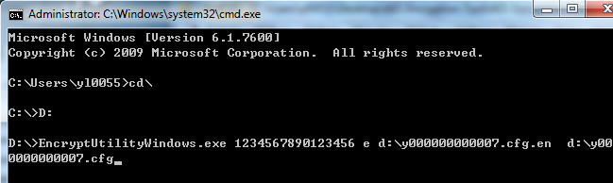

1. Then y000000000007.cfg.en file will created in D: disk
2. Rename y000000000007.cfg.en to y000000000007.cfg
3. Put y000000000007.cfg to your auto provision server
4. Fill AES key(1234567890123456) to the phone webpage(AES key should be 16 characters)

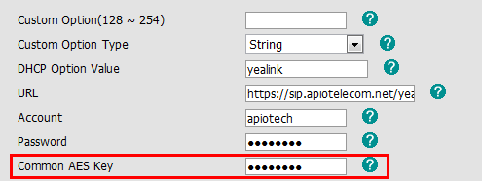

And then click Confirm to save the setting.

1. Execute auto provision, and it will download the y000000000007.cfg successfully.