

Contents

About This Guide 1

Who should use this guide? 1

XML and the Yealink IP Phones 2

What is XML? 2

Functionality 3

How does it work? 3

Phone initiated application 4

Server initiated application 5

XML display control on Yealink IP phones 6

Yealink IP Phone XML Objects 7

TextMenu Object 7

TextScreen Object 12

FormattedTextScreen Object 15

InputScreen Object 19

ImageScreen Object 26

Directory Object 29

PhoneStatus Object 33

PhoneExecute Object 37

PhoneConfiguration Object 41

Yealink IP Phone XML Applications 44

Configuring a HTTP Server 44

Configuring a DSS key 45

Web Configuration 45

Phone Configuration 46

Configuring the Push XML Server 47

Configuring the XML SIP Notify 47

# About This Guide

This Developers’ Guide will show you how to use XML API to control the display of the Yealink IP phone as well as its configuration.

The XML application is a simple sip-phone-custom browser function based on xml. Yealink IP phones with the firmware version V61.0 or higher support XML browser applications.

## Who should use this guide?

This guide is designed specifically to provide development engineers, system administrators, or network engineers with information for developing and deploying XML browser feature to Yealink IP phones on the network. This guide is not intended for end users and does not provide user-level information on how to use any specific XML applications.

Before reading this guide, you should be familiar with the following:

* Basic text editors, or full IDE-like Eclipse or Microsoft Visual Studio for creating or writing code.
* General application and software development.
* Adequate planning, creating, and testing resources needed to produce a fully deployable Web-based application.
* Yealink IP phones and provisioning methods, and transport protocol.
* The experience of using the XML editor.
* The XML-based schema and syntax

# XML and the Yealink IP Phones

## What is XML?

XML stands for eXtensible Markup Language. It is a markup language much like HTML. HTML was designed to display data and to focus on hoe data looks. XML was designed to describe data and to focus on what data is.

**The following are characteristics of XML:**

* XML tags are not predefined. You must define your own tags
* XML uses an XML Schema is designed to be self-descriptive
* XML with an XML Schema is designed to be self-descriptive
* XML is a W3C Standard Recommendation

**Sample of Basic XML document:**

<YealinkIPPhoneTextMenu>

<Title Warp="yes">Phone Services</Title>

<MenuItem>

<Prompt>Ask Google</Prompt>

<URI>http://10.2.11.158/aastra/google/google.php?user=</URI>

<Dial>456</Dial>

</MenuItem>

<MenuItem>

<Prompt>CNN News</Prompt>

<URI>http://10.2.11.158/aastra/rss/rss.php?feed=cnn</URI>

<Dial>1001</Dial>

</MenuItem>

</YealinkIPPhoneTextMenu>

Child elements of the root

Root element

## Functionality

The XML Browser in the Yealink IP phones allows users to create custom services which meet user functional requirements on the server. Users can customize practical applications, such as weather report, stock information, Google search and news service, etc.

**There are 2 types of XML objects:**

**UI objects**: XML objects used to control the display of the IP phone.

**Non UI objects**: ML objects which have no direct impact on the display of the IP phone.

**The supported objects are:**

• TextMenu object (UI)

• TextScreen object (UI)

• FormattedTextScreen object(UI)

• InputScreen object (UI)

• ImageScreen object(UI)

• Directory object(UI)

• PhoneExecute object

• PhoneConfiguration object

• PhoneStatus object

Some of these objects also support customizable softkeys that are declared as an independent object.

## How does it work?

Depending on the IP infrastructure, Yealink has developed the XML browser capability on the phone using the HTTP transport protocol. The Yealink IP phones support two types of applications:

* **Phone-initiated**
* **Server-initiated**

### Phone initiated application

You can press the predefined key to trigger the phone initiated application of XML browser. After pressing the key, the IP phone issues an HTTP(s) GET command to the server, waits for the answer, decodes and displays the answer on the LCD screen such as Microsoft Internet Explorer or Firefox would do as a web client. For more information on how to configure an XML browser key, you can refer to .

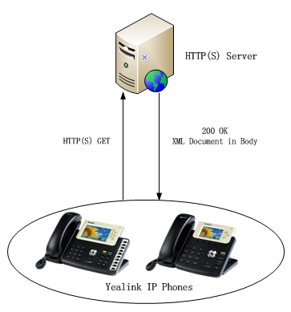

Figure1 Yealink IP phone acting as a client

### Server initiated application

The other type of application would be more used on the network. The end users do not need to operate. The server alters the XML application by posting an HTTP(S) message to the phone. For more information on how to configure the Push XML Server, you can refer to . In addition, Yealink IP phones support to accept SIP NOTIFY messages from SIP proxy server, and act as a limited web server. For more information on how to configure the Push XML Server, you can refer to .

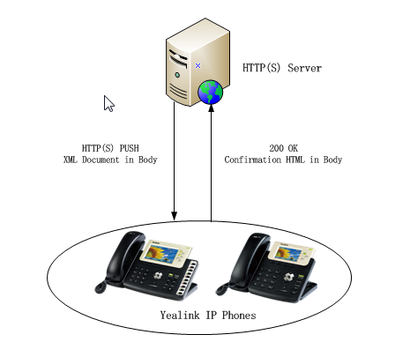

Figure2 Yealink IP phone acting as a server (HTTP(S) post)

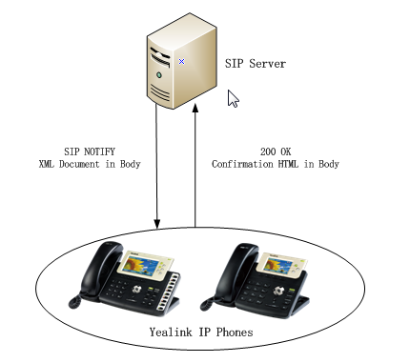

Figure3 Yealink IP phone acting as a server (SIP NOTIFY)

## XML display control on Yealink IP phones

This chapter describes the available part of the display for Yealink SIP-T38G and Yealink SIP-T32G IP phones as well as the keys that are controlled by the XML objects.

**The display and keys available for XML applications on a Yealink SIP-T38G IP phone are:**

* 8 lines of 43 characters for the display
* The left and right arrow navigation keys
* The up and down rocker navigation keys

The 3rd line of the display is a command line and will be used to display the labels of the available actions. Depending on the XML object displayed on the phone, the **X** key can also be interpreted as a “cancel” key, the **OK** key can also be interpreted as a confirm key.

**The display and keys available for XML applications on a Yealink SIP-T32G IP phone are:**

* 6 lines of 34 characters for the display
* The left and right arrow navigation keys
* The up and down rocker navigation keys

The 3rd line of the display is a command line and will be used to display the labels of the available actions. Depending on the XML object displayed on the phone, the **X** key can also be interpreted as a “cancel” key, the **OK** key can also be interpreted as a confirm key.

# Yealink IP Phone XML Objects

This chapter details all the XML objects supported by the Yealink IP phones.

**Note**

The size of an XML object can not exceed 10000 bytes (10 kb).

Per XML specifications, only one XML object is supported in the XML document sent to the phone.

## TextMenu Object

TextMenu object allows users to display a list of menu items on IP phones. You can use the TextMenu object to customize some functions such as weather report, stock information, new services, etc. You can browse the menu item by linking HTTP requests.

TextMenu XML example:

|  |
| --- |
| <****TextMenu  defaultIndex = “some integer”  style = “numbered/none/radio”  Beep = “yes/no”  Timeout = “some integer”  LockIn = “yes/no”  WrapList = “yes/no”  >  <Title wrap = “yes/no”>Menu Title</Title>  <MenuItem>  <Prompt>First Choice</Prompt>  <URI>http://somepage.xml</URI>  <Dial>Number to dial</ Dial >  <Selection>Selection</ Selection >  </MenuItem>  <!-Additional Menu Items may be added (up to 30) - ->  <!-Additional Softkey Items may be added (softkey phones) - ->  </****TextMenu> |

**Note**

The “****” in “****TextMenu” can be any string or null

The parameters of the TextMenu object are listed in the following table:

| **Parameter** | **Type** | **Value** | **Description** |
| --- | --- | --- | --- |
| ****TextMenu | mandatory | none | The root element of the TextMenu. |
| defaultIndex | optional | Integer | Position of the cursor to enter into the menu interface. If not specified, the cursor is positioned on the first menu item. Default value is 1. |
| style | optional | “numbered”  “none”  “radio” | **Menu Type:**  **numbered** (default)**:** Use digital to indicate the menu order before the menu.  **none:** No sign before the menu.  **radio:** Use circle before the menu. |
| Beep | optional | “yes”  “no” | Whether to play a tone when entering into the menu. Default value is “no”. |
| wrapList | optional | “yes”  “no” | Whether to display the title specified by the Prompt parameter in multi-lines, when the content of the title is longer than one line. Select “yes” to display in multi-lines, and “no” for one line. Default value is “no”. |
| Timeout | optional | “integer”  Unit: sec | If the user has no operation at a fixed interval, the phone will automatically exit the menu interface. Default value is 45s. |
| LockIn | optional | “yes”  “no” | If set to be “yes”, there is no responses to any operation except the soft key after entering into the menu. Default value is “no”.  I.e. The phone will not go to the dial-up interface by off hook. |
| Title | mandatory | string | The content of the menu item. |
| wrap | optional | “yes”  “no” | Whether to display the title in multi-lines when the content of the title is longer than one line. Select “yes” to display in multi-lines, and “no” for one line. Default value is “no”. |
| MenuItem | mandatory | none | The element of menu item.(Up to 30 instance, minimum is 1) |
| Prompt | mandatory | string | The label of menu item, its display is controlled by “wrapList”. |
| URI | mandatory | URI | The operation of menu item. |
| Dial | optional | Phone number | The phone will dial out the number by an off-hook action with the cursor on this menu item. |
| Selection | optional | string | If the URI of soft key is the HTTP server address, it will send a request with the "selection= the parameter".  (E.g. "http://10.1.0.105/menu1.xml? Selection =1”.) |
| SoftKey | optional | XML object | Refer to SoftKey Object for more information. |

If there is no soft key defined in the TextMenu object, the default soft keys label show as the following table:

|  |  |  |
| --- | --- | --- |
| **SoftKey Index** | **Label** | **URI** |
| 1 | Exit | SoftKey: Exit |
| 4 | Select | SoftKey: Select |

The function keys are listed in the following table:

| **Key Name** | **Statement** | **Description** |
| --- | --- | --- |
| Up/Down | Up and down key | To move the cursor up and down. |
| Digitkey | Digit 1~9 | To move the cursor to the number keys of the index value menu item. The cursor moves to the last menu item except the index number. |
| Select | SoftKey, URI=”SoftKey: Select” | Dial out the URI command in the menu item. |
| Exit | SoftKey, URI=”SoftKey: Exit” | Redisplay the previous XML interface, otherwise return to the idle interface. |
| Offhook/ LineKey/ Handfree | Off hook/Line Key/  Handfree Key | If there is content in the Dial tag, the phone will dial out the number. If no content in the Dial tag and the value of the LockIn is “yes”, there will be no responses to any operation. The phone will enter into dial-up interface when the value of the LockIn is “no”. |
| Cancel | The “X” key of the phone | Return to the idle interface. |
| OK | The “OK” key of the phone | If the value of the LockIn is “no”, the function of “OK” key is the same as “Select”, if the value of the LockIn is “no”, there will be no response. |
| DSS key except “Sip Truck” | DSS key(include the Expansion key) | If the value of the LockIn is “yes”, there will be no response. If the value of the LockIn is “no”, it will execute the operation of DSS key. |

An example of the TextMenu object:

|  |
| --- |
| <YealinkIPPhoneTextMenu  style="radio"  Beep="no"  WrapList="yes"  Timeout="30"  LockIn="yes">  <Title Warp="yes">Phone Services</Title>  <MenuItem>  <Prompt>Ask Google</Prompt>  <URI>http://10.2.11.158/aastra/google/google.php?user=</URI>  <Dial>456</Dial>  </MenuItem>  <MenuItem>  <Prompt>CNN News</Prompt>  <URI>http://10.2.11.158/aastra/rss/rss.php?feed=cnn</URI>  <Dial>1001</Dial>  </MenuItem>  </YealinkIPPhoneTextMenu> |

The screenshot of the phone user interface for reference is shown as below:

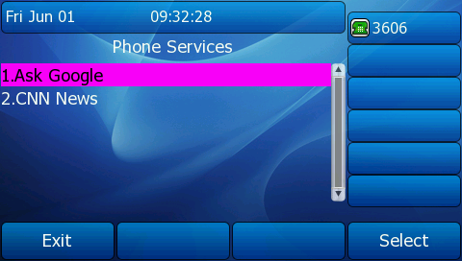

## TextScreen Object

TextScreen object allows users to display the text on IP phones. You can use the TextScreen object to display the news of TextMenu object.

TextScreen XML example:

|  |
| --- |
| <****TextScreen  doneAction = “some URI”  Beep = “yes/no”  Timeout = “some integer”  LockIn = “yes/no”  >  <Title wrap = “yes/no”>Screen Title</Title >  <Text>The screen text goes here</Text>  <!-Additional Softkey Items may be added (softkey phones) - ->  </****TextScreen > |

**Note**

The “****” in “****TextScreen” can be any string or null.

The parameters of the TextScreen object are listed in the following table:

| **Parameter** | **Type** | **Value** | **Description** |
| --- | --- | --- | --- |
| ****TextScreen | mandatory | none | The root element of the TextScreen. |
| Beep | optional | “yes”  “no” | Whether to play a tone when entering into the Text Screen. Default value is “no”. |
| doneAction | optional | URI | To execute the URI when selecting “done” SoftKey. |
| Timeout | optional | “integer”  Unit: sec | If the user has no operation at a fixed interval, the phone will automatically exit the menu interface. Default value is 45s. |
| LockIn | optional | “yes”  “no” | If set to be “yes”, there is no responses to any operation except the soft key after entering into the Text Screen. Default value is “no”.  I.e. The phone will not go to the dial-up interface by off hook. |
| Title | mandatory | string | The Label of the text. |
| wrap | optional | “yes”  “no” | Whether to display the title in multi-lines when the content of the title is longer than one line. Select “yes” display in multi-lines, and “no” for one line. Default value is “no”. |
| Text | mandatory | string | The content to be displayed.  (Size ranges from 1~2000B) |
| SoftKey | optional | XML object | Refer to SoftKey Object for more information. |

If there is no soft key defined in the TextScreen object, the default soft keys label show as the following table:

|  |  |  |
| --- | --- | --- |
| **SoftKey Index** | **Label** | **URI** |
| 1 | Exit | SoftKey: Exit |

The function keys are listed in the following table:

| **Key Name** | **Statement** | **Description** |
| --- | --- | --- |
| Up/Down | Up and down key | To see the content of text tips by pressing up and down. |
| Digitkey | Digit 1~9 | No response. |
| Exit | SoftKey,URI=”SoftKey: Exit” | Redisplays the previous XML interface, otherwise return to the idle interface. |
| Offhook/ LineKey/ Handfree | Off hook/Line Key/ Handfree Key | If there is content in the Dial tag, the phone will dial out the number. If no content in the Dial tag and the value of the LockIn is “yes”, there will be no responses to any operation. The phone will enter into dial-up interface when the value of the LockIn is “no”. |
| Cancel | The “X” key of the phone | Return to the idle interface. |
| OK | The “OK” key of the phone | Dial out the “doneAction” command. |

An example of the TextScreen object:

|  |
| --- |
| <YealinkIPPhoneTextScreen  doneAction="http://10.2.11.158/ cancel.php"  Timeout="15"  LockIn="no"  Beep="no"  >  <Title wrap="yes">Screen Title </Title>  <Text>The screen text goes here. When you see this, congratulations to you complete the configuration.</Text>  </YealinkIPPhoneTextScreen> |

The screenshot of the phone user interface for reference is shown as below:

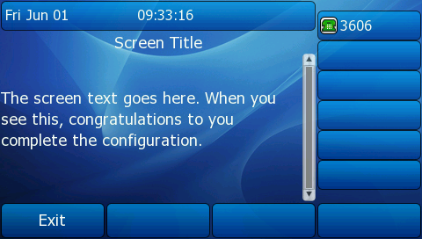

## FormattedTextScreen Object

FormattedTextScreen object allows users to display formatted (alignment, size, color and scrolling) text.

This text is divided into 3 distinct blocks, any of which can be empty.

* The first block is displayed at the top of the display and contains static text. This block takes up as many lines as the XML object specifies and can range from 0 up to the size of the physical screen.
* The next block, displayed below the first block, displays scrolling text and takes up as many lines as the designer specifies up to the size of the screen.
* The final block of contains static text and will take up whatever lines are left on the screen.

Footer Zone

Scroll Zone

Header Zone

FormattedTextScreen XML example

|  |
| --- |
| <****FormattedTextScreen  doneAction = “some URI”  Beep = “yes/no”  Timeout = “some integer”  LockIn = “yes/no”>  <Line  Size="normal/small/doulble/large"  Align="center/left/right"  Color="white/black/red/green/brown/blue/magenta/cyan/lightgray/darkgray  /lightred/lightgreen/yellow/lightblue/lightmagenta/lightcyan"  >Header Line<Line>  <!-Additional Line may be added- ->  <Scroll>  <Line  Size="normal/small/doulble/large"  Align="center/left/right"  Color="white/black/red/green/brown/blue/magenta/cyan/lightgray  /darkgray/lightred/lightgreen/yellow/lightblue/lightmagenta/lightcyan"  >Scroll Line<Line>  <!-Additional Line may be added- ->  </Scroll>  <Line  Size="normal/small/doulble/large"  Align="center/left/right"  Color="white/black/red/green/brown/blue/magenta/cyan/lightgray/darkgray  /lightred/lightgreen/yellow/lightblue/lightmagenta/lightcyan"  >Footer Line<Line>  <!-Additional Line may be added- ->  <!-Additional Softkey Items may be added (softkey phones) - ->  </****FormattedTextScreen > |

**Note**

The “****” in “****FormattedTextScreen” can be any string or null.

The parameters of the FormattedTextScreen object are listed in the following table:

| **Parameter** | **Type** | **Value** | **Description** |
| --- | --- | --- | --- |
| ****FormattedTextScreen | mandatory | none | The root element of the FormattedTextScreen. |
| Beep | optional | “yes”  “no” | Whether to play a tone when entering into the FormattedTextScreen. Default value is “no”. |
| doneAction | optional | URI | To execute the URI when selecting “done” SoftKey. |
| Timeout | optional | “integer”  Unit: sec | If the user has no operation at a fixed interval, the phone will automatically exit the menu interface. Default value is 45s. |
| LockIn | optional | “yes”  “no” | If set to be “yes”, there is no responses to any operation except the soft key after entering into the Formatted Text Screen. Default value is “no”.  I.e. The phone will not go to the dial-up interface by off hook. |
| Line | mandatory | string | Text to be displayed on the line. If the text is larger than the display, line is cropped to the last word. |
| Size | optional | “normal”  “small”  “double”  “large” | Size of the font for the line, “normal” for the regular font, “double” for a double height font. “normal” is the default value if not specified. |
| Align | optional | “center”  “left”  “right” | Alignment of the line, “left”, “right” or “center”. If not specified the default value is “left”. |
| Color | optional | “white”  “black”  “red”  “green”  “brown”  “blue”  “magenta”  “cyan”  “lightgray”  “darkgray”  “lightred” “lightgreen” “yellow” “lightblue” “lightmagenta”  “lightcyan” | Color of the line. If not specified the default value is “white”. |
| Scroll | optional | none | Defines the scrolling section of the display. The Line above the Scroll is as header, under the Scroll is as Footer. The Header can display two lines at most, and the Footer display only one line. |
| SoftKey | optional | XML object | Refer to SoftKey Object for more information. |

If there is no soft key defined in the FormattedTextScreen object, the default soft keys label show as the following table:

|  |  |  |
| --- | --- | --- |
| **SoftKey Index** | **Label** | **URI** |
| 1 | Exit | SoftKey: Exit |

An example of the FormattedTextScreen object:

|  |
| --- |
| <YealinkIPPhoneFormattedTextScreen  doneAction="http://10.1.0.105/menu.php"  Beep="yes"  Timeout="60"  LockIn="no">  <Line Size="large" Align="center">Header line1</Line>  <Line Align="left" Color="black">Header line2</Line>  <Line Size="small" Align="right" Color="white">Header line3</Line>  <Scroll>  <Line Size="large" Align="center">Scroll line1</Line>  <Line Align="left" Color="black">Scroll line2</Line>  <Line Size="small" Align="right" Color="white">Scroll line3</Line>  </Scroll>  <Line Size="small" Align="right" Color="white">Footer line1</Line>  <Line Size="double" Color="green">Footer line2</Line>  </YealinkIPPhoneFormattedTextScreen> |

The screenshot of the phone user interface for reference is shown as below:

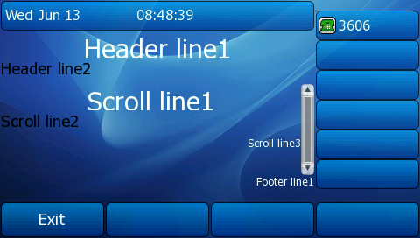

## InputScreen Object

InputScreen object allows users to create a screen capable of gathering user input. It prompts user to input content, and sends the input content to the server. You can use InputSceen object for user login or saving something on server. You can define the content and format of input.

InputScreen XML example:

|  |
| --- |
| <****InputScreen  type = “IP/string/number/timeUS/timeInt/dateUS/dateInt”  password = “yes/no”  editable = “yes/no”  Beep = “yes/no”  Timeout = “some integer”  LockIn = “yes/no”  defaultIndex = “some integer 1 to 6”  displayMode = “normal/condensed”  inputLanguage = “English/French/German/Italian/Spanish”  >  <Title wrap = “yes/no”>Title string</Title>  <Prompt>Guidance for the input</Prompt>  <URL>Target receiving the input</URL>  <Parameter>name of the parameter add to URL</Parameter>  <Default>Default Value (1) </Default>  <InputField  type = “IP/string/number/timeUS/timeInt/dateUS/dateInt/empty”  password = “yes/no”  editable = “yes/no”  >  <Prompt>Guidance for the input</Prompt>  <URL>Target receiving the input</URL>  <Parameter> parameter name add to URL</Parameter>  <Default>Default Value</Default>  <Selection>Selection</Selection>  <!-Additional Softkey Items may be added (softkey phones) - ->  </InputField>  <!-Additional Input fields Items may be added - ->  <!-Additional Softkey Items may be added (softkey phones) - ->  </****InputScreen > |

**Note**

The “****” in “****InputScreen” can be any string or null.

The parameters of the InputScreen object are listed in the following table:

| **Parameter** | **Type** | **Value** | **Description** |
| --- | --- | --- | --- |
| ****InputScreen | mandatory | none | The root element of the InputScreen. |
| Type | mandatory | “IP”  “string”  “number”  “timeUS”  “timeInt”  “dateUS”  “dateInt”  “empty” | Data input options:   1. IP 2. String(default) 3. number 4. timeUS, 12hour format, AM/PM stand for the forenoon/afternoon 5. timeInt, 24 hour format 6. dateUS, format MM/DD/YYYY 7. dateInt, format DD/MM/YYYY 8. empty, null string, the line number is determined by “displayMode”. |
| Beep | optional | “yes”  “no” | Whether to play a tone when entering into the InputScreen. Default value is “no”. |
| Password | optional | “yes”  “no” | Whether to mask the input by “*” characters. Default value is “no”. |
| Timeout | optional | “integer”  Unit: sec | If the user has no operation at a fixed interval, the phone will automatically exit the menu interface. Default value is 45s. |
| LockIn | optional | “yes”  “no” | If set to be “yes”, there is no responses to any operation except the soft key after entering into the InputScreen. Default value is “no”.  I.e. The phone will not go to the dial-up interface by off hook. |
| InputLanguage | optional | “English”  “French”  “German”  “Italian”  “Spanish” | The language of user input. Default value is English (It just only supports the English now). |
| displayMode | optional | “normal”  “condensed” | **normal** (default)**:** Display the prompt and input box in two lines.  **condensed:** Display the prompt and input box in one line |
| defaultIndex | optional | integer | Position of the cursor to enter into the InpuScreen. If not specified, the cursor is positioned on the first input box. Default value is 1. |
| Title | mandatory | string | The title of input object. |
| Wrap | optional | “yes”  “no” | Whether to display the title in multi-lines when the content of the title is longer than one line. Select “yes” display in multi-lines, and “no” for one line. Default value is “no”. |
| Prompt | optional | string | The prompt of user input. |
| URL | mandatory | URL | Send the content to the URL after user completed his input. |
| Parameter | mandatory | string | Name of parameter is added after the URL. (E.g. http://10.1.0.105/menu1.xml ? parameter) |
| Default | optional | string | Default value to be displayed in input field. |
| InputField | optional | none | Set several input boxes.  (Value ranges from 1-6.) |
| editable | optional | “yes”  “no” | Whether to allow users input something. Default value is “yes”. Users can not input something if it is “no”.  Applicable scenario: only allow some users to login. |
| Selection | optional | string | If the URI of soft key is the HTTP server address, it will send a request with the "selection= the parameter". (E.g. "http://10.1.0.105/menu1.xml? Selection =1”.) |
| SoftKey | optional | XML object | When the cursor moves to the input box, the soft key will add the accordingly soft key.  E.g. add the input mode.  Refer to SoftKey Object for more information. |

**Note**

1.The InputField element in the XML file is optional. You can use this element to customize more input fields on the IP phone.

2. The four formats of timeUS/timeInt/dateUS/dateInt are listed in the following table:

| **Type** | **Format** | **Example** |
| --- | --- | --- |
| timeUS | HH:MM:SS AM/PM  HH:1-12, MM:0-59, SS:0-59 | 02:00:23 AM  12:59:00 PM |
| timeInt | HH:MM:SS  HH:0-23, MM:0-59, SS:0-59 | 23:25:00 |
| dateUS | MM/DD/YYYY MM:1-12,DD:1-31,YYYY:0000-9999 | 12/31/2009 |
| dateInt | MM/DD/YYYY MM:1-12,DD:1-31,YYYY:0000-9999 | 31/01/2010 |

If there is no soft key defined in the InputScreen object, and the Type for input box is “IP”, the default soft keys label show as the following table:

|  |  |  |
| --- | --- | --- |
| **SoftKey Index** | **Label** | **URI** |
| 1 | Exit | SoftKey: Exit |
| 2 | Dot”.” | SoftKey: Dot |
| 3 | BackSpace | SoftKey: BackSpace |
| 4 | Submit | SoftKey: Submit |

If there is no soft key defined in the InputScreen object, and the Type for input box is ”Number”, the default soft keys label show as the following table:

|  |  |  |
| --- | --- | --- |
| **SoftKey Index** | **Label** | **URI** |
| 1 | Exit | SoftKey: Exit |
| 3 | BackSpace | SoftKey: BackSpace |
| 4 | Submit | SoftKey: Submit |

If there is no soft key defined in the InputScreen object and the Type for input box is “String”, the default soft keys label show as the following table:

|  |  |  |
| --- | --- | --- |
| **SoftKey Index** | **Label** | **URI** |
| 1 | Exit | SoftKey: Exit |
| 2 | 2aB | SoftKey: ChangeMOde |
| 3 | BackSpace | SoftKey: BackSpace |
| 4 | Dot”.” | SoftKey: Dot |
| 5 | NextSpace | SoftKey: NextSpace |
| 6 | Submit | SoftKey: Submit |

If there is no soft key defined in the InputScreen object, and the Type for input box is “timeUS”, “timeInt”, “dataUS” or “dataInt”, the default soft keys label show as the following table:

|  |  |  |
| --- | --- | --- |
| **SoftKey Index** | **Label** | **URI** |
| 1 | Exit | SoftKey: Exit |
| 4 | Submit | SoftKey: Submit |

The functions of the keys are listed in the following table:

| **Key Name** | **Statement** | **Description** |
| --- | --- | --- |
| Up/Down | Up and down key | To move the cursor up and down. |
| Left/Right | Left and right key | To move the cursor left and right. |
| Digitkey | Digit 1~9 | If “editable” of the cursor input item is "yes", then input character; otherwise no response. |
| Backspace | Softkey, URI= “SoftKey: Backspace” | Delete the character before the cursor in the input item. |
| Dot‘.’ | Softkey, URI= “SoftKey: Dot” | Add the character “.” at the cursor in the input item. |
| Submit | Softkey, URI= “SoftKey: Submit” | Execute the command comprised of the URI and input content. |
| Exit | SoftKey, URI=”SoftKey: Exit” | Return to the last XML interface, otherwise return to the idle interface. |
| 2aB | SoftKey, URI= “SoftKey: ChangeMode” | Input method switch, i.e. switch the input method among “2aB”, “ABC”, “abc” or ”123”. |
| NextSpace | SoftKey, URI= “SoftKey: NextSpace” | Add “ ” at the cursor in focus input item, i.e. <space>. |
| Offhook/ LineKey/ Handfree | Off hook/Line Key/ Handfree Key | If the value of the LockIn is “yes”, there will be no responses to any operation. The phone will enter into dial-up interface when the value of the LockIn is “no”. |
| Cancel | The “X” key of the phone | Return to the idle interface. |
| OK | The “OK” key of the phone | If the value of the LockIn is “no”, the function of “OK” key is the same as “Select”, if the value of the LockIn is “no”, there will be no response. |
| DSS key except “Sip Truck” | DSS key(include the Expansion key) | If the value of the LockIn is “yes”, there will be no response. If the value of the LockIn is “no”, it will execute the operation of DSS key. |

An example of the InputScreen object:

|  |
| --- |
| <YealinkIPPhoneInputScreen  type="string"  Timeout="15"  Beep="yes"  LockIn="yes">  <Title wrap="yes">Proxy Server</Title>  <Prompt>Server IP:</Prompt>  <URL>http://10.1.0.105/menu.php</URL>  <Parameter>proxy</Parameter>  <Selection>1</Selection>  <Default>10.1.0.105</Default>  <InputField>  <Prompt>User Name:</Prompt>  <URL>http://10.2.11.158/ menu.php </URL>  <Parameter>proxy</Parameter>  <Default></Default>  </InputField>  <InputField>  <Prompt>Password:</Prompt>  <URL>http://10.2.11.158/XML/ menu.php </URL>  <Parameter>proxy</Parameter>  <Default></Default>  </InputField>  </YealinkIPPhoneInputScreen> |

The screenshot of the phone user interface for reference is shown as below:

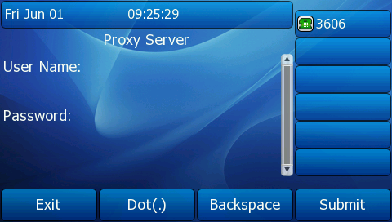

## ImageScreen Object

ImageScreen object allows users to display simple image on the IP phone. The user can specify where the image should be placed by setting horizontal and vertical alignment of the upper left hand corner, along with the height and width of the image.

Image XML example:

|  |
| --- |
| <****ImageScreen  doneAction = “some URI”  Beep = “yes/no”  Timeout = “some integer”  LockIn = “yes/no”  mode="regular/fullscreen"  >  <Image  horizontalAlign="right/middle/left"  verticalAlign="top/middle/bottom"  >some URL contain image</Image>  </**** ImageScreen > |

**Note**

The “****” in “****ImageScreen” can be any string or null.

The parameters of the ImageScreen object are listed in the following table:

| **Parameter** | **Type** | **Value** | **Description** |
| --- | --- | --- | --- |
| ****ImageScreen | mandatory | none | The root element of the ImageScreen. |
| Beep | optional | “yes”  “no” | Whether to play a tone when entering into the ImageScreen. Default value is “no”. |
| doneAction | optional | URI | To execute the URI when selecting “done” SoftKey. |
| Timeout | optional | “integer”  Unit: sec | If the user has no operation at a fixed interval, the phone will automatically exit the menu interface. Default value is 45s. |
| LockIn | optional | “yes”  “no” | If set to be “yes”, there is no responses to any operation except the soft key after entering into the Image Screen. Default value is “no”.  I.e. The phone will not go to the dial-up interface by off hook. |
| Mode | optional | “regular”  “fullscreen” | The display mode of the image. If not specified the default value is “regular”. |
| Image | mandatory | string | The access URL of the image.  (Now it supports only one image, and the format must .jpg or .png, the size maximum is 500k.) |
| horizontalAlign | optional | “left”  “middle”  “right” | Vertical position of the image. If the tag is not specified, the object will use “middle” as a default value. |
| verticalAlign | optional | “top”  “middle”  “bottom” | Horizontal position of the image. If the tag is not specified, the object will use “middle” as a default value. |
| SoftKey | optional | XML object | Refer to SoftKey Object for more information. |

If there is no soft key defined in the ImageScreen object, the default soft keys label show as the following table:

|  |  |  |
| --- | --- | --- |
| **SoftKey Index** | **Label** | **URI** |
| 1 | Exit | SoftKey: Exit |

An example of the ImageScreen object:

|  |
| --- |
| <YealinkIPPhoneImageScreen  doneAction="http://10.1.0.105/menu.php"  Beep="yes"  Timeout="60"  LockIn="yes"  mode="regular">  <Image  horizontalAlign="right"  verticalAlign="top"  >http://10.2.6.3:8080/xmlroot/bg2.jpg</Image>  </YealinkIPPhoneImageScreen> |

The screenshot of the phone user interface for reference is shown as below:

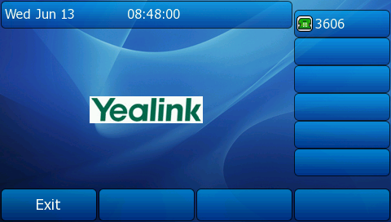

## Directory Object

Directory objectallows user to browse an online directory in real time. Directory object likes the remote phonebook. It displays an automatically numbered list of contacts. By selecting a contact with the cursor, the contact can be dialed directly by pressing the “Dial” softkey, picking up the handset, or pressing line key.

Directory XML example:

|  |
| --- |
| <****Directory  Next = “some URI”  Previous = “some URI”  Beep = “yes/no”  Timeout = “some integer”  LockIn = “yes/no”>  <Title wrap = “yes/no”>Directory Title</Title>  <MenuItem>  <Prompt>Contact Name</Prompt>  <URI>number</URI>  </MenuItem>  <!-Additional Menu Items may be added - ->  <!-Additional Softkey Items may be added - ->  </****Directory> |

**Note**

The “****” in “****Directory” can be any string or null.

The parameters of the Directory object are listed in the following table:

| **Parameter** | **Type** | **Value** | **Description** |
| --- | --- | --- | --- |
| ****Directory | mandatory | none | The root element of the Directory. |
| Next | optional | URI | The URI of “Next” SoftKey. |
| Previous | optional | URI | The URI of “Previous” SoftKey. |
| Beep | optional | “yes”  “no” | Whether to play a tone when entering into the Directory. Default value is “no”. |
| Timeout | optional | “integer”  Unit: sec | If the user has no operation at a fixed interval, the phone will automatically exit the menu interface. Default value is 45s. |
| LockIn | optional | “yes”  “no” | If set to be “yes”, there is no responses to any operation except the soft key after entering into the Directory. Default value is “no”.  I.e. The phone will not go to the dial-up interface by off hook. |
| Title | mandatory | string | The content of the address book title. |
| wrap | optional | “yes”  “no” | Whether to display the title in multi-lines when the content of the title is longer than one line. Select “yes” display in multi-lines, and “no” for one line. Default value is “no”. |
| MenuItem | mandatory | none | Address item.  Value ranges from 1-15. |
| Prompt | mandatory | string | The title of address item. |
| URI | mandatory | URI | The operation of address item, such as the telephone number. |
| SoftKey | optional | XML object | Refer to SoftKey Object for more information. |

If there is no soft key defined in the Directory object, the default soft keys label show as the following table:

| **SoftKey Index** | **Label** | **URI** |
| --- | --- | --- |
| 1 | Exit | SoftKey: Exit |
| 2 | Previous | The URI specified by “Previous” of Directory Object, “SoftKey: Previous” |
| 3 | Next | The URI specified by “Next” of Directory Object, “SoftKey: Next” |
| 4 | Dial | SoftKey: Dial |

The function keys are listed in the following table:

| **Key Name** | **Statement** | **Description** |
| --- | --- | --- |
| Up/Down | Up and down key | To move the cursor up and down. |
| Digitkey | Digit 1~9 | To move the cursor to the number keys of the index value menu item. The cursor moves to the last menu item except the index number. |
| Dial | SoftKey, URI=”SoftKey: Dial” | Dial out the number of the focus address. |
| Previous | SoftKey, URI=”SoftKey: Previous” | Dial out the URI of “Previous” command, such as “http”. |
| Next | SoftKey, URI=”SoftKey: Next” | Dial out the URI of “Next” command, such as “http”. |
| Exit | SoftKey, URI=”SoftKey: Exit” | Redisplay the previous XML interface, otherwise return to the idle interface. |
| Offhook/ LineKey/ Handfree | Off hook/Line Key/ Handfree Key | Dial out the number of the focus address. |
| Cancel | The “X” key of the phone | Return to the idle interface. |
| OK | The “OK” key of the phone | If the value of the LockIn is “no”, the function “OK” key is the same as “Select”, if the value of the LockIn is “no”, there will be no response. |
| DSS key except “Sip Truck” | DSS key(include the Expansion key) | If the value of the LockIn is “yes”, there will be no response. If the value of the LockIn is “no”, it will execute the operation of DSS key. |

An example of the Directory object:

|  |
| --- |
| <YealinkIPPhoneDirectory  Next="http://myserver.com/more.php"  Previous="http://myserver.com/back.xml"  LockIn="yes"  >  <Title>My Directory</Title>  <MenuItem>  <Prompt>Joy</Prompt>  <URI>10.2.11.163</URI>  </MenuItem>  <MenuItem>  <Prompt>John Doe</Prompt>  <URI>1003</URI>  </MenuItem>  </YealinkIPPhoneDirectory> |

The screenshot of the phone user interface for reference is shown as below:

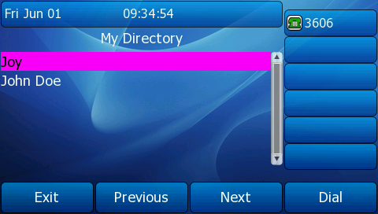

## PhoneStatus Object

PhoneStatus objectallows users to display a status message on a single designated line on the phone’s idle screen when XML information is pushed from the servers. The Status object can prompt user about received messages, missed calls, news, notify, etc.

PhoneStatus XML example:

|  |
| --- |
| <****Status  Beep = “yes/no”  WrapList = “yes/no”>  <Message  Size="normal/small/doulble/large"  Align="center/left/right"  Color="white/black/red/green/brown/blue/magenta/cyan/lightgray/darkgray  /lightred/lightgreen/yellow/lightblue/lightmagenta/lightcyan"  Account=”int”  Icon=“Forward/DND/Message/Note/Warning”  >Status Message < Message >  <!-Additional Messages may be added- ->  </**** Status> |

**Note**

The “****” in “****PhoneStatus” can be any string or null.

The parameters of the PhoneStatus object are listed in the following table:

| **Parameter** | **Type** | **Value** | **Description** |
| --- | --- | --- | --- |
| ****PhoneStatus | mandatory | none | The root element of the PhoneStatus. |
| Beep | optional | “yes”  “no” | Whether to play a tone when entering into the PhoneStatus. Default value is “no”. |
| wrapList | optional | “yes”  “no” | Whether to display the title in multi-lines when the content of the title is longer than one line. Select “yes” display in multi-lines, and “no” for one line. Default value is “no”. |
| Timeout | optional | “integer”  Unit: sec | The time for status information displaying. The phone will automatically exit the status interface at a fixed interval. Default value is 30s. |
| SessionID | optional | string | Session ID, it is used to mark different Status Object. (Minimum 0) |
| Message | optional | none | Display the message. (Value ranges from 0~10) |
| Size | optional | “normal”  “small”  “double”  “large” | Size of the font for the line, “normal” for the regular font, “double” for a double height font. If not specified, default value is “normal”. |
| color | optional | “white”  “black”  “red”  “green”  “brown”  “blue”  “magenta”  “cyan”  “lightgray”  “darkgray”  “lightred” “lightgreen” “yellow” “lightblue” “lightmagenta”  “lightcyan” | Color of the line. If not specified the default value is “white”. |
| Align | optional | “center”  “left”  “right” | Alignment of the line, “left”, “right” or “center”. If not specified the default value is “left”. |
| Account | optional | string | The account and the address of server. E.g.123@10.2.1.199 |
| Icon | optional | “Forward”  “DND”  “Message”  “Note”  “Warning” | Display relevant icon. The default is null. |
| SoftKey | optional | XML object | Refer to SoftKey Object for more information. |

The function keys are listed in the following table:

|  |  |  |
| --- | --- | --- |
| **Key Name** | **Statement** | **Description** |
| Up/Down | Up and down key | To see the content of message by pressing up and down. |
| Digitkey | Digit 1~9 | To move the cursor to the number keys of the index value message item. The cursor moves to the last menu item except the index number. |
| Exit | SoftKey, URI=”SoftKey: Exit” | Return to the last XML interface, otherwise return to the idle interface. |
| Offhook/ LineKey/ Handfree | Off hook/Line Key/ Handfree Key | There will be no responses if the value of the LockIn is “yes” and to execute the operation of DSS Key if the value of the LockIn is “no”. |
| Cancel | The “X” key of the phone | Return to the idle interface. |
| OK | The “OK” key of the phone | Dial out the “doneAction” command. |

An example of the PhoneStatus object:

|  |
| --- |
| <YealinkIPPhoneStatus  Beep="yes"  wrapList="no">  <Session>2</Session>  <Message  Size="large"  Align="center"  Color="white"  Icon="DND"  >Foward to 321</Message>  <Message  Size="normal"  Align="left"  Color="black"  Icon="FWD">Foward to 654</Message>  <Message  Size="small"  Align="right"  Color="green"  Icon="Message">Message 1 displayed</Message>  </YealinkIPPhoneStatus> |

The screenshot of the phone user interface for reference is shown as below:

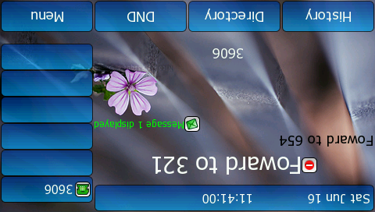

## PhoneExecute Object

PhoneExecute object allows an external application to ask the phone to execute a sequence of local commands using URIs. The phone will execute each specified command in order.

PhoneExecute XML example:

|  |
| --- |
| <****PhoneExecute  Beep = “yes/no”>  <ExecuteItem URI = “URI”/>  <!-Additional Execute Items may be added - ->  </****PhoneExecute> |

**Note**

The “****” in “****PhoneExecute” can be any string or null.

The parameters of the PhoneExecute object are listed in the following table:

|  |  |  |  |
| --- | --- | --- | --- |
| **Parameter** | **Type** | **Value** | **Description** |
| ****PhoneExecute | mandatory | none | The root element of the PhoneExecute. |
| Beep | optional | “yes”  “no” | Whether to play a tone when beginning the execute command. Default value is “no”. |
| ExecuteItem | mandatory | none | Command item.  (Value ranges from 0~30) |
| URI | optional | URI | The operation of command item, such as call user, download the data from server according to the URL, etc. |

Common use command:

| **Name** | **URI Value** | **Function** |
| --- | --- | --- |
| Any Supported URI | http(s)://myserver.com/myscript.pl | Dial out the URL |
| Dial：XXXXX | Dial out the number |
| Led：XXXX=on/off/slowflash/fastflash | To control the LEDs according to the commands |
| Key：XXXX | Press XXXX operation |
| Wav.Play:[tftp|http://[username[:password]@]<host>[:port][/<Path>]/<file>  Wav.Stop: | Play or close the wav file |
| Phone Reboot | Command: Reset | Reset to the factory |
| Phone Fast Reboot | Command: Reboot | Phone reboot |
| Phone Lock | Command: Lock | Lock the phone key |
| Phone Unlock | Command: Unlock | Unlock the phone |
| Clear | Command: ClearCallersList | Clear local call record list |
| Command: ClearDirectory | Clear contact list |
| Command: ClearRedialList | Clear redial list(call out record) |
| Do nothing | none | none |

Specification of “XXXX” in “Led：XXXX=on/off/slowflash/fastflash”:

| **Setting Method** | **Indicator** | **Example** |
| --- | --- | --- |
| EXP38-%d-%d2-%s | **%d:** the “%d”th expansion module, value range 1~6;  **%d2:** the “%d”th button of expansion module, value range 1~38;  **%s:** the light color, value: “RED”, “GREEN”. | “Led：EXP38-2-3-RED=on”: Lighten the indicator of the third button of the second expansion module to be red |
| LINE%d | **%d:** It represents the serial number of corresponding indicator, value 1~6. | “Led:LINE3=on”: Lighten the corresponding indicator of Line3 |
| MEMO%d_%s | **%d:** It represents the memory key’s serial number, value 1~10  **%s:** The light color, value : “RED”, “GREEN” | “Led: MEMO5_GREEN= on”: Lighten the indicator of Memory5 to be green |
| SMS | Message indicator |  |
| HEADSET | Headset switch indicator |  |
| BACKLIGHT | Backlight indicator |  |
| HANDFREE | Handfree indicator |  |
| POWER | Power indicator |  |

Specification of “XXXX” in “Key: XXXX”:

| **Setting Method** | **Indicator** | **Example** |
| --- | --- | --- |
| EXP38-%d-%d | **%d:** the “%d”th expansion module, value range 1~6  **%d2:** the “%d”th button of expansion module, value range 1~38 | “Key: EXP38-2-3”: It means the third key of the second expansion module |
| OFF_HOOK | Off hook |  |
| ON_HOOK | On hook |  |
| OK | Ok key |  |
| CANCEL | X key |  |
| UP | Up key |  |
| DOWN | Down key |  |
| LEFT | Left key |  |
| RIGHT | Right key |  |
| INCREASE | Increase volume |  |
| DECREASE | Decrease volume |  |
| REDIAL | Redial key |  |
| HOLD | Hold the line |  |
| MUTE | Mute |  |
| CONFERENCE | Conference |  |
| TRANSFER | Transfer |  |
| SMS | Message key |  |
| FWD | Forward key |  |
| PHONEBOOK | Remote phone book key |  |
| SWITCH | Switch key |  |
| HEADSET | Headset switch key |  |
| HANDFREE | Handfree key |  |
| LINE%d | Line key, value 1~6 |  |
| HOTKEY%d | Hot key, value 1~4 |  |
| MEMORY%d | Memory key, value 1~10 |  |
| KEY_%d | Number key, value 0~9 |  |
| STAR | ‘*’ key |  |
| POUND | ‘#’ key |  |
| GROUP_LISTEN | Group listening key |  |
| HOLD_PUBLIC | Public hold for BLA |  |
| HOLD_PRIVATE | Private hold for BLA |  |

An example of the PhoneExecute object:

|  |
| --- |
| <YealinkIPPhoneExecute Beep="yes">  <ExecuteItem URI="Dial:1001" interrupetCall="no"/>  <ExecuteItem URI="Key:HANDFREE" />  <ExecuteItem URI="http://10.2.11.158/menu.xml"/>  <ExecuteItem URI="LED: SMS=slowflash"/>  </YealinkIPPhoneExecute> |

There is no prompt screenshot during the execute process.

## PhoneConfiguration Object

PhoneConfiguration objectallows an external application to modify configuration of the phone.

PhoneConfiguration XML example:

|  |
| --- |
| <****Configuration Beep = “yes/no”>  <Path  config = “LineKey/MemKey/EXP1/EXP2/EXP3/EXP4/EXP5/EXP6”>  <Item>DSS key.parameter=value</Item>  <!-Additional Items may be added - ->  </Path>  <!-Additional Paths may be added - ->  </****Configuration> |

**Note**

The “****” in “****PhoneConfiguration” can be any string or null.

The parameters of the PhoneConfiguration object are listed in the following table:

| **Parameter** | **Type** | **Value** | **Description** |
| --- | --- | --- | --- |
| ****PhoneConfiguration | mandatory | none | The root element of the PhoneConfiguration. |
| Beep | optional | “yes”  “no” | Whether to play a tone when doing the configuration. Default value is “yes”. |
| Path | mandatory | null | The path item. |
| config | mandatory | LineKey/MemKey/EXP1/EXP2/EXP3/EXP4/EXP5/EXP6 | The type of DSS key. |
| Item | optional | string | The setting content: DSS key.parameter=value. |

The details of the Item tag:

|  |  |
| --- | --- |
| **DSS key** | **Description** |
| memory1~memory10 | The sequence number of memory keys. |
| linekey1~linekey6 | The sequence number of line keys. |
| expkey1~expkey40 | The sequence number of expansion keys. |

|  |  |
| --- | --- |
| **parameter** | **Description** |
| DKtype | The type of DSS key. |
| Label | The label of DSS key. |
| Line | The line of DSS key. |
| Value | The value of DSS key. |
| PickupValue | The pickup code of DSS key. |

|  |  |  |
| --- | --- | --- |
| **The value of DKtype.** | | |
| N/A  Line  SpeedDial  BLF  BLFList  VoiceMail  PickUp  GroupPickUp  CallPark  Intercom  DTMF  Prefix | LocalGroup  XMLGroup  XMLBrowser  LDAP  BroadSoftGroup  Conference  Forward  Transfer  Hold  DND  Redial  CallReturn | SMS  Record  URLRecord  Paging  GroupListen  PublicHold  PrivateHold  ShareLine  Zero-sp-touch  URL  Switch(only for EXP) |

The format of the Item tag: DSS key.parameter=value.

For example: memorykey1.DKtype=BLF

Explain: The type of the first memory key is set to “BLF”.

**Note**

The line number of BLF, BLF list, BLA, ACD is from 0, i.e. linekey0 stands for line1. Others are from 1. If there is “Auto” optional in value of parameter, 0 stands for Auto.

An example of the PhoneConfiguration object:

|  |
| --- |
| <YealinkIPPhoneConfiguration  Beep="yes" >  <Path config="MemKey">  <Item>memory1.DKtype=BLF</Item>  <Item>memory1.Label=1</Item>  <Item>memory1.Line=1</Item>  <Item>memory1.Value=1</Item>  <Item>memory1.PickupValue=1</Item>  <Item>memory2.DKtype= PickUp</Item>  <Item>memory2.Label=1</Item>  <Item>memory2.Line=1</Item>  <Item>memory2.Value=1</Item>  <Item>memory2.PickupValue=*98</Item>  </Path>  <Path config="LineKey">  <Item>linekey2.DKtype=SpeedDial</Item>  <Item>linekey2.Label=1</Item>  <Item>linekey2.Line=1</Item>  <Item>linekey2.Value=1</Item>  <Item>linekey2.PickupValue=1</Item>  </Path>  <Path config="EXP1">  <Item>expkey2.DKtype=DND</Item>  <Item>expkey2.Label=1</Item>  <Item>expkey2.Line=1</Item>  <Item>expkey2.Value=1</Item>  <Item>expkey2.PickupValue=1</Item>  </Path>  </YealinkIPPhoneConfiguration> |

# Yealink IP Phone XML Applications

Yealink IP phones only support to download using the HTTP (HTTPS) protocol. You can set up the HTTP(s) server, and place some Xml Browser files on the server for downloading. You also can contact your system administrator for more information.

## Configuring a HTTP Server

**Configure the HTTP server using HFS application:**

1. Double click the HFS.exe.
2. Click **Menu** in the main page and select the IP address of the PC from **IP address**.

The default HTTP port is 80. You can also reset the HTTP port (make sure the port isn’t used before reset).

1. Right click the icon on the left of the main page, select **Add folder from disk** to add the HTTP Serverroot directory.
2. Locate the root directory from the computer system. Select the folder you want.
3. Select one of the XML files, then the access URL of XML file displays in the address bar.
4. Copy the access URL to fill in the **Value** field of the **DSS Key**.

The screenshot for reference is shown as below:

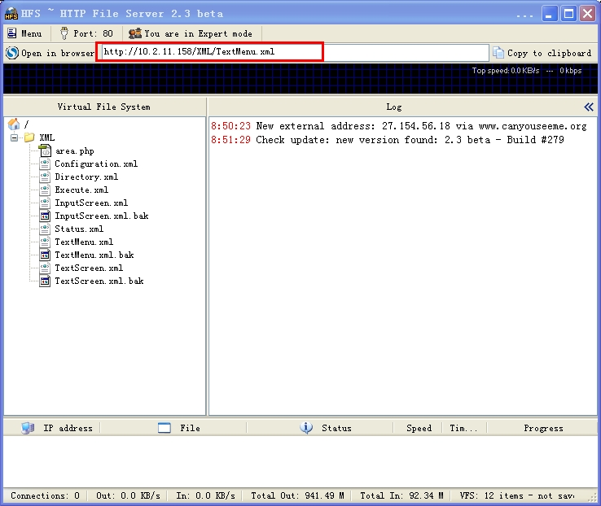

## Configuring a DSS key

### Web Configuration

**To configure the XML Browser via web user interface:**

1. Access the web interface of the phone.
2. Click on **DSS Key** and then select **Memory Key (Line Key)**.
3. Select **XML Browser** from the pull-down list of **Type**.
4. Fill the available access URL in the **Value** field.
5. Click the **Confirm** to accept the change.

The screenshot of the web interface for reference is shown as below:

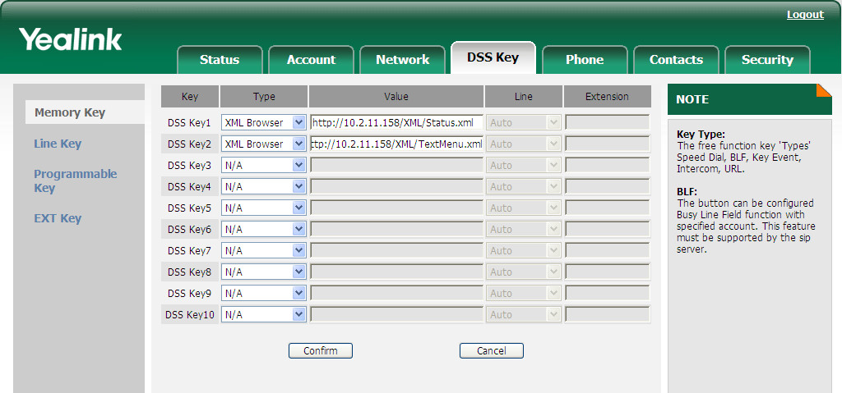

### Phone Configuration

**To configure the XML Browser via IP phone:**

1. Press **Menu** ->**Call Feature** ->**DSS Keys-> Memory Keys (Line Keys)**.
2. Select the desired DSS Key.
3. 16.png15.pngPress or , or the **Switch** soft key to select **XML Browser** from the **Type** field.
4. Enter the available access URL in the **XML Browser** field.
5. Press the **Save** soft key to accept the change.

The screenshot of the phone interface for reference is shown as below:

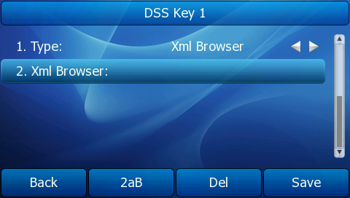

## Configuring the Push XML Server

The IP phone will accept the HTTP(s) POST from the IP addresses set in the Push XML Server IP.

**To configure the Push XML Server via web user interface:**

1. Access the web interface of the phone.
2. Click on **Phone**->**Features**.
3. Enter IP addresses or domain names in the **Push XML Server IP** field.

The maximum of the input in the Push XML Server IP field is 10, each one is separated by a comma.

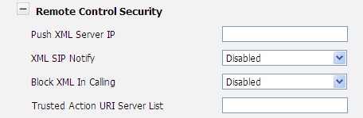

**Note**

The default value of “Block XML In Calling” is disabled, that is, if press the XML Browser key in calling status, the phone will display the XML interface or execute the command.

## Configuring the XML SIP Notify

You can configure the XML SIP Notify from the Web user interface. It will enable or disable SIP NOTIFY message processed by the phone.

**To configure the XML SIP Notify via web user interface:**

1. Access the web interface of the phone.
2. Click on **Phone**->**Features**.
3. Select Enable from the pull-down list of **XML SIP Notify** field.

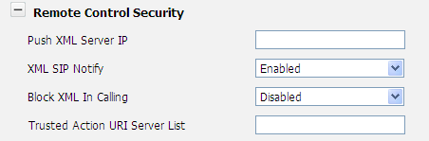

When the phone receives the XML SIP notify message, the phone will display the information or execute the command in the NOTIFY message.

Example of a SIP Notify with XML content:

